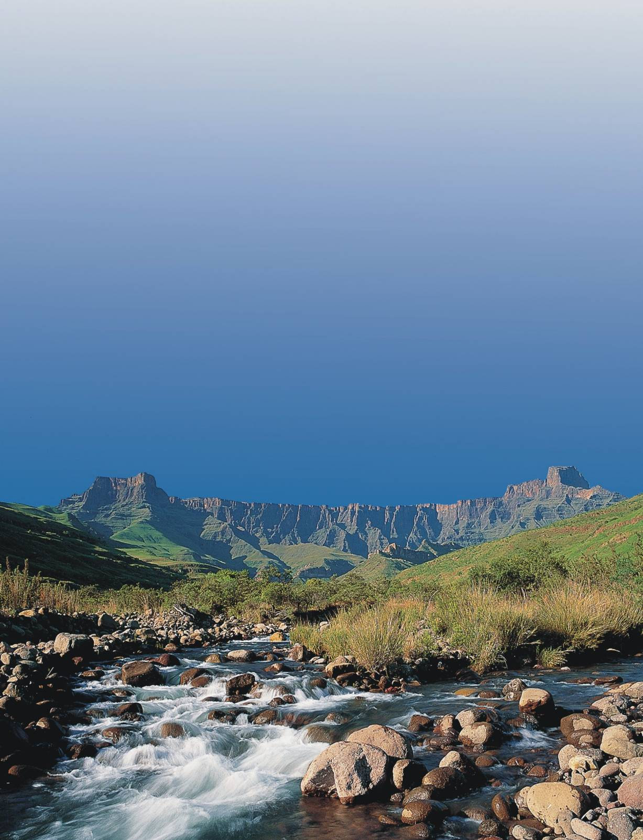

I.D.P
Review

2010/2011

Prepared By : Department Strategic Planning and Economic Development
Address :PO Box 116
Ladysmith, 3370
Email :gents@uthukeladm.co.za
Tel: 036 638 2400Fax: 036 635 5501

TABLE OF CONTENTS
SECTION A: EXECUTIVE SUMMARY
A1.1.1 INTRODUCTION 8
A1.1.2 UTHUKELA DISTRICT MUNICIPALITY 8
A1.1.3 CHALLENGES FACED BY UTHUKELA DISTRICT 9
A1.1.4 OPPORTUNITIES OFFERED BY THE DISTRICT 10
A1.1.5 STRATEGIES FOR IMPROVEMENT 11
A1.1.6 UTHUKELADISTRICT MUNICIPALITY IN THE NEXT 5 YEARS 11
A1.1.7 MEASURING THE PROGRESS 12
A1.1.8 DEVELOPING THE UTHUKELA IDP 12

SECTION B: SITUATIONAL ANALYSIS
B1.1.1 SITUATIONAL ANALYSIS 15
B1.1.2 TOTAL POPULATION 16
B1.1.3 POPULATION BREAKDOWN PER GROUP 16 B1.1.4 AGE AND GENDER 17 B1.1.5 EDUCATION LEVELS 18
B1.1.6 MIGRATION 19
B1.1.7 URBANISATION 19
B1.1.8 HIV AIDS PREVELANCE 20
B2 ECONOMY OF UTHUKELA DISTRICT MUNICIPALITY 21
B2.1.1 INTRODUCTION 21
B2.1.2 STRUCTURE OF THE DISTRICT ECONOMY 21
B2.1.3 ECONOMIC GROWTH 21
B2.1.4 ANNUAL HOUSEHOLD INCOME 23
B2.1.5 POVERTY 23
B2.1.6 EMPLOYMENT RATIOS 25
B2.1.7 EMPLOYMENT SECTORS 25
B2.1.8 INCOME BY SECTOR 26
B2.1.9 LOCAL ECONOMIC DEVELOPMENT STRATEGY 28
B2.1.10 UTHUKELA DISTRICT LED FORUM 28
B2.1.11 UTHUKELA DISTRICT TOURISM FORUM 28
B2.1.12 DEVELOPMENT OF SMMES AND SECOND ECONOMY 29
B2.1.13 SECTOR DEVELOPMENT 29
B2.1.14 AGRICULTURE 29
B2.1.15 TOURISM 30
B2.1.16 DISTRICT GROWTH AND DEVELOPMENT SUMMIT 31
B2.1.17 ALIGNMENT OF LED STRATEGY WITH PROVINCIAL AND
NATIONAL OBJECTIVES (PGDS, ASGISA AND NSDP) 31
B3 PROVISION OF BASIC INFRASTRACTURE AND SERVICES 36
B3.1.1 INTRODUCTION 36
B3.1.2 WATER 36
B3.1.3 WATER QUALITY 37
B3.1.4 WASTE WATER TREATMENT 37
B3.1.5 WATER SERVICES DEVELOPMENT (WSDP) 38
B3.1.6 SANITATION 38
B3.1.7 FREE BASIC WATER AND SANITATION 39
B3.1.8 HOUSING 39
B3.1.9 ENERGY/ELECTRICITY 40
B3.1.10 FREE BASIC ELECTRICITY 41
B3.1.11 REFUSE COLLECTION AND DISPOSAL 41
B3.1.12 ROADS AND PUBLIC TRANSPORT 45
B3.1.13 HEALTH FACILITIES 46
B3.1.14 EDUCATION FACILITIES 47
B3.1.15 EXPANDED PUBLIC WORKS PROGRAMME 47
B4 ENVIRONMENTAL ANALYSIS 49
B4.1.1 ENVIRONMENTAL MANAGEMENT 50
B4.1.2 INTEGRATED WASTE MANAGEMENT PLAN 50
B4.1.3 AIR QUALITY MANAGEMENT PLAN 50
B4.1.4 POLICIES AND BYLAWS 50
B4.1.5 PUBLIC PARTICIPATION AND ENGAGEMENT ON
ENVIRONMENTAL MANAGEMENT 51
B4.1.6 CAPACITATION OF LOCAL MUNICIPALITIES ON
ENVIRONMENTAL ISSUES 51

B4.1.7 PROJECTS AND PROGRAMMES AIMED AT ENVIRONMENTAL
PROTECTION 51
B5 INSTITUTIONAL ANALYSIS 52
B5.1.1 POWERS AND FUNCTIONS OF UTHUKELA DISTRICT
MUNICIPALITY 53
B5.1.2 ROLES AND RESPONSIBILITIES OF THE HEADS OF
DEPARTMENTS 53
B5.1.3 SKILLS DEVELOPMENT 55
B5.1.4 EMPLOYMENT EQUITY 55
B5.1.5 HUMAN RESOURCE STRATEGY 56
B5.1.6 INTERGOVERNMENTAL RELATIONS 57
B6 SOCIAL DEVELOPMENT 58
B6.1.1 SPORTS AND YOUTH 58
B6.1.2 PHYSICALLY CHALLENGED 58
B6.1.3 GENDER ISSUES 59
B6.1.4 SENIOR CITIZEN 59
B6.1.5 SAFETY AND SECURITY 59
B6.1.6 DISASTER MANAGEMENT 59
B7 GOOD GOVERNANCE, PUBLIC PARTICIPATION AND
ALIGNMENTS 61
B7.1.1 TRADITIONAL LEADERSHIP 63
B7.1.2 PORTFOLIO COMMITTEES 63
B7.1.3 WARD COMMITTEES 63
B7.1.4 COMMUNITY DEVELOPMENT WORKERS 64
B7.1.5 AUDIT COMMITTEE 64
B7.1.2 ALIGNMENT OF UTHUKELA IDP WITH LOCAL
MUNICIPALITIES 64
B7.1.3 SERVICE PROVIDERS ALIGNMENT 65
B7.1.4 CROSS MUNICIPAL BORDER ALIGNMENT 65
B8 SWOT ANALYSIS 66
B8.1.1 INTRODUCTION 66
B8.1.2 STRENGTHS 66
B8.1.3 WEAKNESSESS 66
B8.1.4 OPPORTUNITIES 66
B8.1.5 THREATS 68
B9 KEY PRIORITY ISSUES 69

SECTION C: DEVELOPMENT STRATEGIES

C1.1.1 INTRODUCTION 70
C1.1.2 MUNICIPAL VISION AND MISSION 70
C1.1.3 MUNICIPAL STRATEGIC OBJECTIVES 71
C1.1.4 TURN AROUND STRATEGY 77

SECTION D: SPATIAL DEVELOPMENT FRAMEWORK
D1.1.1 BACKGROUND 79
D1.1.2 SPATIAL ANALYSIS 97
D1.1.3 ALIGNMENT OF UTHUKELA SDF WITH LOCAL MUNICIPALITIES AND NEIGHBOURING DISTRICTS 98
D1.1.4 ALIGNMENT OF SDF WITH NSDP 98
D1.1.5 ALIGNMENT OF SDF WITH PSEDS 100
D1.1.6 LAND USE MANAGEMENT SYSTEM 101
D1.1.7 LAND USE MANAGEMENT GUIDELINES/FRAMEWORK 101
SECTION E: SECTOR INVOLVEMENT
E1.1.1 INTRODUCTION 105
E1.1.2 DEPARTMENT OF ARTS AND CULTURE 105
E1.1.3 PUBLIC WORKS 108
E1.1.4 DEPARTMENT OF HUMAN SETTLEMENTS 109
SECTION F: IMPLEMENTATION PLAN
F1.1.1 IMPLEMENTATION PLAN 111

SECTION G: PROJECTS
G1.1.1 ONE YEAR OPERATIONAL PLAN 114
G1.1.2 SANITATION PROJECTS WITHOUT FUNDING 116
SECTION H: FINANCIAL VIABILITY AND
MANAGEMENT
H1.1.1 INTRODUCTION 117
H1.1.2 SUPPORT ON LOCAL MUNICIPALITIES 117
H1.1.3 DEBT COLLECTION 118
H1.1.4 AUDIT COMMITTEE 118
H1.1.5 INTERNAL AUDIT 118
H1.1.6 INDIGENT POLICY 118
H1.1.7 BILLING SYSTEM 118
H1.1.8 SUPPLY CHAIN MANAGEMENT POLICY 119
H1.1.9 ASSETS MANAGEMENT STRATEGY 119
H1.1.10 FRAUD PREVENTION PLAN 119
H1.1.11 RISK MANAGEMENT POLICY 119
H1.1.12 RISK MANAGEMENT COMMITTEE 121
H1.1.13 INVESTMENTS 122
H1.1.14 INTEGRATED FINANCIAL SYSTEMS 122
H1.1.15 AUDITOR GENERAL OPINION 122
H1.1.16 REPORT OF THE AUDITOR GENERAL 123
H1.1.17 RESPONSE TO AUDITOR GENERAL 128
H1.1.18 BUDGET 137

SECTION I: ORGANISATIONALPERFOMANCE
MANAGEMENT SYSTEM
I1.1.1 INTRODUCTION 145
I1.1.2 BACKGROUND 145
I1.1.3 ORGANISATIONAL SCORECARD 148
I1.1.4 STATUS OF UTHUKELA PMS 158
I1.1.5 ANNUAL REPORT 158

SECTION J: ANNEXURES
J1.1.1 LIST OF ANNEXURES 159

SECTION A : EXECUTIVE SUMMARY

A.1.1 INTRODUCTION
The structure of this plan is based on the revised approach and framework for IDP’s 2007/08 published and endorsed by the National IDP Steering Committee.

The uThukela District Municipality, as a government institution is legally obligated to develop a municipal Integrated Development Plan (IDP), which will act as the guiding document towards municipal development and service delivery. According to chapter 5 of the Municipal systems Act (MSA) of 2000 as amended states that, all municipalities have to undertake an IDP process to produce Integrated Development Plans (IDP)

The uThukela Integrated Development Plan is based on the legislative mandate that governs the operations of the local government sphere. In addition, the IDP framework Guide has been taken into consideration during the process.

Guidance was obtained from the following documentation namely: The municipal Systems Act (Act 32 of 2000), Local Government municipal planning and Performance Management regulations (2001) that set out the components of the IDP’s and the requirements for public participation in the drafting of the IDP

A1.1.2 UTHUKELA DISTRICT MUNICIPALITY
uThukela District Municipality (UTDM) is one of ten District Municipalities in the Province of KwaZulu-Natal.It was established during the 2000 transformation of local government UThukela District Municipality derives its name from one of the major rivers in the Province of KwaZulu-Natal, the uThukela River that rises from the Drakensberg Mountains and supplies water to a large portion of KZN and as well as Gauteng.uThukela District Municipality has three district municipalities bordering onto it within the Province of Kwazulu -Natal, namely Amajuba,Umzinyathi and Umgungundlovu.

The size of the Municipality is approximately 11500km².It is located in the western boundary of KwaZulu-Natal. It is predominately rural, with three of the five Local Municipalities, rural based. This Municipality is characterised by the socio-economic indicators such as low revenue base, poor infrastructure, limited access to services and obviously low economic base; high levels of poverty, unemployment, skills shortage, lack of resources and low level of education; un/under-developed land and settlement patterns that make it difficult to plan for effective service delivery. There are a number of challenges that are also associated with attraction of investors, tourists and skilled human resource due to its location away from the two major cities namely, Durban and Johannesburg.

uThukela District municipality consists of five Local Municipalities and one District Management Area (DMA), namely, Indaka local municipality, Emnambithi/Ladysmith municipality, Umtshezi local Municipality, Okhahlamba local Municipality, Imbabazane local Municipality, and District Management Area 23.Indaka and Okhahlamba are both Project Consolidate Municipalities in our District.
(See the Map below 1.1 for the location of uThukela District Municipality).
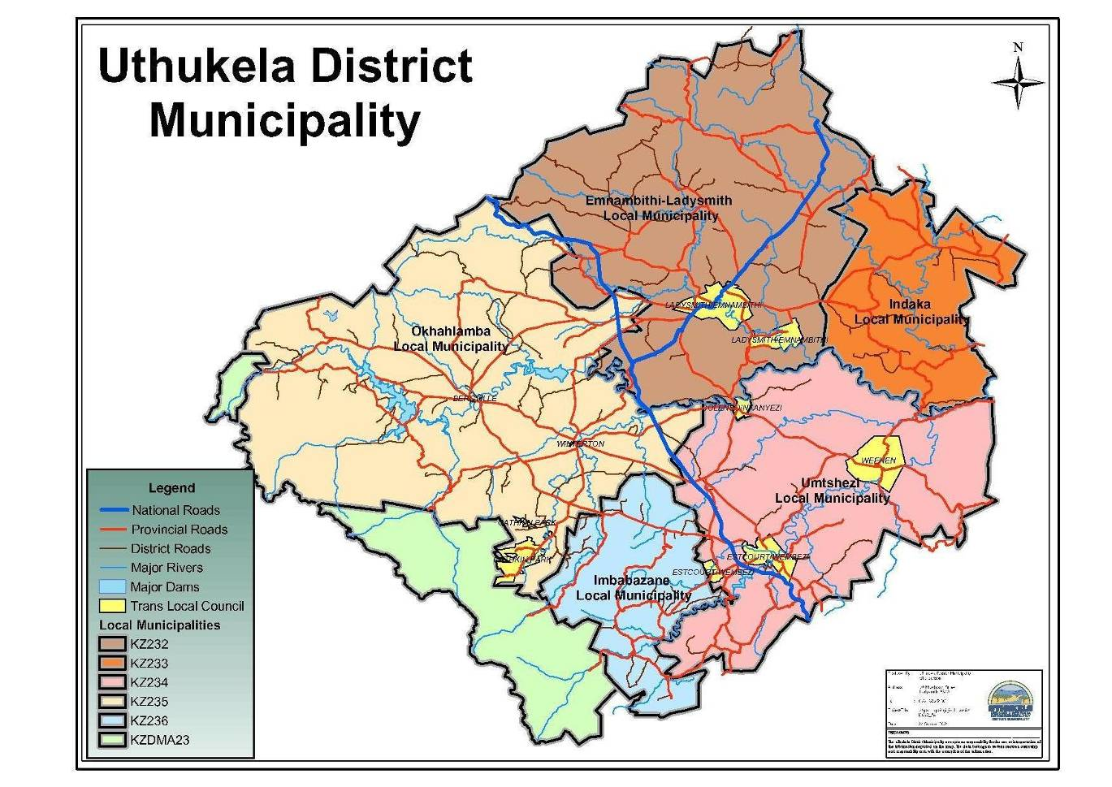

Map 1.1

A1.1.3 CHALLENGES
This Municipality is characterised by the socio-economic indicators such as low revenue base, poor infrastructure, limited access to services and obviously low economic base; high levels of poverty, unemployment, skills shortage, lack of resources and low level of education; un/under-developed land and settlement patterns that make it difficult to plan for effective service delivery. There are a number of challenges that are also associated with attraction of investors, tourists and skilled human resource due to its location away from the two major cities namely, Durban and Johannesburg. The key issues that will have an impact in economy of the District are as follows:
- Provision of sustainable infrastructure, water and sanitation services and backlog thereof
- Economic Development
- Prevention of ill-health and promotion wellness
- Public safety and security
- Financial viability and administrative capacity of the district
- Accountability and public participation institutions
- Coordination of services
- The newly established municipalities which is Indaka and Imbabazane are without a well established economic centre and as a result the most significant poverty is found in these municipalities.

A1.1.4 OPPORTUNITIES OFFERS BY THE DISTRICT
The UThukela District located in the World Heritage Site. uThukela District Municipality is a unique mix of the majestic Drakensberg Mountains, historical and world renowned battle sites and out of Africa experiences. These qualities have created a District that is a tourism magnet in Southern Africa. The investments opportunities are as follows:
- Two national roads which is N3 and N11 which has a potential for economic development because it forms the critical link between uThukela, Provincial and International destinations
- Cable Way-Mnweni Valley which takes the tourism investment to new heights
- Spionkop lodge offers an investor the opportunity to become a 50% partner in a unique out of Africa tourism experience
- Weenen Cultural theme park offers the opportunity to invest in tourism fascination with the customs, traditions and culture of the amaZulu.
- Zulu Gateway an opportunity for investors to become involved in a tourism experience strategically positioned on the N3, Midway between Durban and Johannesburg
- Woodstock Dam it gives an investor an opportunity to invest in a fishing and camping attraction on the banks of a dam located in the foothills off the Drakensberg
- The Cannibal Route an opportunity to invest in a unique and historic visitor attraction within an established tourism district.
- The Zulu Experience an opportunity for an investor to import, distribute and sell arts and crafts in selected international markets
- Dinosaur Valley it gives an investor an opportunity to invest in archaeology based visitor attraction in an established tourism sector of the Drekensberg Mountains
- The District is well endowed with water, pockets of good soils and the cultural beauty of the Drakensberg.
A1.1.5 STRATEGIES FOR IMPROVEMENT
To deal with the challenges faced by the District, the uThukela District Municipality have highlighted the following strategies for 2010/2011 and beyond:
- Implementing financial management capacity building programme
- Supporting public safety programmes aimed at combating and reducing crime
- Promoting the investment initiative in the identified nodes
- Promoting the Tourism in the District because the District is rich in Tourism especially in the Drakensberg Mountains
- Implementation of an SMME’s programme and promote PPP’S
- Through efficient and effective management of resources and assets
- Through the creation of an environment that is conducive to Economic Development
- Capacitating of Cooperatives in the District.
- Optimizing of 2010 opportunities
- Establishment of the effective Shared Services centre.
- Optimal utilisation and management of the District resources
- Localisation of the National policies

A1.1.6 UTHUKELADISTRICT MUNICIPALITY IN THE NEXT FIVE YEARS

UThukela is now part of the Global Economy and is striving to become competitive, not only locally or nationally but internationally. The emphasis will be on retaining industry and commercial activities in Ladysmith and Estcourt.The District Municipality will strive to spread the economic activities to the disadvantaged areas of the region. The natural beauty of UThukela should be enhanced through marketing and maintenance of the existing infrastructure. The regional Development that will applied to UThukela District is the establishment of the Industrial Park that aims to concentrate in one area a number of high technology industrial firms that will provide jobs and skills and which will eventually generate enough income and demand to sustain economic growth.

A1.1.7 MEASURING THE PROGRESS
uThukela District Municipality as a water service authority managed to decrease the water and sanitation backlogs from 21% to 17% (water) and 61% to 36% (sanitation) in August 2009.In the 2007/2008 there was no Disaster management personnel in the District whereas our District is faced with the severe disasters and efforts were made in coming up with a fully fledged disaster management that is in line with the Disaster Management Act in the 2008/2009 financial year. The Municipality has also established the Disaster Management Advisory Forum. Senior Citizen Forum was also formed in 2008.The Fraud Prevention Plan was also developed by the District in 2009.The Bucket Eradication system was completed by Indaka local municipality. uThukela District has established the shared resources for the delivery of development planning services as well as the GIS.uThukela District Municipality received an unqualified report from the Auditor General for the past three financial years.

A1.1.8 DEVELOPING THE UTHUKELA IDP
uThukela District municipality IDP was developed in house. For purposes of review of the 2010/11 IDP document, a Process Plan and Framework Plan were drafted and adopted by uThukela District Municipality on the 09 September 2009. The Framework Plan was drafted to ensure that the review process of the District IDP and local municipality’s IDP’s are linked and equally informed by each other. The Process Plan specifies the time frames for the different planning steps, as well as the appropriate mechanisms, processes and procedures for consultation and participation in reviewing the IDP document of the previous year. uThukela IDP Process Plan was also aligned to the local municipalities. This IDP has been informed by the IDP’s of the Local Municipalities. This plan used the Community Survey for 2007 because the 2001 statistical information was outdated.
In developing this plan the following Key Focal Areas which are the cornerstone of sustainable service delivery and development in the UThukela District municipality were taken into consideration:
- Municipal Transformation and Institutional Development
- Service Delivery and infrastructure
- Local Economic Development
- Good governance and Public participation
- Spatial Development
- Financial Viability

For the UTDM to ensure that the IDP is used as a coordination tool for development activities it has for the past years, with increasing success, engaged the relevant stakeholders through the IDP Representative forum, Mayor’s Forum, service providers forum, ward committees of the local municipalities and other structures to deliberate and make input on this critical document. This consultation process has had significant impact in ensuring that stakeholders realise and embrace the importance of integrated planning within the municipality. The various sectors are now in step with the process and they work hard to ensure timeous inclusion of their programmes as well as planning together in the IDP. Furthermore, the process has ensured that members of the community have an opportunity to contribute to the UTDM’s IDP and as a result this has fostered a sense of ownership among stakeholders.

It is also promoting the spirit of good governance and a positive professional relationship. It is significant to note that UTDM has provided a platform for stakeholders to understand the roles and responsibilities of the municipalities as well as the budgeting processes for the identified projects. The stakeholders have been able to come together with a common objective in ensuring that the citizens within the family of Municipalities work towards “improving the quality of life for all in a globally interconnected, stable and developed region “

The 2010/2011 IDP focuses largely on economic development programmes as a priority area. This is expected to improve the socio-economic conditions of the area and contribute towards poverty reduction. In planning for LED programmes as well as other programmes such as skills development and capacity building within the Municipality, the principles and goals of the Accelerated and Shared Growth and Development Initiative of South Africa (ASGISA) have been incorporated in integrated planning. This type of integration extends to the Provincial Growth and Development Strategy (PGDS), the IDP’s of Local Municipalities, the resolutions of the District Growth and Development Summit .In addition to the latter, the District Municipality is fully aware of the Millennium Development Goals and the target date set nationally for extension of basic services.

The Process Plans for all local municipalities were agreed upon and the Framework plan that ensures alignment was also agreed upon and progress reports were submitted on a monthly basis to ensure uniformity in meeting the stipulated deadlines for the IDP process set-out by the Department of Local Government and Traditional Affairs as well as the Department of Provincial Local Government (dplg). For the 2010/11 IDP, uThukela District Municipality revisited the status of all projects identified for implementation in 2009/10. The completed projects were removed from the current IDP and the remaining projects for 2009/10 are those that are still under implementation, targeted for completion during the course of the 2010/11 financial year. This is one way of ascertaining that the IDP’s also serve as a monitoring tool for the Municipality. Consultation formed a critical path for the current IDP.

The UTDM prides itself in presenting the 2010/11 IDP, which has addressed all the comments made during IDP Analysis in 2010/11 draft IDP,Comments made by the MEC for COGTA in 09/10 IDP as well as the inputs made by stakeholders during meetings and during IDP/Budget public participation. Integrated Planning is central to the Municipality’s philosophy as it relates to effective service delivery.

The 2010/2011 IDP is also taking into consideration the following provincial priorities that were raised in the MEC letter:
- Rural Development and Agrarian Reform
- Creating decent work and economic growth
- Fighting crime and Corruption
- Development of human capability and education
- Creation healthier and sustainable communities
- Nation Building and good governance

SECTION B: THE CURRENT SITUATIONAL ANALYSIS

B1.1.1 SITUATIONAL ANALYSIS
uThukela District Municipality (DC23) is one of ten District Municipalities in the Province of KwaZulu-Natal. uThukela District Municipality derives its name from one of the major rivers in the Province of KwaZulu-Natal, the uThukela River that rises from the Drakensberg Mountains and supplies water to a large portion of KZN and as well as Gauteng. uThukela District Municipality has three district municipalities bordering onto it within the Province of KwaZulu -Natal, namely Amajuba, Umzinyathi and UMgungundlovu.

uThukela District Municipality consists of five Local Municipalities and one District Management Area (DMA), namely, Indaka (kz233), Emnambithi/Ladysmith (kz232), Umtshezi (kz234), Okhahlamba (kz235), Imbabazane (kz236), and District Management Area 23.Indaka and Okhahlamba are both Project Consolidate Municipalities in our District.

The size of uThukela District Municipality is approximately 11500km².Emnambithi is occupying 2,965.92km²,Indaka is on 991.71km²,Umtshezi 2130.85km²,Okhahlamba which is the largest is on 3540.63km²,Imbabazane is on 827.74km² and the DMA 23 is on 874.33km² It is located in the western boundary of KwaZulu-Natal. It is predominately rural, with three of the five Local Municipalities, rural based. This Municipality is characterised by the socio-economic indicators such as low revenue base, poor infrastructure, limited access to services and obviously low economic base; high levels of poverty, unemployment, skills shortage, lack of resources and low level of education; un/under-developed land and settlement patterns that make it difficult to plan for effective service delivery. There are a number of challenges that are also associated with attraction of investors, tourists and skilled human resource due to its location away from the two major cities namely, Durban and Johannesburg.

UThukela District Municipality comprises of 18 Traditional leadership. uThukela Local House has been established and they are meeting on regular basis to discuss the issues related to Amakhosi and development in the District.

DEMOGRAPHICS
B1.1.2 TOTAL POPULATION
According to the 2007 Community Survey, there are 714 909 people living at uThukela, The Community Survey that was conducted in 2007 indicates that the number of people living in uThukela has been increased from 656 986 into 714 909 which is 7.0% of the Province. The population of UThukela District Municipality is unevenly distributed. The largest population is in Emnambithi/Ladysmith and the small population is in the DMA (District Management Area) there is proposal from the Demarcation Board that says all the DMA’s will be incorporated into the local municipalities adjacent to it. At this point in time is still under discussion with the relevant stakeholders.
The population of UThukela is distributed as follows
Municipality | Wards | 2001 census | Percentage | 2007 survey | Percentage
Emnambithi | 25 | 225 459 | 34,3 of district | 236 748 | 33% of district
Okhahlamba | 13 | 137 525 | 20,9 of district | 151 441 | 21% of district
Imbabazane | 12 | 119 925 | 18,3 of district | 140 745 | 20% of district
Indaka | 10 | 113 644 | 17,3 of district | 101 557 | 14% of district
Umtshezi | 7 | 59 921 | 9,1 of district | 83 906 | 12% of district
DMA |  | 465 | 0,1 of district | 515
Total population of Uthukela | 67 | 656986 | 100 | 714 909 | 7.0%of province
(Source: Statistics SA: Census 2001 and Community survey 2007)

B1.1.3 POPULATION BREAKDOWN PER GROUP
The following table indicates the population breakdown of the uThukela District Municipality. This breakdown is showing the Africans, Coloureds, Indians and Whites. The majority of the people that lives in uThukela District Municipality are Africans and Coloureds are minority. Population breakdown per Group
Group | 2001 | % | 2007 survey | %
African | 620 733 | 94.48 | 681998 | 95.4
Coloured | 4 055 | 0,62 | 2231 | 0.3
Indian | 17 156 | 2.61 | 23200 | 3,2
White | 15 042 | 2,29 | 7482 | 1,0
Total | 656 986 | 100.00 | 714,909 | 100.00
(Source: Statistics South Africa: Census 2001 and Community Survey 2007)
B1.1.4 AGE AND GENDER

The highest percentage of the population of uThukela is between the 0 to 4 years of age (13%). This shows a relatively high birth rate. The young generation constitute more than 60% being between the ages of 5 to 34 years. Ages 0 to 24 are relatively constant showing a 4.1% decrease. Ages from 0 to 4 years is at 13.1% and decrease slightly on ages between 20 and 24 to 9%. It is not clear whether the 4.1% difference is due to factors like infant mortality or migration.

The population pyramid has a broad base that reflects a high proportion of children and youth, commonly known as the youth bulge. It also shows a tapering off of adults, indicating two possible trends: out migration of economically active people, and the impact of AIDS-related deaths. The lower proportion of men to women (46:54) would support the former explanation, as men continue to leave the area and follow historical migrancy patterns.

The pyramid below shows a decline in population by band from the age of 25 upwards. This clearly suggests that the life expectancy in the district is low. This explains the low population growth rate seen in Table 1.Clearly this points towards factors that result in drastic increase in population mortality. They can suggest that the impact of HIV/AIDS is being felt.
The population structure of the municipality indicates several challenges. First, the district has a young population that accounts for more than 60% of the total district municipality. Secondly, the economically active population accounts for only 36% of the district population. Thirdly, the prevalence estimates among the antenatal clinic attendees in 2007 recorded HIV/AIDS at 36.3%. Finally, these factors consequently put pressure onto the state to provide grants and the municipalities to provide adequate services, such as water, electricity and sanitation.

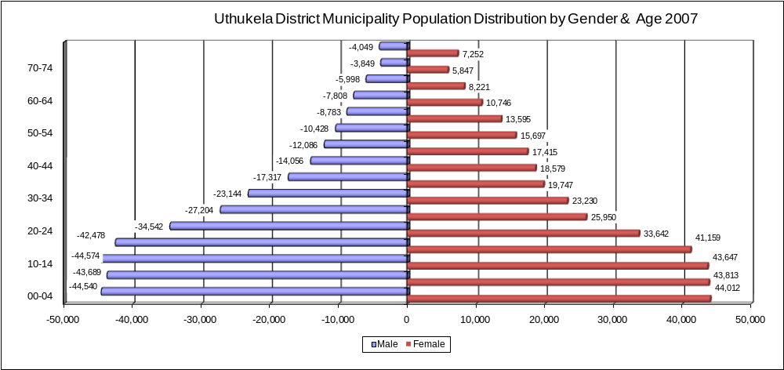
uThukela district municipality population distribution by gender and age, 2007

B1.1.5 EDUCATION LEVELS
Overall the district’s literacy levels have increased from 19% to 21% from 2003 to 2007. The above table shows that the functional literacy of the Black population has increased more substantially than that of other population groups.

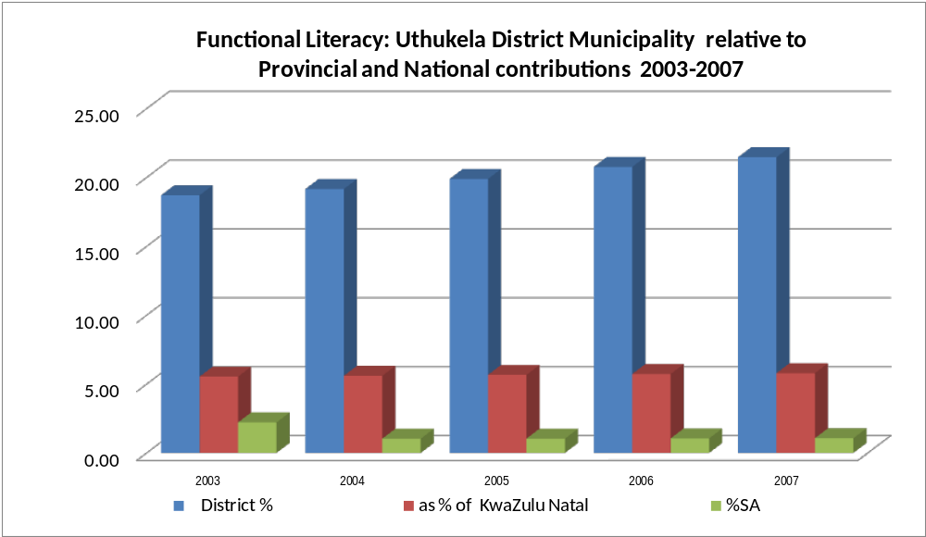

uThukela has no tertiary education institution or voluntary associations that can champion research and development. There is one FET and other smaller private colleges. Most people seeking degrees and diplomas either move to Pietermaritzburg or Durban or migrate to the north to Gauteng. Similarly, the district depends on other towns like Pietermaritzburg and Durban in the south and Johannesburg and Pretoria in the north for innovation, research and development in the economic fields. However, there is high presence of University of KwaZulu-Natal research institutions like Farmer Support Group (FSG) in Okhahlamba.

B1.1.6 MIGRATION – internal/external
The population movement in the district follows the concentration of economic and employment opportunities. These are located mainly in the town of Ladysmith
(Emnambithi) followed by the smaller industrial town of Estcourt in Umtshezi. Ladysmith has a high concentration of social and economic infrastructure resulting in a development imbalance compared to other towns in the district. Smaller towns and rural settlements in Okhahlamba, Umtshezi, Imbabazane and Indaka flock to Ladysmith for a number of activities beyond employment. The same trend is noticed with small towns and rural settlements of Umzinyathi District Municipality coming to Ladysmith. This could be influenced by the number of regional government offices located in Ladysmith and serving both uThukela and Umzinyathi District Municipalities. Consequently this puts pressure on Ladysmith suggesting strain on local and physical infrastructure. Few economic and employment opportunities in the district pulls people to larger urban areas in the district. The N11 leads them to Newcastle and Johannesburg, while the N3 corridor leads them to Johannesburg in the north and Pietermaritzburg and Durban in the south.

B1.1.7 URBANIZATION
The most urbanized population group is the Asian community (98%) followed by Coloureds (83%) and Whites (82%). Only 25% of the Black population lives within urban areas. This urbanization rate for the Black population has been increasing steadily each year, unlike the other groups which have displayed static or slightly declining rates of urbanization.
Urbanization rates by race, uThukela district municipality, 2003 - 2007
 | Black | White | Colored | Asian | Total
2003 | 23.7% | 81.7% | 83.6% | 97.7% | 27.5%
2004 | 24.0% | 81.5% | 83.4% | 97.7% | 27.7%
2005 | 24.3% | 81.4% | 83.2% | 97.7% | 28.0%
2006 | 24.6% | 81.3% | 82.9% | 97.7% | 28.2%
2007 | 24.9% | 81.4% | 82.6% | 97.7% | 28.5%
Source: Global Insights Africa International

B1.1.8 HIV/AIDS PREVALENCE
In keeping with the national trend, the overall district HIV estimate has decreased between 2003 and 2007. Within the district, this trend is echoed in all the local municipalities. However, it has increased for the province as a whole. However, the AIDS prevalence estimate has increased marginally at all levels over the same period.

At 15% HIV+ prevalence in the district is double than that of the province (7%) and a little than that of the country as a whole (12%). This prevalence is quite consistent within the local municipalities, ranging from 16.6% in Emnambithi to 13.4% in Indaka.
The District municipality is playing a significant role in mitigating the impact of HIV/AIDS in the whole of District through the awareness programmes, by establishment of the District AIDS Council and implementation of the HIV/AIDS strategy.

HIV+ and AIDS profile, uThukela district municipality relative to local, provincial and national estimates
Locality | Population 2007 | HIV Estimate 2003 | HIV Estimate 2007 | Difference 2003-2007 | HIV % within area | HIV + % of Province HIV + 2007 | HIV % of SA HIV + 2007
South Africa | 47,864,260 | 5,711,167 | 5,552,053 | -159,114 | 12
Province | 10,052,455 | 650,209 | 667,623 | 17,415 | 7 |  | 12
District Municipality | 714,909 | 116,939 | 109,973 | -6,966 | 15.34 | 16.47 | 1.98
Emnambithi/ Ladysmith LM | 225,459 | 44,430 | 43,448 | -982 | 16.60 | 6.51 | 0.78
Indaka LM | 113,644 | 17,549 | 16,084 | -1,465 | 13.43 | 2.41 | 0.29
Imbabazane LM | 119,925 | 19,768 | 16,589 | -3,178 | 14.25 | 2.48 | 0.30
Okhahlamba LM | 137,525 | 24,020 | 22,758 | -1,262 | 15.25 | 3.41 | 0.41
Umtshezi LM | 59,921 | 11,172 | 11,093 | -79 | 15.87 | 2 | 0.20
Locality | Population 2007 | AIDS Estimate 2003 | AIDS Estimate 2007 | Difference | AIDS % within area | AIDS % of Province AIDS 2007 | AIDS % of SA 2007
South Africa | 47,864,260 | 265,634 | 433,417 | 167,783 | 1
Province | 10,052,455 | 27,714 | 48,960 | 21,246 | 0 |  | 11
District Municipality | 714,909 | 6,072 | 9,281 | 3,210 | 1.29 | 18.96 | 2.14
Emnambithi/ Ladysmith LM | 225,459 | 2,291 | 3,673 | 1,383 | 1.40 | 7.50 | 0.85
Indaka LM | 113,644 | 929 | 1,358 | 429 | 1.13 | 2.77 | 0.31
Imbabazane LM | 119,925 | 1,030 | 1,400 | 371 | 1.20 | 2.86 | 0.32
Okhahlamba LM | 137,525 | 1,251 | 1,915 | 664 | 1.28 | 3.91 | 0.44
Umtshezi LM | 59,921 | 571 | 935 | 364 | 1.34 | 2 | 0.22
Source: Global Insights Africa International

B2 ECONOMY OF UTHUKELA DISTRICT MUNICIPALITY

B2.1.1 INTRODUCTION
Economic development is uneven across the district, with large disparities across local municipalities. Emnambithi dominates, with smaller towns being less developed. Outside the urban areas, are areas of rural poverty and some wealthier commercial farming areas especially in Okhahlamba. In terms of employment and GVA, Okhahlamba is predominantly agricultural followed by Indaka. Community services consistently dominate in terms of employment in all local municipalities besides Emnambithi where manufacturing is neck to neck with community services.

B2.1.2 STRUCTURE OF THE DISTRICT ECONOMY
The spatial economy of the district is dominated by Emnambithi that remains the economic hub of the district. Manufacturing is concentrated in Ladysmith. Limited industrial activities are also found in Estcourt. The other municipalities have relatively small economies that are dependent on community services. Okhahlamba has a window of opportunity to improve is agriculture and tourism economies.

Major players in the manufacturing sector in Ladysmith are Zorbatex, Dunlop rubber products and the Defy plant. Estcourt has town houses food and beverages manufactures like Nestle, Sasko Milling, Eskort meat factory and Clover SA. There is Masonite Africa (wood products) glass manufactures (Glamosa Glass) and Karbotek. Okhahlamba leads with agriculture in the district.

There is an opportunity to exploit economic opportunities in the tourism sector in Okhahlamba and Emnambithi. Okhahlamba has Ukhahlamba-Drakensberg World Heritage site while Emnambithi is linked to the popular Battlefields products. Further studies to explore the location opportunities brought by the N3 and N11 corridors need to be investigated.

B2.1.3 ECONOMIC GROWTH
According to uThukela NSDP, Emnambithi contributes considerably higher levels of GVA than the other four municipalities, with Umtshezi contributing the lowest to the district GVA.
At 26% Community Services is the largest GVA contributor, followed by manufacturing (18%), financial services (16%), agriculture (13%), transport (11.5%), trade (11%), electricity (3%), construction (2%) and mining (1%).The over dominance of the community services sector is illustrated by its negligible provincial (2.6%) and national (2.5%) GVA contributions. The second most significant sector in the district, in terms of GVA, is the manufacturing sector which contributed 18% of the total district GVA in 2007. This is slightly lower than the sector’s contribution to the provincial GVA (19%) and that of the sector’s national share (22%). The third most significant sector is financial services, which represents almost 16% of the district GVA, but only contributes a marginal 2.5% GVA share in both the provincial and national economies. The contribution of the transport sector at the district level (11.5%) is similar to the sector’s provincial share (12%) and higher than the national (9%) shares. Conversely, trade’s GVA contribution at the district level (11%) is much higher than that at the provincial economy (2%), but somewhat closer to that of the national (8%) level.

All sectors in the district and within each of the local municipalities recorded positive growth during the 2003-2007 period. However, provincial and national growth has generally outstripped the performance of sectors in uThukela, particularly in the mining, electricity and construction sectors. The district showed a slightly higher percentage change in both the agriculture and finance sectors than provincial and national rates.

Umtshezi, in particular, has registered change in agriculture, finance and community services sectors that are higher than both the provincial and national rate of change over this five year period. Okhahlamba, too, has shown higher than average performance in the agriculture, manufacturing and finance sectors.
The GVA contribution by sector has increased by sector in all municipalities save for the mining sector that has remained stagnant in Indaka. This clearly points out that the district has experienced economic growth.

B2.1.4 ANNUAL HOUSEHOLD INCOME

Household income: uThukela district municipality contributions, 2007
Income Category | Black | White | Coloured | Asian | Total | % Total district income
0-2400 | 1,238 | 0 | 31 | 0 | 1,269 | 0.84
2400-6000 | 5,359 | 12 | 33 | 0 | 5,403 | 3.57
6000-12000 | 28,012 | 29 | 206 | 111 | 28,357 | 18.75
12000-18000 | 26,959 | 38 | 102 | 129 | 27,229 | 18.00
18000-30000 | 25,030 | 92 | 105 | 323 | 25,550 | 16.89
30000-42000 | 16,661 | 89 | 89 | 408 | 17,246 | 11.40
42000-54000 | 10,666 | 237 | 56 | 335 | 11,293 | 7.47
54000-72000 | 8,019 | 400 | 66 | 634 | 9,120 | 6.03
72000-96000 | 5,560 | 601 | 63 | 672 | 6,895 | 4.56
96000-132000 | 3,944 | 862 | 64 | 315 | 5,184 | 3.43
132000-192000 | 2,987 | 997 | 58 | 545 | 4,588 | 3.03
192000-360000 | 2,884 | 1,849 | 89 | 778 | 5,600 | 3.70
360000-600000 | 1,091 | 859 | 47 | 289 | 2,285 | 1.51
600000-1200000 | 433 | 390 | 1 | 151 | 975 | 0.64
1200000-2400000 | 109 | 86 | 0 | 26 | 222 | 0.15
2400000+ | 25 | 15 | 0 | 2 | 42 | 0.03
Total | 138,976 | 6,555 | 1,010 | 4,718 | 151,258 | 100.00
Source: Global Insights Africa International

The highest numbers of households are to be found in the income categories between R6000 and R42000 per annum. These income categories account for almost 65% of all households in the district. This proportion is higher than provincial (51%) and national statistics (47%), and this means that in uThukela, a larger proportion of households earn lower than the provincial and national income levels.
Black households have the highest number of income earners, followed by White, Asian and Coloured households. In the higher income earning categories (R72000-R96000) to the highest category (R2400000), Black households remain highest, while the white population is the second highest group. In the lowest income categories (R0-R6000) White, Coloured and Asian populations are negligible.

B2.1.5 POVERTY
The HDI for the vast majority of the population is low (0.43) and has not increased over the past five years. In stark contrast, the White population exhibits a high HDI of 0.85 which is comparable to Northern European levels of development. The Asian and Coloured communities show high and middle range levels of development with indices of 0.60 and 0.74 respectively.

The high Gini coefficient of 0.65 for the district means that there are high levels of income inequality across the district. This poverty disparity is growing as is shown in the time based graph below.

The overall proportion of people living in poverty in uThukela has decreased from 63% in 2003 to 58% in 2007. This still represents a high proportion of the population, and still remains higher than the 2007 provincial average (62%) and the national average (43%). The overwhelming majority of people living in poverty are from the Black community, and despite the improvement during this period, in 2007, 61% remain living in poverty. This decline, however, masks the real increase in inequality revealed through the growing Gini Coefficient.

The three measures of poverty and social inequality clearly show that poverty is concentrated in the Black communities and that inequality are widening over time.
Percentage of people living in poverty by race, uThukela 2003/2007
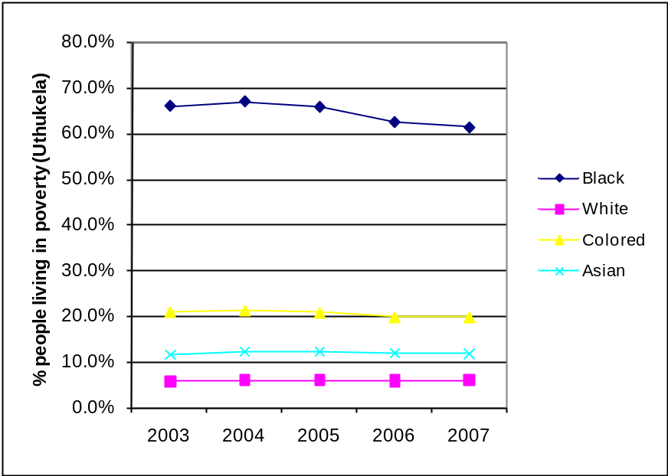

B2.1.6 EMPLOYMENT RATIOS

UNEMPLOYMENT RATE

There were more males (44%) than females (37.2%) employed in 2000 in the district. A similar trend remained up to 2007 with males at 44.7% and females catching up at 42.6%. The unemployment rate for males in the district was at 46% in 2000 and has decreased by 3.6% in 2007. Female figures have remained stagnant. Interestingly the unemployment rate of the district (48.3%) is lower than the province which is at 56.9% but higher the national at 36.9%.

Unemployment rate (%)
 |  | 2000 | 2001 | 2002 | 2003 | 2004 | 2005 | 2006 | 2007
UThukela | Male | 46.0% | 45.8% | 50.0% | 50.3% | 48.5% | 45.7% | 44.2% | 43.6%
 | Female | 53.0% | 52.4% | 55.1% | 57.3% | 56.7% | 54.5% | 53.1% | 52.8%
 | Total | 49.5% | 49.1% | 52.6% | 53.9% | 52.7% | 50.2% | 48.8% | 48.3%

B2.1.7 EMPLOYMENT SECTORS
The graphs below illustrate employment by sector over time, comparing the situation in each local municipality with that of the district.
Employment by sector, uThukela district municipality 2003 – 2007
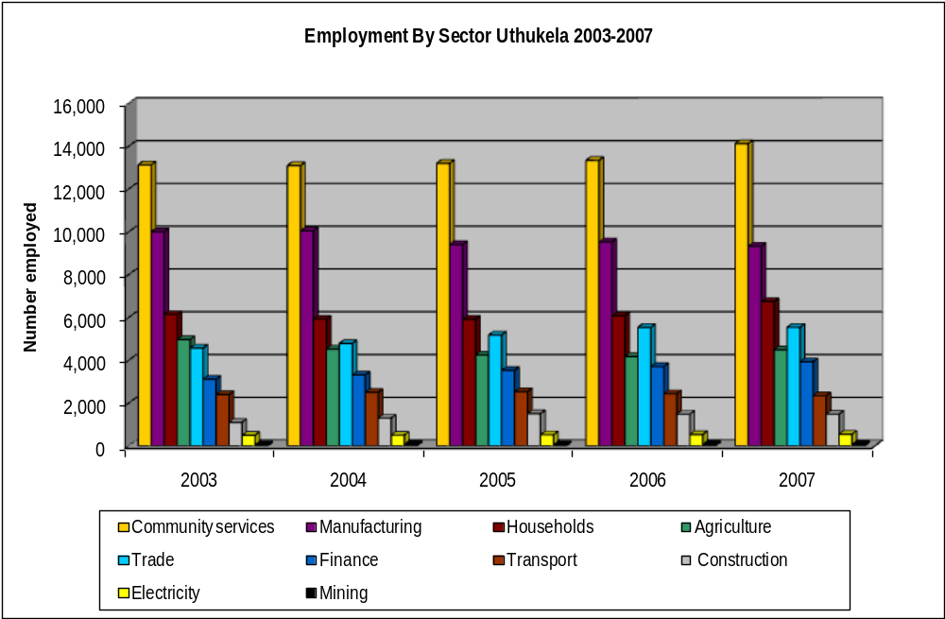

B2.1.8 INCOME BY SECTOR

Income by primary sector, uThukela district municipality, 2003 – 2007
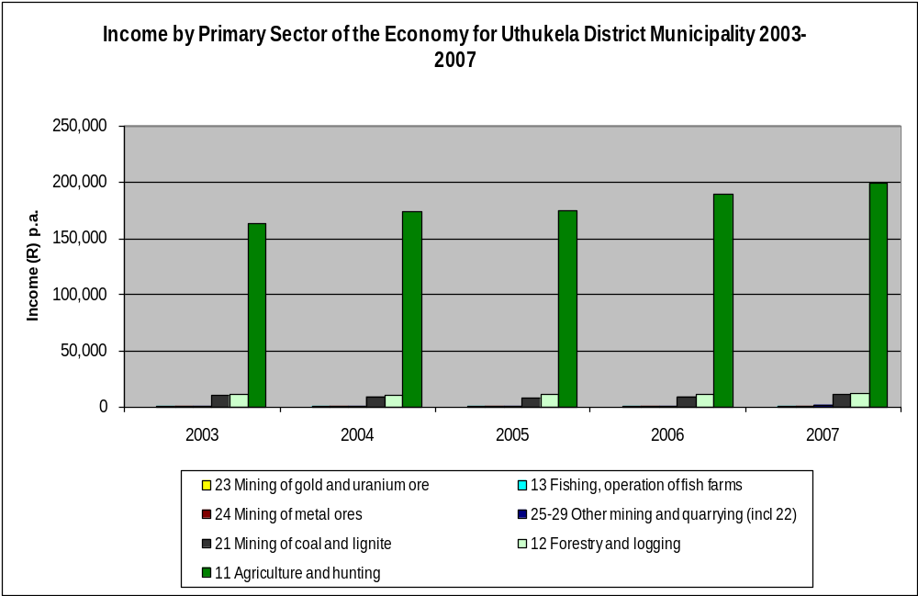

With regards to the primary sector, the highest income generating sector during the period 2003 to 2007 was agriculture and hunting. This sector saw consistent income growth and it generated incomes of over R150 000 to R200 000 p.a. during this period. All other sectors generated incomes of less than R50 000 p.a. over the same period.

Income by secondary sector, uThukela district municipality, 2003 – 2007
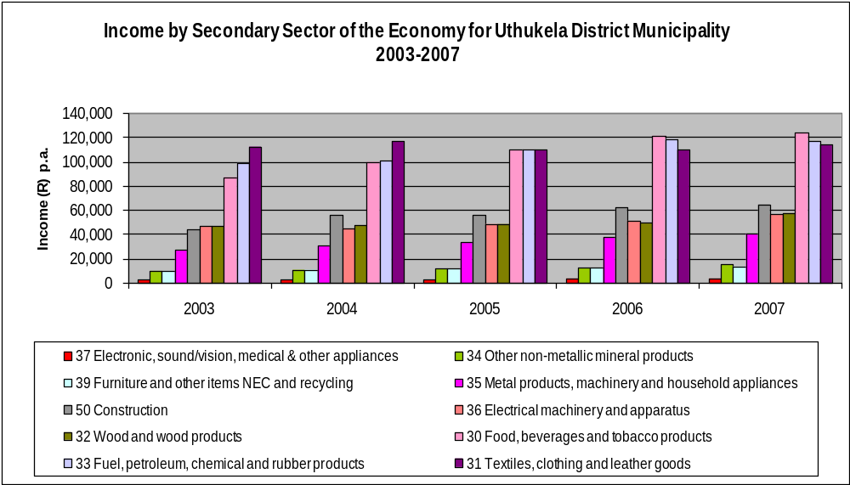
During the period 2003 to 2007, in the secondary sector the three highest income generating sectors were textiles, clothing and leather goods, followed by fuel, petroleum, chemical and rubber products and lastly, food, beverages and tobacco products. They generated incomes of between R80 000 p.a. and just over R120 000 p.a. Most other sectors generated incomes of around R40 000 p.a and less. The three highest income generating sectors all showed growth over the period, although the textiles, clothing and leather goods sector only showed a marginal increase, and both the other sectors overtook it in 2006, with food, beverages and tobacco products showing the greatest growth.
Income by tertiary sector, uThukela district municipality, 2003 – 2007
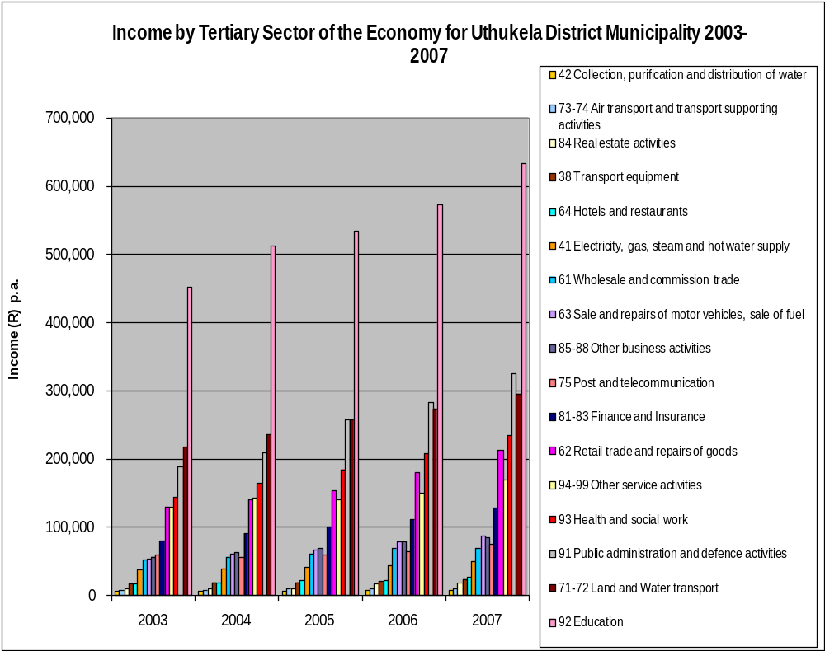

The tertiary sector, during the period 2003 to 2007, was dominated by, in order of importance, the education, transport equipment, public administration and defence activities, health and social work, and retail trade and repairs of goods, which generated incomes of over R200 000 pa by 2007. They all exhibited convincing rates of growth, particularly in the education, public administration, health and retail sectors. Between R130 000 p.a. and R650 000 p.a. The education sector generated the most income, reaching levels above R650 000 p.a. in 2007. All other sectors generated incomes of less than R100 000 p.a. over the same period, except other business activities which exceeded this income level in 2006.

B2.1.9 LOCAL ECONOMIC DEVELOPMENT STRATEGY
An LED Strategy has been compiled, reviewed and adopted by Council. The strategy contains the economic analysis, employment analysis, infrastructure analysis; agriculture analysis etc.The strategy takes into consideration the weakness and the strengths of the existing economic sectors so as to direct the new efforts for development. This strategy has been workshopped throughout the district and a number of projects have also been identified

The strategy is having the strategies that take advantage of economic opportunities to mitigate weaknesses in the district economy and also assist in the development of an appropriate institutional environment. The strategy is also talking about the facilitation of the second economy into first economy as we know that South Africa has a highly unequal economy in which people with access to wealth experience South Africa as a developed modern economy, while the poorest still struggle to access even the most basic services.
The LED Strategy has identified competitive advantages of the District as follows:
Agricultural sector
Tourism sector
Manufacturing/Industrialization

B2.1.10 UTHUKELA DISTRICT LED FORUM
uThukela District Municipality has managed to establish the LED Forum. The Forum is coordinated at the District level and it is comprises of five local municipalities, private sector companies within the District, NGO’s and LED stakeholders where they discuss the issues pertaining to Local Economic Development (LED).

B2.1.11 UTHUKELA DISTRICT TOURISM FORUM
uThukela has established the tourism forum on the 4th August 2009.The forum consist of the representative from all the local municipalities, Private sector and Provincial department responsible for Tourism. The committee is chaired by the Deputy Mayor of uThukela District municipality. The main responsibility of the forum is to integrate the provincial tourism objectives into District plans and priorities and also inform the District budgetary process for the effective implementation of tourism in line with provincial objectives.

B2.1.12 DEVELOPMENT OF SMME’S AND SECOND ECONOMY

The South African economy is highly centralised and dominated by a set of monopoly industries. Capital intensive industries tend to exclude SMME’S participation and make employment creation expensive.
uThukela District Municipality is in the process of finalising the strategy for the SMME,s The strategy will deal with the following:
- Addressing poverty, economic marginalisation and equality.
- Improving the distribution of returns from economic activity more equitably across the society
- Ensuring the basic needs are accessible and affordable
- Improving the way in which people participate in the economy
- Increasing poor people’s ability to gain and secure assets.
- Reducing unemployment
Currently the uThukela District Municipality is engaged in partnership with SEDA to try and assist all the emerging business entrepreneurs within the jurisdiction of the district. The partnership started in 2006; SEDA offers technical support to the entrepreneurs

B2.1.13 SECTOR DEVELOPMENT- CRAFTERS

Through partnership with Gijima KZN the District is embarking on craft projects with an aim of formalising this sector. Crafters within uThukela District Municipality engage in a variety of craft products, and these can be summarised in the following manner:
  - Clothing / Sewing
  - Accessories
  - Grass work
  - Other
Assessing quality of craft products proved to be a daunting task since at present there are no set standards that seek to regulate this aspect of craft manufacturing. At present various groups have their own internal mechanism which they use to assess the quality of craft products manufactured.

B2.1.14 AGRICULUTURE
The Department of Agriculture and Environmental Affairs has supported various projects within uThukela District as part of its Agrarian Revolution Programme. The main objective of this programme is to facilitate economic development and food security through agriculture.
The District has produced an Agricultural Development Plan which is reviewed annually and informs agricultural planning for the District and is linked to the IDP as well as the departmental strategy.
According to our bio- resource information, uThukela District has a agricultural potential in the following commodities
- Beef farming
- Crop production
- Poultry farming
- Goat and game farming
- Production of delicious fruit, lemon and oranges.
Two flagship agricultural projects for economic development in the district are the Imbabazane and Okhahlamba Bean projects.

B2.1.15 TOURISM
The tourism plan has been developed, Apart from the Drakensberg World Heritage Site, this has an obvious scenic attraction and many battles that were fought within the District are a major tourism attraction. The tourism opportunities created by these historical events include cultural and historical tourism.
In the Tourism Plan the secondary corridors are identified to each tourism node along the World Heritage Site. These routes lead from a primary corridor route running between the town of Estcourt and Oliviershoek Pass. Tertiary corridors are identified to lead into rural areas adjacent to the World Heritage Site.

According to research conducted by Tourism KwaZulu-Natal, 32% of KwaZulu-Natal’s foreign ‘air arrival’ market primarily visited the Drakensberg and 7% the Battlefields. This supports the fact that the Drakensberg is becoming a more popular destination for foreign tourists than was the case in previous years. This could be due to the Drakensberg being more aggressively promoted since it was declared a World Heritage Site (Uthukela Economic Review, ROP, Gijima-KZN Report, 2005).
The town of Ladysmith is known for the roots and home of the Ladysmith Black Mambazo, and popular Black traditional music known as Isicathamiya.
The town of Ladysmith has retained its linkages with the discoveries of gold and diamonds in Kimberly and Witwatersrand as it became the midway stop-over from Port Natal.
Ladysmith forms part of the Battlefields route. The Anglo-Boer wars put Ladysmith on the international map. Today Ladysmith and its surrounding enjoy a distinctive and tourism competitive advantage emanating from historical wars. Major attractions include the following products:
- Ladysmith is surrounded by major battle sites that form the Battlefields. These are battles of Colenso, Spioenkop, Wagon Hill/Platrand, Elandslaagte, Nicholson’s Nek, Thukela Heights, Gun Hill and Lombard’s Kop.
- Siege Museum is located next to the Town Hall
- The town building still maintains the colonial architectural styles

Okhahlamba Municipality has Ukhahlamba-Drakensberg World Heritage site. It offers a range of eco-tourism products ranging from hiking, walking in the mountains, game- viewing to river-rafting. This is unique product supported by the presence of KZN Ezemvelo Wildlife.

It must be noted that uThukela District Municipality is “Tourism Potential”. Opportunities to grow the tourism sector are present in the district.

B2.1.16 DISTRICT GROWTH AND DEVELOPMENT SUMMIT (DGDS)

The first uThukela growth and development summit was held in February 2007. The outcome of the summit was the compilation of the action programme to be implemented by the various stakeholders. There was a series of follow up meetings with the various stakeholders in making sure that the outcomes are implemented.

B2.1.17 ALIGNMENT OF LED STRATEGY WITH PROVINCIAL AND NATIONAL OBJECTIVES

- KZN PROVINCIAL GROWTH AND DEVELOPMENT STRATEGY(PGDS)
The main responsibility of the KZN Provincial Growth and Development Strategy is to ensure that the development and planning is taking the strategic direction in the province. uThukela District municipality doesn’t see itself as isolated from the national and provincial context ,In preparation of the uThukela LED strategy the 6 PGDS priorities were considered. The priorities are as follows:
- Strengthening Governance and Service Delivery
- Integrating investments in Community Infrastructure
- Sustainable Economic Development and Job creation
- Developing Human Capacity
- Developing comprehensive response to HIV/Aids
- Fighting Poverty and protecting vulnerable groups in society
The identified projects of the District address the above priority areas and also the Spatial Development Framework of the municipality is aligned to the PGDS priorities. The following indicates the proper alignment between the 6 PGDS priorities and uThukela IDP.
PGDS Priority 1: Strengthening Governance and Service Delivery
Issues and Projects in the uThukela IDP:
- Priority 1. - Provision of sustainable infrastructure water and sanitation services and backlog thereof
  - Implementation of MIG projects
  - Various youth and gender project
  - Implementation of two RSS initiatives
- Priority 5. - Financial viability and administrative capacity within the district
  - Implementation of PMS
  - Implementation of Disaster Management Plan
  - Planning support to local municipalities
  - Strengthening Inter-governmental cooperation
_ Engage with potential funding sources, e.g. Gijima KZN
PGDS Priority 2: Integrating Investments in Community Infrastructure
Issues and Projects in the uThukela IDP:
- Priority 1. -- Provision of sustainable infrastructure water and sanitation services and backlog thereof.
- Review WSDP to address water and sanitation backlogs
- Review of the PTP (Public Transport Plan)
- Support Land Reform Programs
- Development of sports facilities
PGDS Priority 3: Sustainable Economic Development and Job Creation
Issues and Projects in the uThukela IDP:
- Priority 2. – Economic Development
  - LED, Tourism and Agricultural sector plan development and implementation
  - Job creation through the MIG program
  - Establishing cooperatives to support LED and SMMEs
  - Implementation of various Gijima KZN projects
  - Engaging partnerships with developmental entities
PGDS Priority 4: Developing Human Capacity
Issues and Projects in the uThukela IDP:
- Priority 7. – Financial viability and administrative Capacity within the District
- Initiating an Environmental Education program
- Hosting of various internships
PGDS Priority 5: Developing a Comprehensive response to HIV/AIDS
Issues and Projects in the uThukela IDP:
- Priority 3. – Prevention of ill-health and promotion of wellness
  - Implementation of an HIV/AIDS Strategy
  - Implementation of an HIV/AIDS Policy
  - Establishment of a Health Safety Committee
PGDS Priority 6: Fighting Poverty and Protecting Vulnerable Groups in Society
Issues and Projects in the uThukela IDP:
- Priority 2. – Economic Development
- Development and Implementation of an LED, Tourism and Agriculture Strategy
- Development and enhancement of a 5-year poverty alleviation program
- Priority 4. – Public Safety and Security
Development and support of a public safety program
Review and implementation of the disaster management plan

- THE ACCELERATED AND SHARED GROWTH INITIATIVE OF SOUTH AFRICA (ASGISA)
The Accelerated and Shared Growth Initiative of South Africa (ASGISA) is the initiative of the Government that aims to reduce unemployment to be less than 15% and halve the poverty rate. ASGISA proposes an annual growth rate of 4,5% or higher between 2005 and 2009 and growth rate of 6% of GDP between 2010 and 2014.Developing labour absorbing industries that can generate value and skills development are crucial for the ASGISA initiative. In reviewing the LED strategy and finalising the development strategy of uThukela District Municipality, the alignment with ASGISA must be done.

There are constrains that are raised by the ASGISA but the municipality is prepared to deal with those constrains in their Key Issues for 2010/2011 financial year. Some of the Key Issues that will deal with constrains of the ASGISA initiative are as follows:
- Local Economic Development
- Issues of Governance
- Reduce unemployment
- Education
- Basic Infrastructure and development
- Inequality and Economic Marginalisation

- THE NATIONAL SPATIAL DEVELOPMENT PERSPECTIVE(NSDP)
The National Spatial Development perspective is the initiative that is coming from the Office of the Presidency and it was endorsed by the Cabinet in 2003.The main focus of the NSDP are the following:
- Identifies trends in the space economy
- Identifies 5 types of space economy by resource potential, human need and economic activity
- Argues that the potential of an area should inform a rationale for focused & infrastructure spending
- Seeks alignment between infrastructure investment and development programme
- National and provincial priorities inform coordinated planning that guides development objectives,infrastracuture investment and resource allocation

In making sure that UThukela LED Strategy is talking to National Spatial Development Perspective (NSDP) and PSEDS, a workshop was held on the 4th March2009 where all the stakeholders including sector departments, NGO’s, Chamber of Business, Internal Departments and Local Municipalities were present where the service provider that was appointed by the Office of the Presidency engaged with the stakeholders in trying to verify the District profile, identify the key driving forces and to develop a new scenarios for future development of the District.

It must be noted that part 1 and 2 of UThukela NSDP has now been completed and it contains a significant analysis of the UThukela District Municipality spatial and economic development. The table below shows the alignment between the NSDP Principles and uThukela Programmes.

NSDP Principles UTDM IDP Priority Focus for 2010/2011
Rapid Economic Growth that is sustained and inclusive is a pre requisite for the achievement of other policy objectives, among which poverty alleviation | Economic Development
Government spending on fixed investment should be focused on localities of economic growth in order to gear up private-sector investment, to stimulate sustainable economic activities and create long term employment opportunities | Provision of sustainable infrastructure, water and sanitation services and backlog thereof. Coordination of social services
Efforts to address the past and current social inequalities should focus on people not places. In localities where there are high levels of poverty and demonstrated economic potential, this could include fixes capital investment beyond basic services to exploit the potential of those localities | Economic Development
Future settlement and economic development opportunities should channelled into activity corridors and nodes that link the main growth centre.Infrastracture investment should support localities that will be the major growth nodes in South Africa. | Economic Development and Spatial Development Framework
To provide basic service to all citizen wherever they reside | Provision of sustainable infrastructure, water and sanitation services and backlog thereof.

B3 PROVISION OF BASIC INFRASTRACTURE AND SERVICES

B3.1.1 INTRODUCTION
The provision of the basic infrastructure is still a challenge to the municipality but a lot has been done in reducing the backlogs especially in water and sanitation. The number of indigent people is very high in the District that makes it difficult for the people to pay for the services at the same time the District Municipality is expected to provide services to them in making sure that the District vision is attained.
The other challenges that is facing the District is the overall assessment of service delivery in the DM, the budgets, institutional issues, namely policies, processes and structure, which have an impact on service delivery.
The purpose of this process is to determine the infrastructure projects required to achieve the 2014 goals, assist and support the planning framework, provide input in to the IDP process and provide input to the MTECH process.

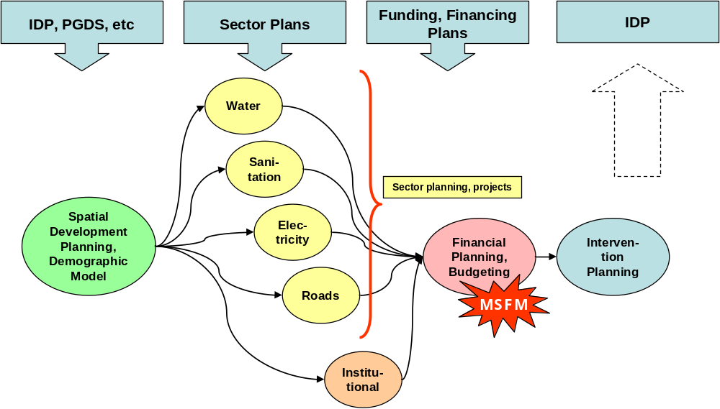

B3.1.2 WATER
uThukela District Municipality is the Water Services Authority (WSA) that provides potable water for its consumers of about 714 909.The District Municipality has identified 10 water related projects at a cost of R1.4 billion.4 of these projects are bulk water projects and 4 are water reticulation projects.
The table below shows the current backlog and it was reduced from 21% to 17% to date and this translates that 23,910 households that does not have access to safe water supply
Current (Sep 09) Water Backlog in uThukela District Municipality
LM Code | Municipality | Households | Backlogs (%) | Backlogs
KZ232 | Emnambithi | 50,259 | 7% | 3,387
KZ233 | Indaka | 21,080 | 21% | 4,380
KZ234 | Umtshezi | 15,232 | 20% | 2,994
KZ235 | Okhahlamba | 28,509 | 22% | 6,242
KZ236 | Imbabazane | 24,559 | 28% | 6,907
Total | uThukela | 139,639 | 17% | 23,910

According to the Comprehensive Infrastructure Plan (CIP) an amount of 1, 4 billion is required to address reticulation, treatment, bulk and refurbishment.

It is regrettable to say that uThukela District Municipality cannot meet the targets of eradicating backlogs of water in 2014 because of the financial constrains. The amount that is needed by the Municipality is 1, 4 billion to meet the targets.

B3.1.3 WATER QUALITY
There were 70 drinking water sampling points that were monitored in uThukela District. Chemical and Physical analysis were conducted over a period of 12 months by qualified and experienced Laboratory Technicians and Environmental Health Practitioners of uThukela District Municipality. The analysis was done to ensure that the water supplied to the public is good for human consumption.
In terms of compliance for overall microbiological uThukela is on 96.0%.The total number number of samples taken in the previous financial year was 2 648.

B3.1.4 WASTE WATER TREATMENT
uThukela District Municipality currently operate 7 waste water treatment namely Ladysmith, Colenso, Estcourt, Bergville, Ekuvukeni, Wembezi and Ezakheni waste water works.uThukela waste water works receive waste water(grey water) from industrial(efficient) and domestic premises. The above waste water works are operated in with the guidelines and general standards issued by Department of Water Affairs (DWA)

B.3.1.5 WATER SERVICES DEVELOPMENT PLAN (WSDP)
uThukela District Municipality has developed has developed and adopted the Water Services Development Plan(WSDP)in 2003.This plan was prepared in accordance with the Department of Water Affairs and Forestry’s (DWAF) preparation guide. This sector plan (WSDP) is reviewed annually to ensure relevancy in the municipality. It must also be noted that the WSDP is also dealing with the issues of sanitation.
According to the adopted WSDP the DM has a wealth of surface water resources, however much of the dammed water is transferred to Gauteng Province as part of the Tugela-Vaal scheme. Most surface water is abstracted from the Tugela River or one of its tributaries, such as the Klip, Little Tugela or Bushmans.

DM has developed Water Services By-laws for the district. Council has also resolved a free basic water concept, to help the plight of indigent persons with lower levels of services. In rural areas free water is supplied to communities, under a policy of free communal water provision. However, district strategies on conservation and demand management, as well as monitoring still need to be established. Through the Implementation of Sustainable Water Services Institutions Programme (ISWIP) the DM is assisted to attain the necessary capacity to perform these WSA functions.

Water services infrastructure is more developed in the urban areas supplying a higher level of service, as opposed to the rural areas. Each urban area generally has its own water and wastewater treatment facility. The challenge that is facing the municipality is that some water infrastructure is dilapidated; the date of construction of some components is unknown.
The WSDP is prioritising projects in following phases:
- Phase 1, is the short-term five-year implementation plan and is generally restricted to current projected funding allocations (0 – 5 Yrs);
- Phase 2, constitutes medium- (6 – 10 Yrs) and long-term (11 – 20 Yrs) planning, that targets the alleviation of current water services backlogs by allowing for realistic target setting to improve the quality of life for the entire population;
- Phase 3 is the long-term vision (> 20 Yrs) for water services in the DM constituting ideal goals and objectives.

B3.1.6 SANITATION
Sanitation is one of the core function of the District Municipality. The total number of households currently have below RDP levels of service is about 50.962.The budget for sanitation needs, bulk infrastructure and refurbishment is R668 million. The total sanitation needs is 14% of the total budget, namely R94 million. It is quite clear that uThukela District will not meet the millennium target of 2014 because of the financial constrains unless if the municipality can receive R668 million.

The DM is in the process of developing the Sanitation Master Plan. The plan will be dealing with backlogs, strategies of eradicating the sanitation backlogs. The following table indicates the current sanitation backlogs in the whole of uThukela
Current (Sep 09) Sanitation Backlog in uThukela District Municipality
LM Code | Municipality | Households | Backlogs (%) | Backlogs
KZ232 | Emnambithi | 50,259 | 28% | 13,892
KZ233 | Indaka | 21,080 | 24% | 5,076
KZ234 | Umtshezi | 15,232 | 30% | 4,605
KZ235 | Okhahlamba | 28,509 | 50% | 14,373
KZ236 | Imbabazane | 24,559 | 53% | 13,016
Total | uThukela | 139,639 | 36% | 50,962

B3.1.7 FREE BASIC WATER AND SANITATION
In terms of our Free Basic Water Policy, all rural communities qualify for up to 6kl of free basic water. Urban indigent consumers are required to register as indigent consumers and thereafter qualify for up to 6kl of free basic water. Rural communities are provided with free basic sanitation facilities mainly through Ventilated Improved Pit Latrines (VIPs). Households benefited-(water 21 800 and sanitation 22 720).The municipality is implementing the free basic water which is 6kl.During 2008/2009 financial year 5 785 households were provided with free basic water and the majority of households benefited were rural based. The number of households who were provided with free basic sanitation was 9 617.

B3.1.8 HOUSING
In the uThukela District 92,719 households currently do not have sufficient housing. There are projects identified to address the need for housing. The following table shows the total housing needs and Budgets required to housing needs.
Total Housing Needs and Budgets Required to Address Housing Needs
LM Name | Below RDP | No Of Houses | Total
Emnambithi/Ladysmith | 41,455 | 7,627 | R822
Imbabazane | 13,915 | 13,915 | R604
Indaka | 11,812
Okhahlamba | 18,298 | 2,104 | R91
Umtshezi | 7,240 | 4,345 | R189
Total | 92,719 | 27,991 | R1,706

The housing backlog is very huge to uThukela District Municipality compare to water and sanitation which is the core function of the DM, and a lot need to be done by the Department of Housing to eradicate the backlog. The total amount of 1, 7 million is required to eradicate the backlog of 66%. The table below clearly shows the housing backlog per municipality.
Current (Sep09) Housing backlogs
LM Code | Municipality | Households | Backlogs (%) | Backlogs
KZ232 | Emnambithi | 50,259 | 82% | 41,455
KZ233 | Indaka | 21,080 | 56% | 11,812
KZ234 | Umtshezi | 15,232 | 48% | 7,240
KZ235 | Okhahlamba | 28,509 | 64% | 18,298
KZ236 | Imbabazane | 24,559 | 57% | 39,915
Total | uThukela | 139,639 | 66% | 92,719

B3.1.9 ENERGY/ELECTRICITY
Electricity is supplied by Eskom.Only 65% RDP electricity. Electricity supply is still a challenge especially in rural areas. A pattern emerges which shows that Indaka, Okhahlamba and Imbabazane remain relatively underprovided with all household services.
According to the 2007 Municipal Capacity Assessment, uThukela District Municipality is having the average of 65,2% households with RDP electricity levels,Emnambithi with 69,5%, Indaka with 61,2%,Umtshezi is on the 69,6%,Okhahlamba 62,3% and Imbabazane with 60,1%.The following table shows the backlog as March 2008 with 2% growth and 1%.

Energy Provision in uThukela District Municipality
Municipality | Backlog as March 08 with 2% growth & 1%
DMA | 49
Emnambithi | 18,369
Indaka | 11,746
Umtshezi | 533
Okhahlamba | 14,255
Imbabazane | 7,759
Total (District) | 52,709

B3.1.10 FREE BASIC ELECTRICITY
Free Basic Electricity/Energy was introduced from 01July 2003.Due to initial teething problems and signing of the funding agreement with ESKOM, the Municipality commenced with the initial roll out of Free Basic Electricity on 01 April 2004 and Eskom commenced on 1 August 2004. A total of about 4000 customers benefited from this programme. Relief for the poorest of the poor was continued for the 2005/2006 financial year.

Free basic electricity(50KWh per month was provided to 7803 indigent consumers which is almost 50% more households than the previous year as indicated in Table below: Free basic electricity. Free basic services were expanded to include free basic energy totalling in assistance amounting to R3, 721,250. Fire Gel stoves provided to 4000 consumers.

Free basic electricity
Details | Quantity | Value
7803 households | 50 kWh per indigent household | R18.41 per household per month = R1,723,370.00 per annum

B3.1.11 REFUSE COLLECTION AND DISPOSAL
Access to refuse removal remains a problem in the district, particularly in Imbabazane, which only has 1% of households that benefit from this service.
There is however a decrease of households utilising community and own dumps, as well as households receiving a service from the municipality, other than on a weekly basis. Refuse collection therefore remains a serious environmental health issue. The District municipality has finalized the Integrated Waste Management Plan and is providing strategies in addressing the backlogs in refuse collection, both at district and local level. Less capacitated local municipalities should however start to initiate a community based refuse collection service in order to address the nearly 18% of households that has no means of disposing of refuse. The municipality is also implementing the free basic solid waste for the indigent.
The table below indicates the households with RDP refuse removal levels.
Source: 2007 MDB Municipal Capacity Assessment
Municipality | % Households with RDP refuse removal levels
Uthukela District Municipality | 29.4%
Emnambithi-Ladysmith Local Municipality | 54.3%
Indaka Local Municipality | 12.5%
Umtshezi Local Municipality | 59.1%
Okhahlamba Local Municipality | 6.8%
Imbabazane Local Municipality | 0.9%

A) INTEGRATED WASTE MANAGEMENT PLAN
There are two main categories that describe the waste that is generated within uThukela District Municipality namely,

- General waste: - this is waste that does not pose and immediate threat to humans or the environment (like household waste, building rubble, garden waste and certain dry industrial and business waste).

- Hazardous waste: - means waste that is associated with chemical reactivity or toxic, explosive, corrosive or other characteristics which cause or are likely to cause danger to health or the environment whether alone or in contact with other waste. Medical waste which is quite prevalent in the area falls under this category.
Existing Waste Management Systems and Practice
VARIABLE | EMNAMBITHI | IMBABAZANE | INDAKA | OKHAHLAMBA | UMTSHEZI
Collection Services | Yes | No | Yes | Yes | Yes
Cleansing Services | Yes | No | Yes | Yes | Yes
Transport of Waste | Yes | No | Yes | Yes | Yes
Transfer of Waste | No | No | No | No | Yes
Waste Minimisation | No | No | No | No | No
Recycling Systems | No | No | No | No | No
Waste Disposal | Yes | No | Yes | Yes | Yes

Waste Treatment Facility
DESCRIPTION | EMNAMBITHI | IMBABAZANE | INDAKA | OKHAHLAMBA | UMTSHEZI
Name | None | None | None | Bergville | None
Geographic Location | None | None | None | Cathkin Park | None
Type of Treatment | None | None | None | Incineration | None
Year of Construction | None | None | None | 2001 | None
Capacity | None | None | None | NR | None
Throughput | None | None | None | NR | None
Hours of Operation | None | None | None | 8 | None
Input & Output Chart | None | None | None | None | None
Residue Characteristics | None | None | None | Ash | None
Enviro Monitoring Programme | None | None | None | Monthly | None
Environmental Impact | None | None | None | None | None
Permit Certificate | None | None | None | None | None

Waste Disposal Site

DESCRIPTION | EMNAMBITHI | IMBABAZANE | INDAKA | OKHAHLAMBA | UMTSHEZI
Name | Acaciavale | None | Ekuvukeni | Bergville | Umtshezi
Geographic Location | Acaciavale | None |  | R74 Bergville | Beacon Hill near R103
Area Covered | Ladysmith, Steadville & Zakheni | None | Ekuvukeni T/ship | Bergville & Winterton | Escourt & Weenen
Year of Construction | 1995 | None |  | 1975 | 1993
Resources Available | Compactor | None | None, Ransacked | Incinerator | Guard house, shed, jojo water tank, compactor, leachate dam, high pressure washer, tools & spanners
Permit Certificate | B33/2/2020/p163 | None | None | None | B33/2/2020/15pP76
Type and Quantities | Household, Business & Industrial 44 640 tons | None | Household, 66 tons | Household & Business, 117 tons | Household, Business &  Industrial 581 tons
Description of Neighbouring Area | Residential | None | Residential & Rural | Residential, River | Informal Settlement
Signposting & Road Access | Yes | None | Yes | Poor & Accessible | Yes
Type of Site | General | None | General | General | General
Access Control | No | None | No | Yes | 24 Hour Security
Collection of Disposal Tariffs | Yes | None | Yes | Yes | Yes
Landfill Operation | Compacting & Cover | None | None, just throw staff | Cover | Compacting & Cover
Method of Landfilling | Trench System | None | Trench System | Trench System | Trench System
Co-disposal | Solid Waste Only | None | Solid Waste Only | Solid Waste Only | None
Health Care Waste | None | None | None | None | None
Excavation for Cover | Yes | None | Yes | No | Yes
Drainage | Yes, cut off drains around site | None | None | Not Required | Yes, cut off drains around site
Control of Nuisances | Daily Covering | None | None | Daily Covering | Daily Covering
Salvaging Activities | Prohibited | None | Prohibited | Prohibited | Prohibited
Waste Reclamation | Prohibited | None | None | Prohibited | Prohibited
Leachate & Waste Management | Random Checks | None | None | Not Checked | Random Checks
Rehabilitation | Ongoing | None | None | Ongoing | Ongoing
Final Cover | Ongoing | None | None | Ongoing | Ongoing
Public Participation |  | None | No |  | Yes
Plans for Extending/Closing |  | None | Extension | Closing | No, 10 years left
Environmental Monitoring | Yes, Random | None | None | Yes | Yes, Random

Supporting budgets
LM | 2007 | 2008 | 2009 | 2010 | 2011
Emnambithi | 11 164 537.00 | 12 504 281.00 | 14 004 795.00 | 15 685 370.00 | 17 567 614.00
Imbabazane |  |  | 4 950 000 | 1 500 000 | 1 680 000
Indaka | 679 400 | 781310 | 898 507 | 1 033283 | 1 288 276
Okhahlamba | 1 000 000 | 1 500 000 | 1 680 000 | 1 881 600 | 2 107 392
Umtshezi | 4 000 000 00 | 4 925 841 00 | 5 664 717 00 | 6 514 425 00 | 7 491589 00

It is quite clear from the above discussion that a lot needs to be done for waste management practices within uThukela District Municipality to conform to the National Integrated Pollution and Waste Management Strategy.

B3.1.12 ROADS AND PUBLIC TRANSPORT
- ROADS
uThukela is mainly served by an East-West and North-South corridor. These corridors are the N11 national route that connects the N3 with Mpumalanga Province coal mining areas and the N3 that forms an East-West link which connects two of the country’s most economically active metropolitan areas namely Gauteng and Durban in Kwazulu Natal. The N3 also serves a major urban community namely Pietermazitzburg.

Of all roads in the uThukela District area 1 410km are surfaced roads and 1 320km are un-surfaced or gravel roads. The majority of the surfaced roads can be found in Emnambithi/Ladysmith municipality. According to Comprehensive Infrastructure Plan (CIP), the budget required to eradicate roads backlog in the whole of uThukela District is R141.4 million.

- PUBLIC TRANSPORT

uThukela District Municipality has complied with the National Land Transport Transition Act (NLTTA), act22 of 2000 that requires that the district and local municipalities compile a public transport plan (PTP).The plan is a 5 year plan that is reviewed annually This plan was prepared in conjunction with the local municipalities. It was also aligned with the IDP. In the plan there are number of identified projects that require implementation over the period of 5 years. Additional projects were identified for implementation after 5 year period.

According to the plan there are 31 minibus taxi ranks in the uThukela District Municipality Area. A total of 25 ranks provide commuter services only, while the remaining six provide both commuter and long distance services. Only ten of the 31 minibus-taxi ranks in uThukela are formal ranks, with 22 being located off-street of which nine ranks have any type of all weather surfacing. The following are the projects that are prioritized in the Public Transport Plan

Project
Code Description Priority

KZS1 Pavement Management System A
KZS2 District Transport Forum A
DC23S1 Determine location of public transport stops A
DC23S3 Study to determine modal integration options in the district A
DC23S4 Study to determine pedestrian hotspots (safety issue) A
DC23S5 Review CPTR to include early morning operations and over weekends A
DC23S6 Investigate the status quo of disabled transport in uThukela A
DC23S7 Study to determine rural accessibility to public transport A
DC23S8 Non-motorised transport study for whole district A
DC23I1 Provide shelters at those public transport stops where there is currently
no shelter for passengers A
KZ234F1 Taxi City in Estcourt as part of the IDP urban renewal project A
KZ235S1 Study to determine where roads are often impassable due to flooding A
KZ235F1 Upgrade Bergville minibus-taxi rank A
KZ236S1 Determine best location for existing Loskop minibus-taxi rank A
KZ236F1 New minibus-taxi rank in Loskop A
KZ232F3 Upgrade Ezakheni minibus-taxi rank A
KZ232F5 Upgrade Lylle Street private and municipal minibus-taxi ranks A
KZS3 Investigations into conditions and application of road signage B
DC23S2 Study to determine if enough traffic police is available in district B

Project
Code Description Priority
KZ234F2 New minibus-taxi rank in Weenen B
KZ234F3 New minibus-taxi rank in Ngwenya B
KZ234F4 New minibus-taxi rank in Ngodini B
KZ234F5 New minibus-taxi rank in Nkosini B
KZ235F2 New minibus-taxi rank in Winterton B
KZ235F3 Upgrade Emmaus minibus-taxi rank B
KZ236F2 New minibus-taxi rank at Umtshezi High School B
KZ236F3 New minibus-taxi rank at Emadiphini Amabile B
KZ236F4 Upgrade Hlathikhulu minibus-taxi rank B
KZ236I1 Provide pedestrian walkways in areas determined by project DC23S4 B
KZ233F1 Upgrade Complex of Limehill minibus-taxi rank B
KZ232F4 Upgrade Illing Street minibus-taxi rank B
KZ232F6 Upgrade Lylle Street bus rank B
KZ232F1 New minibus-taxi rank at Peacetown C
KZ232F2 New minibus-taxi rank at Roosboom C
KZ232F7 Upgrade Alexander Street bus rank C

Financial Implications on Public Transport

It is estimated that the total budget required for the identified projects within the uThukela District Municipality is approximately R 30 million. Details of the breakdown of the financial implications per project priority, type and authority are detailed in the Public Transport Plan (PTP) of uThukela district municipality.

B3.1.13 HEALTH FACILITIES
uThukela District Municipality has got 4 Hospitals, 37 Primary Health Care Clinics and 12 Mobile Clinics The challenge that is facing the District is that not all clinics open 7 days a week as some open 5 days a week only. Emergency Medical and Rescue Services are provided in the District; however Ambulance Services are inadequate to provide an equitable and satisfactory service to all the communities within the District. HIV/AIDS, TB and Children not gaining weight are the leading problematic diseases affecting the majority of uThukela communities.

Poverty is a major factor that predisposes the people of uThukela District to the aforementioned diseases. The reality is that uThukela District does not have sufficient Health Services. The deployment of Health Workers is making a difference especially in rural areas but it needs to be strengthening by deploying more Community Workers.

The following table shows the number of Hospitals.PHC and Mobile clinics per local municipality
Municipality | Hospitals | PHC Clinics | Mobile Clinics
Emnambithi | 2 | 13 | 4
Indaka | 0 | 7 | 2
Umtshezi | 1 | 6 | 1
Imbabazane | 0 | 5 | 2
Okhahlamba | 1 | 6 | 3
Total | 4 | 37 | 12

B3.1.14 EDUCATION FACILITIES
There are 445 public schools and 15 independent schools in uThukela District Municipality. The primary and high schools are fairly adequate in the District and institutions for higher learning are not available. Only one Further Education and Training College that is based in Ladysmith Town is offering education and training to prospective students in the district

The District Municipality is facing the vandalisation of schools buildings especially during the school holidays. The District is also facing the shortage of training institutions. Insufficient funds to eradicate the water and sanitation backlog as of now the water backlog in schools is currently 28% and sanitation is backlog in schools is currently at 40%.The District Municipality has done a lot in reducing the backlog of water and sanitation because in the previous financial years the backlog for water and sanitation was more than these figures. In making sure that the backlog is eradicated completely the Department of Water and Forestry to assist the District financially

B3.1.15 EXPANDED PUBLIC WORKS PROGRAMME (EPWP)

uThukela District municipality ensures that they adhere to EPWP guidelines in terms of training, employment targets and distribution of safety clothing as well the rotation of employees.
The municipality also adheres to the following labour targets
Women 60%
Youth 20%
Men 18%
Disabled 2%
It is the policy of the municipality to ascertain that before issuing any tender to a contractor it must first submitted to Expanded Public Works Programme (EPWP) technical support for approval to ensure that all the above mentioned guidelines are considered to by the municipality.

B4 ENVIRONMENTAL ANALYSIS
There is a range of environmentally sensitive areas within uThukela and include amongst others natural resources such as the important species sites, sites of intrinsic biodiversity value, watercourses and steep slopes. The greater central plateau and river valleys, such as the Sundays and Tugela River are some of the natural resources that should be protected. The most important environmental value associated with these valleys, are there value as catchments areas. The prevalence of dongas and soil erosion are also an indication of poor environmental management and there is therefore a need to implement an environmental management approach. The following map shows the Waste Water Purification Works, Unprotected Areas,Wetlands,Major Dams and Topology of uThukela District Municipality.
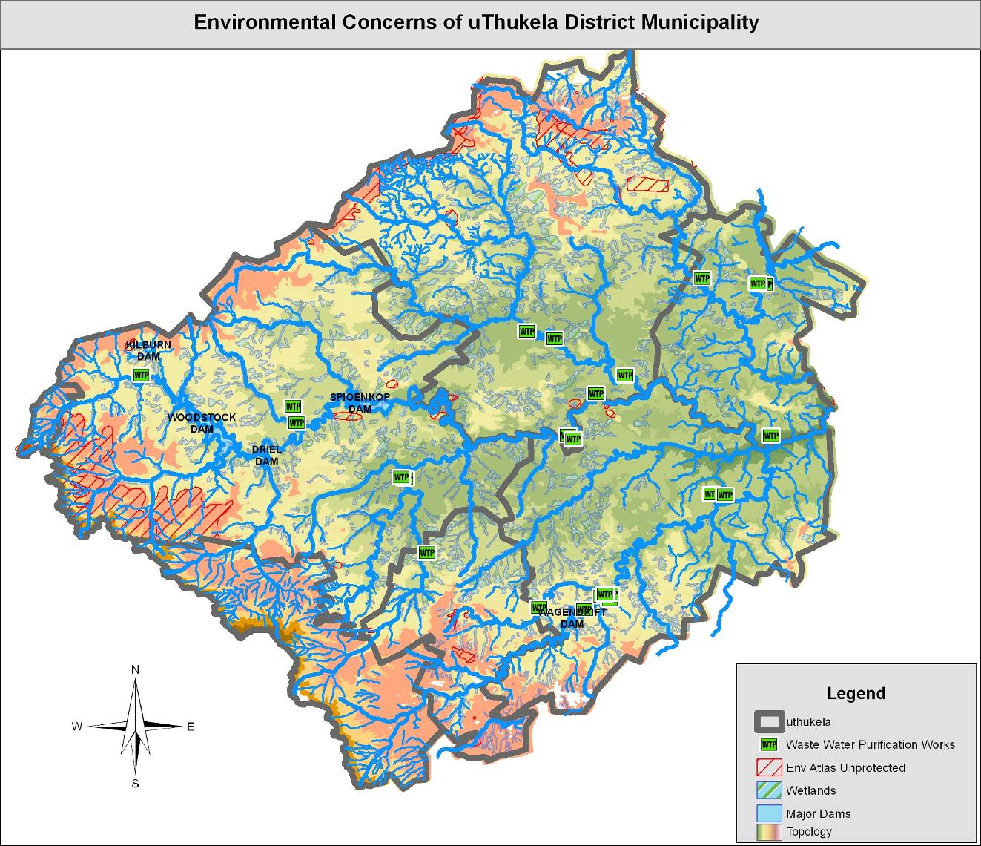

B4.1.1 ENVIRONMENTAL MANAGEMENT
uThukela District municipality has developed the following Environmental Management Plans:

B4.1.2 INTEGRATED WASTE MANAGEMENT PLAN
This plan covers the following key aspects
- Status quo analysis of Waste Management
- Goals and objectives of Waste Management
- Gaps and needs and needs assessment of Waste Management
- Evaluation of alternatives for Waste Management
- Framework for an Implementation Strategy
- Environmental Pollution Control Bylaws

B4.1.3 AIR QUALITY MANAGEMENT PLAN
uThukela has developed the air quality management plan that is implemented to control and prevent air pollution in the district. The plan covers the following aspects
- Priority pollutants (Emission Inventory)
- Goals and objectives of Air Quality Management
- Air Quality Management system
- Emission Quantification and Reduction programme
- Co operative governance approach

B4.1.4 POLICIES AND BYLAWS
UThukela has guiding policies and bylaws relating to the environmental management issues namely:
- Environmental Management policy
- Water services Bylaws
- Environmental Pollution control Bylaws
The water services Bylaws was adopted on the 5 February 2004 and the Environmental Pollution Control By laws on the 30 June 2006.
The critical challenges that face the municipality are that most of the waste disposal sites are full. The district municipality is negotiating with the Department of Land Affairs to assist in acquiring land to be used for solid waste disposal sites.

B4.1.5 PUBLIC PARTICIPATION AND ENGAGEMENT ON ENVIRONMENTAL MANAGEMENT
To preserve its natural environment heritage and to ensure sustainable development, uThukela district municipality has established a multi-sectoral structure that ensures public participation called uThukela Environmental Management Forum. Community also participate and engage on environmental issues through IDP public consultation workshops

B4.1.6 CAPACITATION OF LOCAL MUNICIPALITIES ON ENVIRONMENTAL ISSUES
uThukela district understands the critical role played by the local municipalities in protecting and preserving the natural environment. To this end the District municipality organizes community awareness events annually such as Arbour Day, Wetlands Day and EarthDay.Through these events communities are capacitated with appropriate knowledge and skills to protect and preserve the environment

B4.1.7 PROJECTS AND PROGRAMMES AIMED AT ENVIRONMENTAL PROTECTION
The district has a number of programmes aimed at environmental protection such as water conservation programme, health and hygiene education programme emphasizing safe disposal of human excreta, commemoration of water and sanitation week and establishment of water users associations and waste management forums for waste disposal sites as well as waste recycling clubs.

B5 INSTITUTIONAL ANALYSIS
UThukela District Municipality has adopted the structure that is aligned with the Powers and Functions assigned to the District municipality as well as the implementations of the IDP.The District Municipality is having ± 510 permanent staff members and ±140 part time staff members.
The uThukela District Municipality consist of six Directorates and their responsibilities are aligned to the Performance Management System (PMS) namely:
- Treasury and Finance
- Corporate services
- Infrastructure Development
- Health and Environmental services
- Strategic Planning and Economic Development
- Water Services

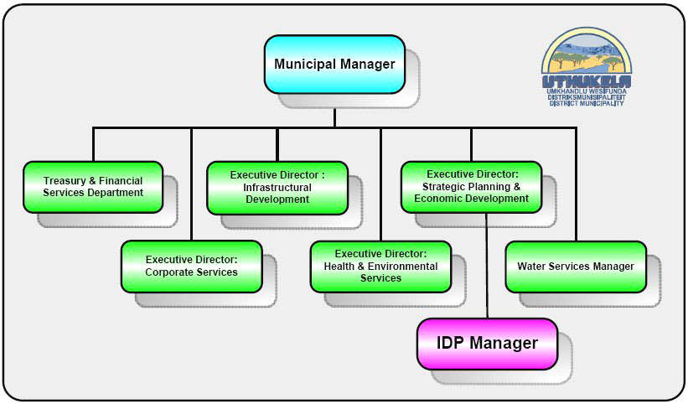

B5.1.1 POWERS AND FUNCTIONS THAT ALIGNS TO ORGANOGRAM OF THE DISTRICT MUNICIPALITY
- Water supply and sanitation services
- Municipal Health services
- Solid waste disposal sites
- Municipal roads
- Regulation of passenger transport services
- Municipal airports serving the area of the whole district
- Fire fighting serving the whole District
- Establishment and control of fresh produce markets
- Establishment, conduct and control of cemeteries
- Promotion of local tourism for the area of the district municipality
- Municipal public works relating to any of the above functions or any other functions assigned to the district municipality.

B5.1.2 ROLES AND RESPONSIBILITIES OF THE HEADS OF DEPARTMENTS
(i) The Municipal Manager
The Municipal Manager is primarily responsible for:
- The management of the Municipality’s administration;
- The implementation of the IDP and monitoring of the plan;
- The implementation of National and Provincial Legislation applicable to the Municipality;
- The management of the provision of services to communities in a sustainable manner;
- Advising the Municipal Council and other political structures as well officials of the Municipalities
(ii) Corporate Services
Corporate Services is charged with:
- Advising Council and its committees on standing orders, code of conduct and applicable Legislation;
- Advises the Council, its Committees and Heads of Departments on Human Resource Policy and labour relations;
- Acts as a Municipal Manager during his absence;
- Approves all agendas and minutes compiled by his staff; and
- Prepares the Disaster Management Plan for the Council.
(iii) Chief Finance Officer
- Implementing the Financial Regulations;
- Acting as the direct link between the Council and the Auditor General;
- Acting as Consultant to Local councils in the region for the administration of projects funded by the Council;
- Compiling the annual budget and financial statements; and
- Controlling the bank account and arrangement of transfers between accounts.

(iv) Strategic Planning and Economic Development
- Develop and implement social programmes;
- Develop youth in the District;
- Develop and promote sports; and
- Promote gender equality
- Identify LED opportunities;
- Develop the LED Plan;
- Source funding for LED projects;
- Promote tourism; and
- Develop the Tourism Plan.
- Management of all planning related functions within UTDM;
- Ensuring that development occurs in terms of UTDM’s Spatial Development Framework;
- Ensuring a sound Information Technology system within UTDM;
- Ensuring a sound and operational GIS within UTDM;
- Drafting and day-to-day management of the IDP; and
- Ensuring that the Local Municipalities adhere to the LUMS guidelines prepared by the UTDM.
(v) Infrastructure Development
- Responsible for the entire technical liaison between UTDM National and Provincial Government Departments;
- Responsible for rendering technical support services to Local authorities within the UThukela area, where such needs exist;
- Representing the Council at conferences, missions, functions etc as directed by the Council;
- Responsible for the approval of the prioritization of projects after technical evaluation; and
- Project administration services including capital budgeting and control of consultants
(vi) Health and Environmental Services
The primary responsibilities of the Municipal Health Service include:
- Ensuring compliance with all Water Service Authority functions contained in the Water Service Act 108 of 1997
- Ensuring that water service policy including the by laws and tariffs are in place
- Monitoring and evaluating all Water Service Providers delivering services within the council jurisdiction
- Ensuring that the WSDP is in place
- Managing and overseeing any programme linked to the Water Service Authority function such as ISWIP
(Vii) Water and sanitation services
  - To develop an Operational and Maintenance Plan for the District
  - To supply water and sanitation in the jurisdiction of the District

B5.1.3 SKILLS DEVELOPMENT
uThukela District Municipality do comply with Skills Development Act. The District has developed and implementing workplace skills development plan in order to enhance the skills of the staff and thereby improve their competencies. Once a Skills Development Plan is adopted by Council it is submitted to LGSETA for accessing funds. However the funding that was received was insufficient to meet the needs of the District.

In the previous financial year 63 staff that received the training and the training cost was R88 410.20.The municipality also offers bursaries to the community for matriculated students. The municipality employee also has a bursary scheme and 09 employees benefited from it in the previous financial year.

B5.1.4 EMPLOYMENT EQUITY
In terms of the Employment Equity Act, 1998, it is the duty of uThukela District Municipality to consult, draft and implement the an Employment Equity Plan in order to achieve equity in the workplace. uThukela has developed an Employment Equity Plan that is promoting equal opportunity and fair treatment in employment through the elimination of unfair discrimination.

In drafting of the Employment Equity Plan all the relevant stakeholders were involved including the Local Labour Forum. One of the objectives of the Plan is to focus on the development of present staff and an affirmative action programme aimed at specifically addressing the training and advancement needs of previously disadvantaged groups

B5.1.5 HUMAN RESOURCE STRATEGY
The Human Resource Polices has been compiled in an enabling spirit and sets out the policy relating to employment within the Municipality, These policies are the enabling tool to facilitate human resources management within the municipality. In compiling the uThukela Human Resource Policies a reference was made to the Employment Equity Act No.55 of 1998, the Labour Relations Act No.66 of 1995, the Skills Development Act No97 of 1998, the Municipal Finance Management Act No.56 of 2003, White Paper on Affirmative Action in the Public Service and the White Paper on Human Resource Management in the Public Service. uThukela District Municipality has developed the following HR policies but these policies are not part of the IDP because of the it’s thickness but are available on request.

    - Promotion policy
    - Placement Policy
    - Employment policy
    - Employment Equity policy
    - Leave policy
    - Recruitment, Retention and Selection policy
    - Permanent employment policy
    - Temporal employment policy
    - HIV/AIDS policy
    - Smoking policy
    - Sexual Harassment policy
    - In service Training policy
    - Communication policy
    - Training and Development policy
    - Training and Development policy
    - S&T policy

B5.1.6 INTERGOVERNMENTAL RELATIONS
UThukela district municipality has established the Intergovernmental Relations that is in line with the Intergovernmental Relations Act. uThukela IGR consist of 5 mayors from the Local municipalities and a chairperson who is the uThukela District Mayor. The Forum was formed to discuss matters of mutual interest, alignment and support to improve service delivery in the District. However, there are challenges regarding the frequency of meetings. Mayors to commit themselves and ensure that the forum meetings take place as scheduled.

The uThukela District Mayor, as chairperson of the Mayors Intergovernmental Forum, attends the KZN Provincial Premier’s Forum meetings and ensures the dissemination of information between the two Forums. The municipality has also established the Technical Support Forum that supports the Mayors Forum. There are number of sub committees that were formed by the municipality in making sure that all the spheres of government talk to each other e.g. Service Provides, Forum, IDP Technical Support Structure, IDP Representative Forum, CFO Forums, and District Aids Council etc.

B6 SOCIAL DEVELOPMENT
B6.1.1 SPORTS AND YOUTH
uThukela District Municipality is playing a vital role in supporting and promoting the sport and youth throughout the District. The primary aim of the municipality is to ensure that the youth take part in sports so that they don’t focus on crime. The District Municipality has appointed a dedicated person that deals with the issues of sport and youth throughout the District. The District Municipality has embarked in the formation of the uThukela District Federations.

They host the competition that is known as the Mayoral Cup that is played on annual basis where the District Municipality invites the professional teams to play with uThukela squad and the professional teams select from the uThukela squad and they will be given an opportunity to play for those teams. They also have the KWANALOGA games that take place annually with all the other District municipalities in the province of KwaZulu Natal. In those games they can be selected to represent the province of KwaZulu Natal. The municipality supports football associations, netball and boxing.
uThukela District is also involved in the arts and culture competitions. They also support the youth on business. uThukela District Municipality has a lot of youth projects that will promote sports in the District.

B6.1.2 PHYSICALLY CHALLENGED
uThukela District Municipality has formed the Disability Forum where all the physically challenged people are able to raise their issues. There had been some several workshops where the relevant stakeholders such as Seda and, Umsobomvu were invited to encourage the physically challenged people to start their own businesses. The following concerns were raised by people with disabilities in one of the meetings of the IDP Review:
- Accessing the Municipal offices
- Transportation
- Recreational Facilities
The following future events are also acknowledged:
Internal Day of Disabled people
Albinism Day
Blind and Deaf Day
Sports and Recreation Day
Deaf and Dumb Sign Language Teaching

B6.1.3 GENDER ISSUES
The municipality has appointed a person who deals with the issues of gender throughout the District. Gender committee has been established and is functional. They had a commemoration of Woman’s Month celebration. They also had workshop on educating communities on legal and human rights.

B6.1.4 SENIOR CITIZEN
Senior citizen forum has been formed and it was launched in 2008.The municipality had visited the old age homes around uThukela. The awareness of the senior citizen was held on the 20th October 2007 where the community were encouraged to take care and support the older people in the community at large.

B6.1.5 SAFETY AND SECURITY
The existence of security services in the District is playing a vital role in fighting crime in all aspects like Theft, fraud, attempted robberies illegal possession of firearms and ammunition murder etc.
uThukela district municipality’s strategies for addressing the issue of crime include both reactive strategies to respond to incidents of crime and pro active strategies aimed at stopping crime before it happens. The response follows an approach that works closely with communities, community policing forum and other spheres of Government (National and Provincial) the strategy of the Municipality covers the following to create safer environments:
Environmental for Safety
Effective policing
Community Safety initiatives
Social Crime Prevention

B6.1.6 DISASTER MANAGEMENT
uThukela District Municipality is concerned about the human suffering and economic loss due to the result of disasters. uThukela District Municipality is affected by numerous disasters that include Veldfires, Floods, Strong Winds, and snow.

The District is in the process of establishing the District Disaster Management Centre. The Disaster Management Plan is completed and adopted by Council. The Disaster Management Plan was developed in accordance with the format developed by the Australian South African Local Government Partnership based on the Comprehensive Hazard and Risk Management (CHARM) process. The plan is going to be reviewed in 2010/2011 financial year to ensure its relevancy to the District.

The District Municipality has also established the Disaster Management Advisory Forum that is comprises of local municipalities, NGO’s, and other relevant stakeholders. The committee meets four times per year. uThukela District is concerned with preventing disasters whenever possible and reducing the impact on the lives of citizens of any disasters that do occur. The District Municipality is ready to respond in an integrated and co-ordinated manner. The District has also installed the communication system to ensure that our contingency plans are working properly and operational committee is able to use it during accidents. As from November 2008 there were storms and strong winds experienced and 1462 households were affected.

B 7 GOVERNANCE, PUBLIC PARTICIPATION AND ALIGNMENTS
Good governance in a municipal context relates to the process whereby Municipalities conduct public affairs and manage public resources in a responsible and accountable manner and in line with the provisions of the rule of law for the benefit of the citizens served and the realization of human rights. The key attributes for good governance are transparency, responsibility, accountability, participation and responsiveness to the need of the people. Consultation with stakeholders is a continuous process within uThukela district municipality, in compliance with the stipulation in Chapter 4 of the MSA of 2000.

After completing the draft IDP and the draft budget, the municipality will advertise both the draft IDP and the draft budget in local newspapers. In order to ensure alignment between the IDP, Budget and PMS review processes, a Process Plan was drafted incorporating all three activities with monthly milestones and this was workshopped with communities and other stakeholders through the Representative Forum and service providers forum meetings. The Framework Plan was also drafted to ensure that the review process of the District IDP and local municipalities IDP are aligned and equally informed by each other, In addition to that, the Mayor of the municipality had several road shows and he used the Ukhozi FM slot informing the community about the draft IDP and draft budget. This formed the basis for stakeholder input to ensure effective public participation in the IDP and Budget process.

It is the policy of uThukela district municipality to ensure that the development is driven by the community. The whole area of uThukela District Municipality was covered and the community was given the chance to comment on their draft IDP and draft budget. Emphasis was on the importance of attending the IDP meetings and make comments because the IDP informs the budget. uThukela’s IDP and budget is community driven from the initial stages and the role of the municipality is to facilitate the whole process. uThukela District Municipality had several road shows in the following areas in ensuring that the community are part and parcel of the IDP and Budget of the municipality
IDP AND BUDGET PUBLIC MEETINGS
L.M | VENUE | DATE | TIME
IMBABAZANE | ENGONYAMENI | 07MAY 2010 | 10H00
OKHAHLAMBA | EDUKUZA | 11 MAY 2010 | 10H00
UMTSHEZI | EMNGWENYA | 13 MAY 2010 | 10H00
EMNAMBITHI | ST CHADS | 18 MAY 2010 | 10H00
INDAKA | SAHLUMBE | 20 MAY 2010 | 10H00

The District municipality’s Communication strategy consists of the following aspects.
- Road shows
- Ukhozi slot
- Local newspapers
- UThukela website
- Annual report
- District Mayors Forum meetings
- IDP and Budget alignment meetings and technical support meetings
- Izimbizo
- Presentation to the Local House of Amakhosi
In ensuring that good governance prevails in the delivery of services to the citizens of uThukela District, uThukela District Municipality and its family of Local Municipalities ensured that they comply with the provisions of the following important legislation: -

- The Constitution of the Republic of South Africa Act.
- Municipal Finance Management Act.
- Municipal Structures Act.
- Municipal Systems Act.

In complying with the aforementioned legislation, the District Municipalities have put the following in place: -
- Functional Audit Committees to audit the performance of municipalities.
- Functional internal audit Committee
- Employment Equity Plan
- Supply Chain Management Policy to guide procurement of goods and services in a fair, transparent, competitive and efficient manner and to ensure that historically disadvantaged individuals (HDI) are accorded preferential consideration.
- UThukela District Municipality and the Local Municipalities established Functional Executive Committees and various Portfolio/Sub U committees in order to ensure effective and smooth functioning of the municipal councils.
- The District Municipality and the Local Municipalities developed the IDP’s and are reviewing such plans annually in line with the provisions of the Municipal Systems Act.
- The Municipalities further developed and adopted a number of Policies and By-laws to enable them to operate efficiently and effectively within their areas of jurisdiction.
- During 2009/2010 financial year, uThukela District Municipality received unqualified audit opinion report from the Auditor General, which clearly indicates that uThukela District Municipality complied with the provisions of the important Municipal Legislation relating to good governance.
- HIV/AIDS strategy for the workplace and for the community and the District Aids Council has been launched and in the strategy there are number of projects identified for the 10/11 financial year and beyond.
- Continuous promotion of the people with disabilities is the main focus of the municipality and there are number of programmes and projects that involve them in the district. In addition to that there is disability forum where they discuss the issues related to them.
- Gender Committee has been established where the majority of people who takes the initiatives are women and the chairperson of the gender committee is the women also they have a number of programmes planned for this financial year. Recently they had a commemoration of Woman’s Month celebration.
- uThukela senior citizen forum has been formed and launched. The municipality had an awareness campaign of the senior citizen.

B7.1.1 TRADITIONAL LEADERSHIPS

In this district the institution of Traditional Leadership is highly recognized and supported. There are 18 Traditional Leaders in the uThukela district. The Municipality works closely with the Traditional Leaders within the district. Traditional Leaders are represented at the District Aids Council Structure and they attend the IDP/Budget road shows as well as the IDP Representative Forums meeting. uThukela local house of AmaKhosi has been established in line with the new legislation on Traditional Leadership. The municipality meets on regular basis with uThukela local house to deal with issues of development, budget.IDP etc.

B7.1.2 PORTFOLIO COMMITTEES
uThukela District Municipality has got 4 standing committees and these committees are Human Resources, Emergency and Health Services, Economic and Planning & technical. All the standing committees have their own programme but reports to Council

B7.1.3 WARD COMMITTEES
Ward Committees are an exciting route of achieving one of the aims of the developmental local government mentioned in the Constitution of the Republic of South Africa. In this Forum is where communities and community organizations are able to participate more on issues of improving service delivery and strengthening local government. uThukela District Municipality have utilised the ward committees that are functional in the District in dealing with the issues of public participation especially in the Budget and IDP.The challenge that is facing the District is that some ward committees are not functional like Umtshezi and Okhahlamba.The other challenge that makes its difficult for the Ward Committees to function is that it is expensive for members to attend Ward Committees meetings as the area is too wide in other municipalities.

B7.1.4 COMMUNITY DEVELOPMENT WORKERS
There are 36 Community Development Workers deployed within uThukela District Municipality. There is a need of deploying more Community Development Workers (CDW) in order to be able to cover all wards in uThukela District Municipality. All the CDW finished their learneships programme

B7.1.5 AUDIT COMMITTEE
uThukela District Municipality has established the Audit Committee in February 2007. The Audit Committee of the municipality is fully functional and it consists of 3 members. They sit four times per year. Some of the functions of the Audit Committee are auditing the performance of the Municipality and to evaluate the reports of the Heads of Departments. They also review the financial statements of the municipality and they discuss the findings from the Auditor General.

B7.1.6 ALIGNMENT OF UTHUKELA IDP WITH LOCAL MUNICIPALITIES
Several strategic meetings have been held involving the District family of Municipalities with the primary objective of aligning this IDP with those of the local municipalities. uThukela has established the IDP Supporting Committee that is comprises of all the IDP Managers in the District and one of the objective of the Committee is to ensure that the IDP’s are talking to each other.

The alignment started at initial stages where all the IDP Managers met to discuss the IDP Framework Guide that was followed in preparation of this plan. That process was instrumental in ensuring that the 2010/2011 IDP is holistic and addresses issues of integrated planning and development. For example, strategic issues of local municipalities were aligned to the District strategic issues, all identified projects for 2010/2011 financial year, as listed in this IDP, emanated from discussions held with local municipalities. Consequently, the project list is a reflection of projects included in the LM’s IDP’s.

B7.1.7 SERVICE PROVIDERS ALIGNMENT
In the 2010/2011 IDP, uThukela engaged sector departments on one on one process in aligning our programmes with them, The challenges that were raised in the engagement with sector Departments is the different budgeting cycles between the municipalities and Sector Departments that makes it difficult to get their programmes with budget on time. There is a lot that need to be done in making sure that the sector departments are on board not only in submitting their programmes but to plan together with the district.

B7.1.8 CROSS MUNICIPAL BORDER ALIGNMENT
UThukela District Municipality had a number of strategic meetings with neighbouring Districts municipalities on cross border issues. The neighbouring districts which includes Amajuba, Umzinyathi and Umgungundlovu District Municipalities, members of the uThukela family of municipalities were invited to the cross border alignment meetings, where issues that are cross border development nature were discussed such as
- Projects that have a service delivery impact across municipal boundaries like transport systems etc.
- Community facilities that are located close to municipal borders that have potential

B8 STRENGTHS, WEAKNESS, OPPORTUNITIES, THREATS ANALYSIS OF UTHUKELA DISTRICT MUNICIPALITY. (SWOT ANALYSIS)

B8.1.1 INTRODUCTION
The following analysis were identified and verified in the NSDP workshop that took place on the 4th March 2009 where the local municipalities, Chamber of Business and Government Departments were present in the workshop.

B8.1.2 STRENGTHS
The district lies between Durban and Johannesburg along the busiest N3 corridor.
The road network linking the district to other areas like Newcastle, Dundee, Grey town and the Free State is fairly well developed.
The UKhahlamba Drakensberg mountain range is a World Heritage Site and forms part of the Maloti-Drakensberg Transfrontier Peace Park between Lesotho and South Africa. It is a competitive tourist attraction area.
The district also contains the basis of the Tugela-Vaal water scheme and good water resources.
Commercial farming is well developed, and is dominated by extensive livestock and field crops. Livestock production focuses primarily on beef, dairy and sheep production.
The district has a large number of tourism attractions linked to its relatively mild climate, fairly well developed infrastructure, well-established recreational tourism and its location relative to the “Battlefields, Berg and Bush”.

B8.1.3 WEAKNESS
Lack of economic diversity & competitiveness of small towns
Economy is dependent on government services
Agriculture and tourism potential not fully exploited
No tertiary education institutions leading to disjuncture between skills & growing sector
Ability to fully leverage location factors – transport, warehousing & logistics
B.8.1.4 OPPORTUNITIES
The upgrading of the N11 will enhance the status of Ladysmith as a strategic distribution centre and spur development of transport, logistics, distribution, warehousing etc. The main areas of benefit relate to the potential for a rail – road junction, and the allied industries that can be developed.
The IDP identified the need for a regional airport and the development of the N3 corridor.
There are opportunities for beneficiation in the following: Sub tropical fruit production and processing; Venison production; Dairy processing; Linen production. The development of an agro-industrial sector could generate self-sustaining economic growth in the district. Okhahlamba local municipality has the most recognized distinctive economic landmark, i.e. Ukhahlamba Drakensberg World Heritage Site. It forms a major component of uThukela District and KZN Provincial tourism economy. Agriculture is the most performing sector in Okhahlamba.

The KZN Provincial Spatial Economic Development Strategy (PSEDS) identifies Okhahlamba as one region with massive potential for growth in agriculture and agro-processing. It is a competitive sector that could be further developed to exploit economic opportunities presented by its location along the major transport routes and abundant water from Thukela River (Thukela-Vaal Scheme). The R74 connects Bergville and Winterton to the N3 and N6 roads in the Free State. This presents Okhahlamba with agro-processing opportunities that will be supported by road freight infrastructure to major South African cities, i.e. the Durban Harbour in the south and Johannesburg in the north.

The district utilities sector has become increasingly important due to the establishment in the 1970s and 1980s of the Tugela-Vaal Augmentation Scheme (TUVA).
The tourism sector is an area with substantial growth potential, potential for black-owned enterprises, for employment generation and for community based initiatives.
The IDP has identified opportunities for expansion of the existing tourism infrastructure through identifying strategic or regionally important projects; the game reserve/eco-tourism sector; expanding and improving existing infrastructure (for example the Woodstock, Spionkop and Wagendrift dams).

Small manufacturing could diversify its products to respond to other markets.
Cultural tourism provides an opportunity for craftwork development. At present there are hundreds of crafters in the district who manufacture beadwork, grass, wood and leather goods but these need assistance in the areas of product design and diversification, quality control, and marketing and distribution arrangements.

B8.1.5 THREATS
Poverty and HIV/AIDS continue to threaten the livelihood security of households and the quality of life. Young people account for the majority of the population. This is not supported by the appropriate education and skilling of this generation to take up market opportunities.

Limited benefits derived from international and national assets situated in the district
Low economic growth and increasing rate of unemployment in major economic sectors
Poor environmental management
Financial sustainability of the district municipality
Declining agricultural performance due to deregulation of the previously protected commercial farming sector, the impact of trade liberalization, weakening global and domestic markets, as well as frequent drought conditions.

Tourism infrastructure is underdeveloped and completely non-existent in traditional areas. Particular attention needs to be paid to accessibility factors: roads, transport and signage
The agricultural sector suffers from a degree of income leakage from the district with the export of raw material for processing elsewhere. Two major agricultural processing facilities have closed down and moved elsewhere in response to restructuring imperatives.

Farming in traditional areas is seriously underdeveloped and suffers from a range of constraints to its future growth (lack of funds for inputs and equipment, distance to markets, absence of irrigation systems, poor natural resource management, and sub- economic size of plots).

B9 KEY PRIORITY ISSUES

The following key priorities were reviewed and prioritised by the members of the IDP steering committee and various workshops were held with Representative Forum and Service Providers Forum to get inputs and comments. In reviewing the priority issues the 5 Key Performance Areas (KPA’s) of the Five Year Local Government Strategic Agenda were taken into account .The priority issues of the District Municipality were also aligned to those of the local municipalities. In reviewing uThukela Priority Issues the issues of environment were taken into consideration to ensure sustainability.

In reviewing the Priority Issues of uThukela District Municipality, the MEC letter was taken into cognisant by aligning with the following Provincial Priorities that was raised in the MEC Letter
- Rural Development and Agrarian Reform
- Creating decent work and economic growth
- Fighting crime and Corruption
- Development of human capability and education
- Creation healthier and sustainable communities
- Nation Building and good governance

It must be noted that the following key Priority issues were also linked into the powers and functions of the municipality. The uThukela District Municipality priority issues were prioritised as follows:
- Provision of sustainable infrastructure, water and sanitation services and backlog thereof
- Economic Development
- Prevention of ill-health and promotion wellness
- Public safety and security
- Financial viability and administrative capacity of the district
- Accountability and public participation institutions
- Coordination of services

SECTION C: DEVELOPMENT STRATEGIES
C1.1.1 INTRODUCTION
The municipal vision and mission was reviewed to ensure its relevancy to the municipality. All the relevant stakeholders were part and parcel of this process. The Municipal Vision didn’t change because it is still relevant to the District. The mission statement was amended to suits the needs of the Council. uThukela District Municipality’s vision statement makes a firm commitment to the following developmental aspects:
- Improved quality of life, which includes cost efficient delivery of services and equitable
- Access to public facilities;
- A stable environment, which refers to both natural and physical environments;
- A developed region, which emphasises linked and systematically ordered projects; and
- Sustainable development.

C1.1.2 MUNICIPAL VISION AND MISSION STATEMENT
The Vision:
An improved quality of life for all in a globally interconnected, stable and developed region.

The Mission:
To enhance development and provide quality services in an efficient, effective, sustainable and cost effective manner.

C1.1.3 MUNICIPAL STRATEGIC OBJECTIVES AND STRATEGIES FOR 2010/2011
PRIORITY | ISSUE | OBJECTIVE | STRATEGIES | RESP. DEPT. | KPI | NATIONAL KPA | TARGETED YEARS
1 | Provision of sustainable infrastructure, water and sanitation services and backlog thereof. | To reduce infrastructure backlogs | Through the implementation and review of water and sanitation projects in line with the WSDP and CIP. | Technical/WSA | - A reviewed and updated WSDP and CIP  - Number of households serviced with water  - Number of households serviced with sanitation | Basic Service Delivery
1 |  | To provide sustainable potable water and sanitation services. | Through efficient and effective management of resources. | Technical | Expenditure of grants received | Basic Service Delivery
1 |  |  | Through the conduction of an internal self-assessment to ensure sustainable and efficient services delivery. | WSA | - Self - assessment document  - O&M Strategy | Basic Service Delivery
1 |  | To provide social services infrastructure. | Through the implementation of emergency water and sanitation projects | Technical | - Water Master Plan  - Sanitation master Plan  - Emergency Water and Sanitation Response Plan | Basic Service Delivery
1 |  | To provide social services infrastructure. | Through the implementation of UTDM social infrastructural programmes | Technical | - Social Infrastructure Program  - Expenditure of allocated budget | Basic Service Delivery
1 |  | To undertake on-going research to the benefit of the district. | Through the identification of relevant areas of research and sourcing of funding. | WSA | - Compilation of a database of possible research areas  - Sourcing of funds | Good Governance and Public Participation

PRIORITY | Issue | OBJECTIVE | STRATEGIES | RESP. DEPT. | KPI | NATIONAL KPA | TARGETED YEARS
2 | Economic Development | To stimulate sustainable economic development and to reduce poverty within the District | Through the creation of an environment that is conducive to economic development. | Planning | - Identification of factors that will create a conducive environment  - Functional LED Forum | LED
2 | Economic Development |  | Through the provision of infrastructure to unlock development. | Planning | Number of factors addressed that will create a conducive environment | LED
2 | Economic Development |  | Through the implementation of an SMME Programme and the development of an SMME Policy. | Planning | - SMME Policy  - Number of projects implemented on the SMME Program | LED
2 | Economic Development | To promote tourism within the District | Through the implementation of LED Plan | Planning | Number of projects implemented | LED
2 | Economic Development | To promote tourism within the District | Through the implementation of Tourism Plan. | Planning | Number of projects implemented | LED
2 | Economic Development | To promote tourism within the District | Through the co-ordination of tourism activities at local level | Planning | - Number of meetings of the district tourism forum  - Number of meetings of the district coordination body | LED
2 | Economic Development | To promote tourism within the District | Through the identification of Tourism opportunities within the District. | Planning | - Document with reviewed tourism opportunities  - Publicizing of tourism opportunities | LED
2 | Economic Development | To develop a marketing  Strategy | Through the development of a marketing and communication strategy. | Corporate | - Marketing and communication strategy  - Terms of reference for PRO function | LED

PRIORITY | ISSUE | OBJECTIVE | STRATEGIES | RESP. DEPT. | KPI | NATIONAL KPA | TARGETED YEARS
3 | Prevent of ill- health and promotion  of wellness | To prevent the occurrence and spread of communicable disease | By monitoring the quality of food stuffs at point of production, transportation, storage and sale to the public | WSA | Adherence to the monitoring program | Good Governance  and Public Participation
3 | Prevent of ill- health and promotion  of wellness | To prevent the occurrence and spread of communicable disease | By implementing the health and hygiene education strategy. | WSA | Number of projects implemented | Good Governance  and P.P
3 | Prevent of ill- health and promotion  of wellness | To prevent the occurrence and spread of communicable disease | By monitoring the quality of water used for domestic purpose. | WSA | Adherence to the monitoring program | Good Governance  and P.P
3 | Prevent of ill- health and promotion  of wellness | To prevent the occurrence and spread of communicable disease | Through the implementation of milk control bylaws. | WSA | Adherence to the milk control bylaws | Good Governance  and P.P
3 | Prevent of ill- health and promotion  of wellness | To prevent the occurrence and spread of communicable disease | Through the development and implementation of relevant bylaws to address all District Health Services components. | WSA | - Identification of relevant bylaws  - Development of identified bylaws | Good Governance  and P.P
3 | Prevent of ill- health and promotion  of wellness | To mitigate the impact of HIV/AIDS within the district | Through the implementation of district HIV/AIDS strategy | WSA | Number of projects implemented | Good Governance and P.P
3 | Prevent of ill- health and promotion  of wellness | To ensure sustainable development of the environment | Through the implementation of the environment Management Plan and Strategic Environmental Assessment. | WSA | Number of projects implemented | Good Governance and P.P
3 | Prevent of ill- health and promotion  of wellness | To promote occupational health and safety | Through implementation of the Health and Safety program | WSA | Number of projects implemented | Good Governance and P.P

PRIORITY | ISSUE | OBJECTIVE | STRATEGIES | RESP. DEPT. | KPI | NATIONAL KPA | TARGETED YEARS
4 | Public safety and security | To reduce the crime rate | Through supporting public safety program aimed at combating and reducing crime | Corporate | Measures put in place to support public safety program | Good Governance and P.P
4 | Public safety and security | To reduce the risk of communities located in potential disaster areas | Through the review and implementation of the disaster management plan | Corporate | Reviewed of disaster management plan | Good Governance and P.P
4 | Public safety and security | To facilitate a swift response to incidents of disaster | Through the proper implementation of the disaster management plan. | Corporate | Number of projects implemented | Good Governance and P.P
4 | Public safety and security | To mobilize external, provincial, national and international funding and investments | Through the identification and engagement of potential funding resources. | Finance | - Number of funding applications submitted  - Amount of funding secured | Financial Viability
4 | Public safety and security | To enhance the revenue collection process. | Through the implementation of the Credit Control Policy. | Finance | Reports on Credit Control | Financial Viability
4 | Public safety and security | To promote sound administration within the applicable legal mandates | Through the provision of appropriate IT infrastructure. | Planning |  | Good Governance and P.P

PRIORITY | ISSUE | OBJECTIVE | STRATEGIES | RESP. DEPT. | KPI | NATIONAL KPA | TARGETED YEARS
5 | Financial and administrative capacity of the district | To facilitate a swift response to incidents of disaster | Through the reviewing of the existing district skills development plan | Corporate | Reviewed Skills Development Plan | Good Governance and P.P
5 | Financial and administrative capacity of the district | To facilitate a swift response to incidents of disaster | Through the optimal utilization and management of district resources | Corporate | - Updated list of resources  - Frequency of minimum resources available | Good Governance and P.P
5 | Financial and administrative capacity of the district | To enhance financial administration capacity to comply with legal requirements | Through planning within the DMA | Planning | Number of planning meetings attended | Good Governance and P.P
5 | Financial and administrative capacity of the district |  | Through implementing financial management capacity building program | Finance | Number of students enrolled in the CPMD | Financial Viability
5 | Financial and administrative capacity of the district |  | Through the implementation of a Turn - around strategy. | Finance | - Review of the Turn-around Strategy  - % Implementation of the Turn-around strategy | Good Governance and P.P
6 | Accountability and public participation institutions | To establish accountability and public participation institutions | Through community participation on governance issues. | Corporate | No. of Community meetings and Road shows held. | Good Governance and P.P
6 | Accountability and public participation institutions | To actively engage accountability and public participation institutions on service delivery. | Through participating in existing accountability and public participation institutions and structures, e.g. Ward committees, IDP Forums, etc. | Corporate | No. of Meetings attended | Good Governance and P.P
6 | Accountability and public participation institutions |  | Through the review of the Employment Equity Plan. | Corporate | Reviewed Employment Equity Plan | Institutional Development

PRIORITY | Issue | OBJECTIVE | STRATEGIES | RESP. DEPT. | KPI | NATIONAL KPA | TARGETED YEARS
7 | Co-ordination of social and other services | To co-ordinate and support social and other services | Through the strengthening and implementation of youth, women and people with disabilities programme | Planning | Reviewed Programme of youth, women and people with disabilities.  No of projects implemented | Good  Governance and PP
7 | Co-ordination of social and other services | To co-ordinate and support social and other services | Through the enhancement of the functioning of the gender working committee. | Planning | No. of Gender Working Committee meetings | Good  Governance and PP
7 | Co-ordination of social and other services | To co-ordinate and support social and other services | Through the support and implementation of sport programmes | Planning | No. of support rendered to sporting codes | Good  Governance and PP
7 | Co-ordination of social and other services | To co-ordinate and support social and other services | Through the support and implementation of programmes for the physically challenged | Planning | No. of projects implemented | Good  Governance and PP
7 | Co-ordination of social and other services | To co-ordinate and support social and other services | Through the support and implementation of programmes for the senior citizen | Planning | No. of projects implemented | Good  Governance and PP
7 | Co-ordination of social and other services | To co-ordinate and support social and other services | Through the engagement with local housing forums in order to align water and sanitation infrastructure with housing development | Technical / WSA | No of engagement with housing Forums | Good  Governance and PP

C1.1.4 TURN-AROUND STRATEGY
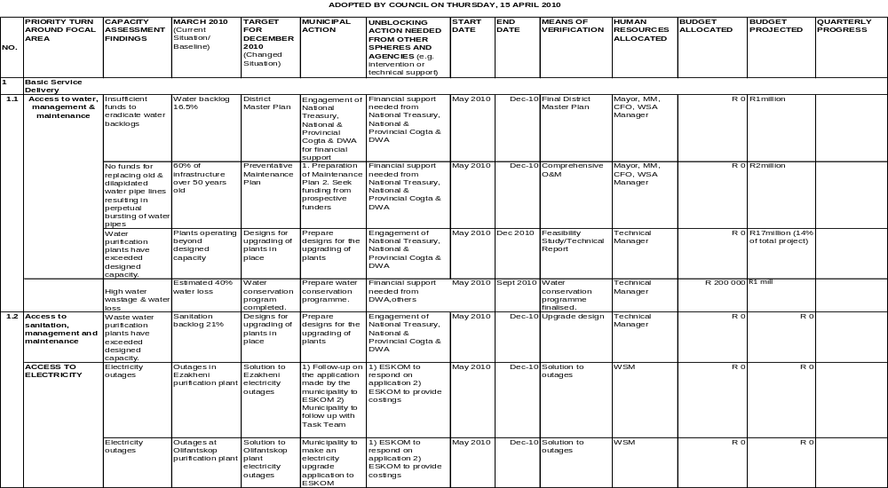

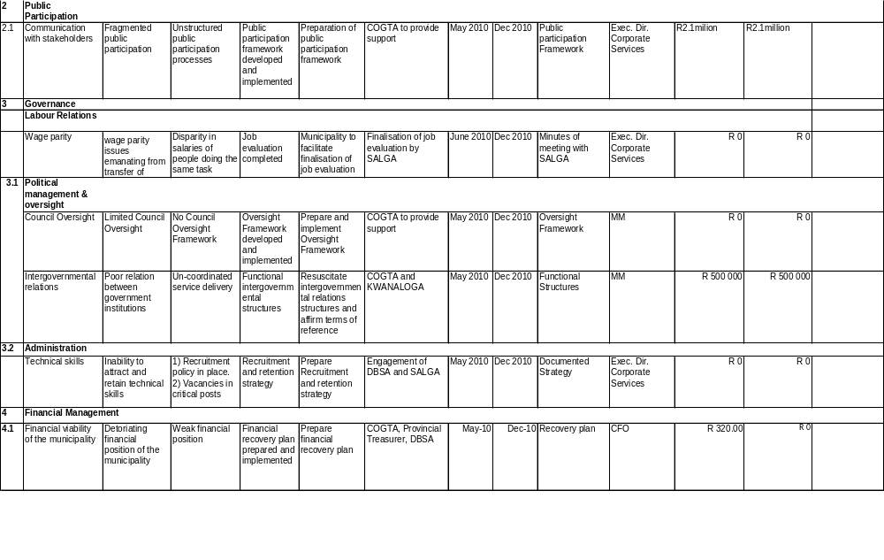

SECTION D: SPATIAL DEVELOPMENT FRAMEWORK

D1.1.1 BACKGROUND
The first development of the Spatial Development Framework of uThukela District Municipality was in 2003 and it has been reviewed on annual basis when the municipality review its Integrated Development Plan (IDP).The current review of the SDF was done in February 2010 to provide a basis of making choices about how much of what kind of development where, which would also need to be informed by a stronger environmental analysis. In reviewing the SDF, the Environmental Toolkit was taken into consideration
uThukela strongly believes that planning of this kind will assist to indicate where development can occur and the areas where it should be contained. It would also indicate the density of development that could be accommodated.

The uThukela District Municipality completed its comprehensive Integrated Development Plan (IDP) in 2002 and is now in the process of reviewing its IDP for the 2010/2011 financial year. In terms of the Municipal Systems Act all municipalities are required to prepare and review their 5-year IDP’s annually. This Spatial Development Framework (SDF) review is intended to assess the existing SDF within the current Integrated Development Plan. This will ensure that the uThukela District Municipality is provided with relevant and sufficient information to guide the process of land use management and development and adhere to Municipal System Act regulations.

LAND INFORMATION

Location
The uThukela District Municipality (uTDM) is one of ten district municipalities in the Province of KwaZulu-Natal and was established during the 2000 transformation of local government. The uThukela District Municipality derives its name from one of the major rivers in the Province, namely the Tugela that originates within the Drakensberg and supplies water to a large portion of KZN and Gauteng. The uThukela District Municipality has three district municipalities bordering onto it, namely Amajuba, Umzinyathi and Umgungundlovu.

The size of the Municipality is approximately 11,500km² and is located along the western boundary of KwaZulu-Natal. It is predominately rural, with three of the five Local Municipalities, being rural in nature. The Municipality is characterised by socio-economic challenges such as a low revenue base, poorly maintained infrastructure and limited access to social and other services. High levels of poverty, unemployment, skills shortage, a lack of resources and low levels of education is also prevalent. The settlement patterns are disbursed, which resulted in underdeveloped land and settlement patterns that make it challenging and expensive to deliver effective services.

The District is well endowed with water, pockets of good soils and the natural beauty of the Drakensberg. Two national roads, the N3 and N11 transcend the District, which has a potential for economic development.

uThukela District Municipality consists of five Local Municipalities, namely: Indaka, Emnambithi/Ladysmith, Umtshezi, Okhahlamba, Imbabazane and a District Management Area (KZDMA23).The Indaka and Imbabazane Local Municipalities are newly established municipalities, without a well established economic centre. As a result, the most significant poverty is found in these two municipalities.

Need for the Spatial Development Framework

A SDF in this report refers to: “A plan that outlines developmental principles, policies and goals that are applicable to a municipal area in relation to physical space.”

The rural nature of the municipality resulted in severe backlogs in infrastructure and is characterized by much poverty. Service provision needs to be addressed and measures, such as the Water Services Development Plan, are in place to address all service backlogs within the near future.

In the development of the Spatial Development Framework, the aims of the following documents were included:

- The principles as contained in Chapter 1 of the Development Facilitation Act (DFA) (Act No. 67 of 1995). Chapter 1 of the DFA sets out a number of principles, which apply to all land development. A number of principles would also apply to the formulation and content of a SDF.

- To give effect to section 26 (e) of the Municipal Systems Act (Act No. 32 of 2000) and its regulations. The Regulations promulgated in terms of the Municipal Systems Act, 2000 set out some of the requirements for a Spatial Development Framework.

- To set out IDP objectives that is spatial in nature and to reflect the desired spatial form of the municipality.
- To set out basic guidelines for a land use management system in the municipality.

Structure of the Document

The document is divided into five components, in addition to the introductory, and can be outlined as follows: -
- Analysis – this provides a spatial overview of factors that affect development and has potential for informing future development.
- Concept Plan – this section reviews the spatial development principles and concepts as a point of reference for developing a SDF.
- The Spatial Development Framework – as revised from the previously adopted SDF and taking into cognisance of the development trends that are currently taking place within uThukela.
- Land Use Management System Guidelines – In terms of the Municipal Systems Act, 2000 and the KwaZulu Natal Planning and Development Act, 1998 each municipality is required to prepare an IDP for the whole municipality. A key component of an IDP is the SDF and Land Use Management System (LUMS).

Land Use and Settlement Pattern

The uThukela District Municipality is predominantly rural in character with a dispersed rural settlement. Rural dense villages with a population of over 5,000 people are mostly found within the traditional areas of the Indaka and Imbabazane Local Municipalities. Both these Municipalities are characterised by very steep mountainous areas with limit opportunities for agricultural activities and creating difficulties in the provision of infrastructure.

Urban Areas

Ladysmith and Estcourt are the two major towns and economic hubs within the uThukela District Municipality. Both Ladysmith and Estcourt are commercial centres for surrounding farming areas and serves as shopping centres for towns such as Bergville, which lacks a strong commercial presence. As Ladysmith is the economic and regional hub, the banking sector is service industry is prevalent. The town is further the industrial hub, with the majority if industries being located around Ladysmith. The only industrial estate in the District is also located a short distance from Ladysmith.

Land Ownership

Traditional Authority Area

Large areas of traditional land are located within uThukela, with about 35% of land classified as either “tribal” or peri-urban. A spatial analysis revealed that a large portion of degraded land is located in traditional areas. This is especially true in the Emnambithi, Indaka and Umtshezi Municipalities. The high propensity for soil erosion in these areas, coupled with land mismanagement, has contributed to this.
Indaka and Imbabazane has by far the largest share in traditional land, with areas as high as 83% being traditional land. As such, very little of the municipality’s land has been transferred through the land reform process. By comparison, the municipalities with the smallest percentage of traditional land, being Emnambithi and Umtshezi have also experienced the highest level of land reform. In terms of overall ownership, tribal lands and land reform areas account for about 40% of all land in uThukela.

Land Reform Projects

The land reform process in uThukela is summarized in the table below. As of 2007 a total of 55,523 hectares were transferred to 8,450 beneficiaries. The largest share of land was transferred in Umtshezi, followed by Emnambithi, accounting for roughly 93% of all land transferred. A single project in Besters accounted for the large portion of land transfer in Emnambithi during 2005. Only 1% of land has been transferred in Imbabazane and 6% in Umtshezi.

Table: Land transferred through the reform process (1994 - 2007)
Year | Emnambithi | Imbabazane | Okhahlamba | Umtshezi | Total (ha)
1994 | 0 | 0 | 0 | 7,301 | 7,301
1996 | 0 | 0 | 0 | 3,955 | 3,955
1997 | 0 | 0 | 1,061 | 1,890 | 2,951
1998 | 1,170 | 0 | 0 | 3,958 | 5,128
1999 | 456 | 0 | 70 | 3,865 | 4,391
2000 | 0 | 0 | 0 | 592 | 592
2001 | 2,032 | 0 | 177 | 2,076 | 4,285
2002 | 1,935 | 0 | 860 | 652 | 3,446
2003 | 254 | 0 | 48 | 2,284 | 2,586
2004 | 0 | 561 | 0 | 334 | 895
2005 | 15,675 | 0 | 1,254 | 0 | 16,929
2006 | 1,712 | 0 | 0 | 73 | 1,785
2007 | 729 | 0 | 0 | 549 | 1,278
Total: | 23,963 | 561 | 3,470 | 27,529 | 55,523
% of Total | 43% | 1% | 6% | 50% | 100%
Grand Total for uThukela: |  |  |  |  | 55,523
Source: Department of Land Affairs and LS Miller

Road Networks

There are two national routes, the N3 and N11, traversing the District, which forms a critical link between uThukela and provincial, national and international destinations. The Indaka and Imbabazane municipal areas are relatively isolated from these routes and can only be accessed via the provincial road network.

The N3 traverses uThukela and form the connection between Durban and Gauteng. This route carries a vast amount of goods and passengers, with only a few filling stations along the route gaining economic benefit. The N11 is an alternative route from Ladysmith to Gauteng and Limpopo and forms an important route between Ladysmith and Newcastle located in the neighbouring Amajuba District Municipality.

Inline with Provincial Guidelines, tourism routes have been identified along the Drakensberg, linking areas such as Cathkin Park, Bergville, Winterton and the Northern Berg. The route has been expanded recently to include linkages to tourism nodes within the Drakensberg range.

Environmental Areas

There is a range of environmentally sensitive areas within uThukela and include amongst others natural resources such as the important species sites, sites of intrinsic biodiversity value, watercourses and steep slopes. The greater central plateau and river valleys, such as the Sundays and Tugela River are some of the natural resources that should be protected. The most important environmental value associated with these valleys, are there value as catchments areas. The prevalence of dongas and soil erosion are also an indication of poor environmental management and there is therefore a need to develop and adopt an environmental management approach.

Agricultural Potential

Three categories of agricultural land have been identified. These are areas with high, good and relatively good agricultural potential. The protection of these areas is addressed within the Land Use Management Guidelines at a later stage.

Tourism

Apart from the Drakensberg World Heritage Site, which has an obvious scenic attraction, the many battles that were fought within the District are a major tourism attraction. The tourism opportunities created by these historical events include cultural and historical tourism. Other events hosted within the District include art and craft events, such as the River Arts Festival in Ladysmith and the Music in the Mountains event, hosted by the Drakensberg Boy’s Quire.

Secondary tourism corridors are identified to each tourism node in line with provincial draft policy identifying a trekking route along the World Heritage Site. These routes lead from a primary corridor route running between the town of Estcourt and the Oliviershoek Pass. Tertiary corridors are identified to lead into the more rural areas adjacent to the Drakensberg World Heritage Site connecting to primary and secondary tourism routes.

Key Spatial Development Issues

The objective of the spatial strategy is to guide spatial growth for uThukela in relation to the physical space. The following are major issues identified during the analysis phase:

- The development of nodes and corridors – The nodal hierarchy is interlinked with a hierarchy of corridors and reinforces the function of nodes. Primary, secondary and tertiary corridors have been identified and these would be focused upon to develop the spatial structure.

- The promotion of small towns and centres – This should be coupled with a well functioning passenger transport system for the integration of settlement hierarchies. The system will create balanced settlements and lead to improvement in service delivery to outlying rural areas.

- Sound land use management practices – The hierarchical development framework should direct development and support land use management systems that mitigate conflicting uses and urban sprawl.

CONCEPT PLAN

Spatial Development Principles

The basic principles of a SDF are to achieve planning outcomes that ensures:

- Land use integration – The SDF should be a framework for spatial restructuring such as “… promoting a diverse combination of land uses and promoting the sustained protection of the environment”.

- Environmental sustainability – In order to promote economic, social and environmental sustainability there is a need to maximize the utilisation of resources, directing private and public investments and other physical development in a manner that ensures that environmental issues are not compromised.

- Spatial and equitable distribution of development – The planning of the past was characterized by fragmented development, which resulted in some areas being better serviced while others faced backlogs in social, economic and technical services. The SDF should therefore promote and guide development to the areas of greatest need and development potential thereby addressing the inequitable historical spatial form.

- Functionality – The establishment of a spatial framework should ensure the functional location of different land use components and patterns taking into consideration movement corridors.

- Sense of place and relevance – The SDF should acknowledge and strengthen the positive unique features of uThukela and use these to enhance the identity of the District.

Transport Corridors as Investment Nodes

The transportation network in the form of roads and rail infrastructure plays a critical role in determining the structure of the area while creating opportunities for investment. This is due to the transportation network providing linkages between different areas, while influencing the level of access to social and economic opportunities whereby the quality of life for individuals can be enhanced.

The access roads within uThukela are also considered to be of major importance, as community access roads are in poor condition. This limits the level of health and social service that can be delivered to rural communities. This is particularly worrying given the impact of HIV/AIDS on rural people.

Natural Resources as Primary Investment Nodes

The key development issues that face uThukela include environmental degradation and the underutilisation of natural and physical resources. This is due to the growth of dispersed settlements with limited infrastructural services. The result is that individuals depend on the environment for energy and water which places the environment at risk and result in human energy being utilised toward non-productive ends. Areas, such as Imbabazane have huge agricultural potential, but lack agricultural infrastructure, such as an irrigation scheme, to gain full benefit of this resource. Without proper control and management, the natural resources that rural people depend on to survive, may be over utilised which would place such communities at a serious risk.

The tourism sector is one of the opportunity industries that have contributed to the economic growth of many local communities. The Drakensberg World Heritage Site is an important natural resource, which should be protected for future generations. To this end, a Special Case Area Plan (SCAP) and Drakensberg Approaches Policy (DAP) have been developed and incorporate in the uThukela SDF. In terms of these documents and the World Heritage Convention Act, a developmental buffer is to be established to ensure the protection of this natural resource. The following are critical aspects to consider in the formulation of a framework for the protection and enhancement of the natural resources base:

- The environmental uniqueness and character of uThukela.
- Identification of functional ecological systems associated with major rivers and other environmental sensitive areas.
- Acknowledging the impact of topographical features and other aspects of the fixed natural environment.
- Creating a framework for managing growth and development within the municipal areas especially the agriculturally productive areas.

Service Centres as a Means for Service Delivery

The uThukela District Municipality is currently addressing the equitable delivery of services as one of their key issues, as was identified in their IDP. This implies a systematic ordering and delivery of services in a manner that promotes accessibility and efficiency in service delivery. This is critical for the economic and social development of the District.

This KZN Provincial Growth and Development Strategy (PGDS) indicate the following nodal hierarchy in addressing service delivery:
- Primary node – location of higher order services and facilities.
- Secondary node – location of Rural Service System Hubs or Emerging Rural Centre.
- Tertiary node – considered as a satellite, provides access to services and facilities at a localized scale. These could also be settlements within the sphere of influence of a secondary node (Hub).

The concept proposes that such nodes be based on existing centres, with new nodes established at major road intersections, higher density settlements and other strategic positions. Depending on local factors, some centres will serve wider thresholds while others will be limited to the immediate area. Initially, public sector funding may be utilised to promote these centres, but should be positioned so as to attract private sector investment.

Establishing a Framework for Growth

Applying the different concepts within uThukela provides a spatial framework consisting of the following spatial indicators:

- Investment nodes and activity corridors within a systemic framework.
- A framework for investment and growth based on different elements of the natural environment.
- A system of service centres as a means for effective service delivery.
- A clear focus on certain dominant nodal points as the basis for urban renewal programs and economic investment.
- Acknowledgement of settlement and their structures as webs.

STRATEGIC SPATIAL ASSESSMENT

IDP Vision

The vision of the uThukela District Municipality as highlighted in the IDP is:

An improved quality of life for all in a globally interconnected, stable and developed region.

The above vision has two main thrusts which have spatial implications, namely to strive for a “…improved quality of life…” suggesting that service provision must be as efficient as possible and secondly to create a “…stable and developed region…” suggesting the promotion of growth areas as outlined in the National Spatial Development Perspective (NSDP).

Spatial Vision

From the above IDP vision one can derive the following spatial vision for the uThukela District Municipality:

“A spatial form that promotes settlement integration, the provision of basic needs, the enhancement of the agricultural and tourism sectors, ensuring benefits to all in a sustainable environment”

Spatial Aims and Objectives

In light of the above and based on the uThukela spatial analysis and national and provincial spatial policies, a set of clear special aims and objectives are highlighted for the SDF in the table below.

Table: Spatial Aims and Objectives
Aim | Objectives
To create sustainable human settlements and quality urban environments in line with the NSDP | - To enhance linkages between the rural areas and urban settlements  - To encourage urban integration at local settlements to redress the imbalances of the past  - To ensure the protection of environmental sensitive areas
To achieve economic growth and development through maximizing the potential comparatives advantages of the District | - To enhance potential movements corridors  - To enhance the comparative economic advantages of uThukela  - To enhance the potential tourism linkages trans-nationally and internationally  - To enhance agricultural activities that will benefit local economic development  - To upgrade infrastructure that will enhance the economic competitiveness of the District

SPATIAL STRATEGIES

In order to achieve the above aims and objectives the following strategies needs to be adopted:

- The town of Ladysmith is to be developed as the Primary Admin Centre of the District.
- The industrial area at Ladysmith is to be developed as the Primary Industrial Hub of the District.
- The town of Estcourt is to be developed as the Primary Agri-processing Hub of the District.
- The towns of Ekuvukeni, Estcourt, Ntabamhlope and Bergville are to be developed as Secondary Admin Centres to locate an admin centre within each local municipality.
- Tertiary Nodes are to be located at Driefontein, Mhlumayo, Weenen, Colenso, Loskop, Kwadakuza and Winterton and will be places where a decentralization of administrative functions may take place. These nodes will also be targeted for economic investment.
- Tourism nodes will be focussed upon along the Drakensberg and in Ladysmith to make full use of the Drakensberg World Heritage Site and the Battlefields routes.
- The N11 and N3 are identified as Primary Corridors and play an important part in making the District economically competitive.
- Secondary Corridors were identified to link the Secondary Nodes and in some cases the Tertiary Nodes where such nodes are located on a route to an adjacent district.
- A Primary Tourism Corridor was identified and runs from Estcourt along the Drakensberg over the Olivier’s Hoek Pass, to give effect to the Provincial tourism/trekking initiative.
- Secondary Tourism Corridors have been identified from the Primary Tourism Corridor to the Tourism Nodes located along the Drakensberg World Heritage Site to benefit the local communities on these routes.
- The portion of N11 stretching between Ladysmith and the N3 has been identified as a priority upgrade, as well as a stretch of dirt road between Loskop and Bergville in order to enhance the access to Ladysmith and the Primary Tourism Corridor respectively.
- The N3 Corridor Development Nodes have been located along the N3 in order to derive some benefits from this major transport route.
- Water and Sanitation Infrastructure Investment are identified in the uThukela District Municipality Water Services Development Plan (2007)

MAPS
The following series of maps presents the status quo and concludes with an integrated Spatial
Development Framework for the uThukela District.
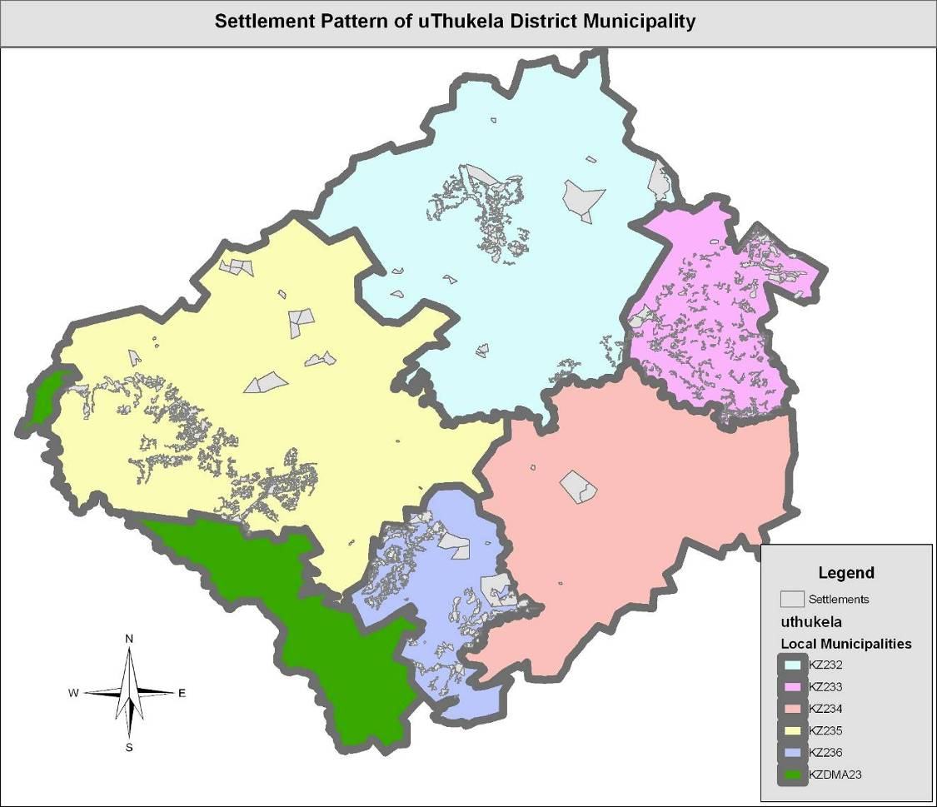
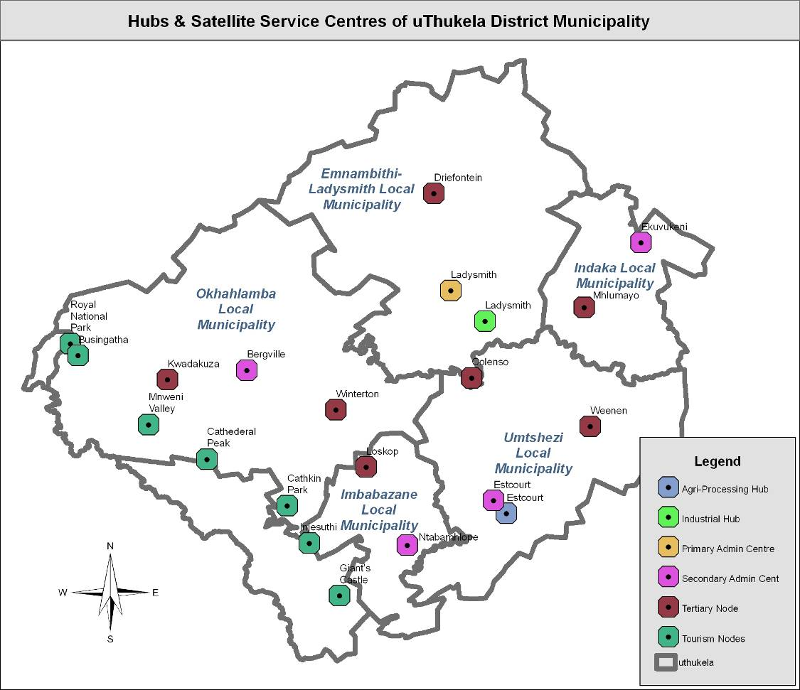
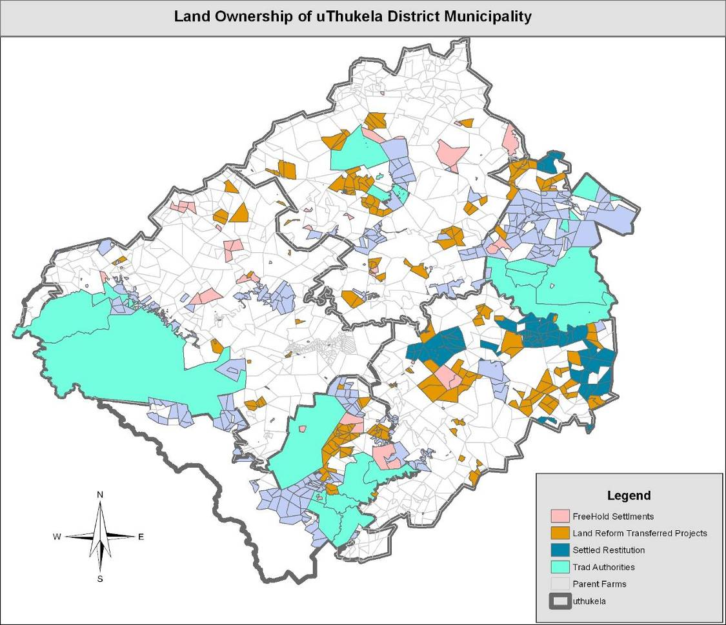
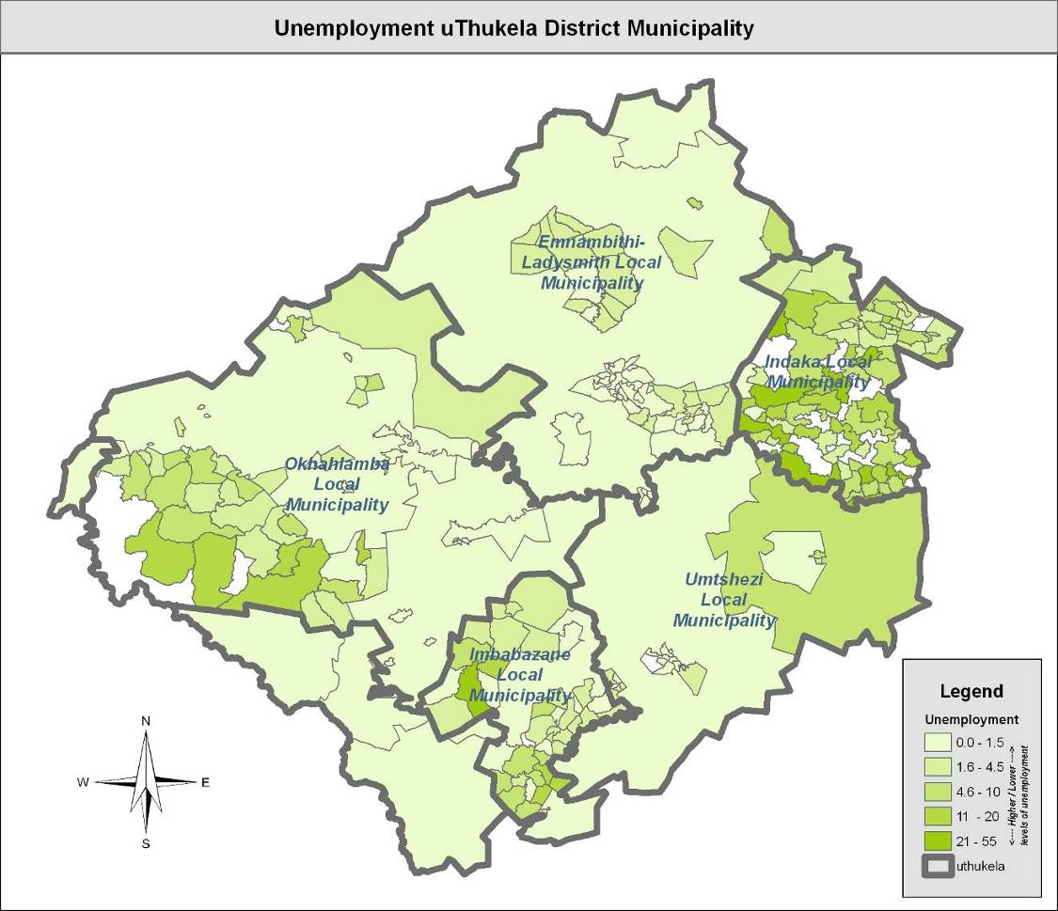
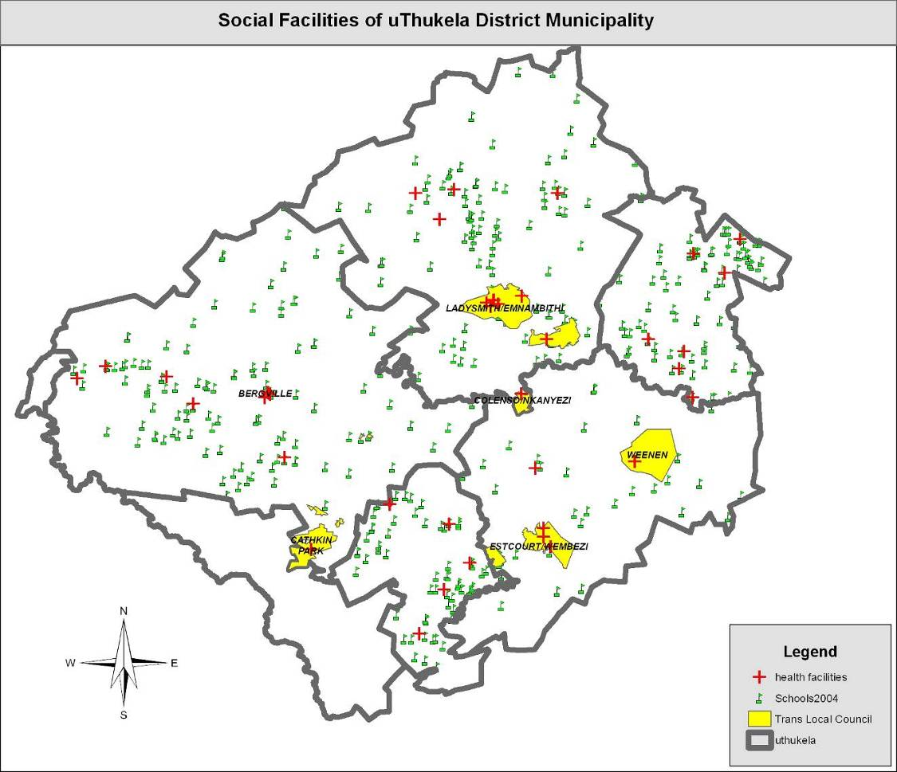
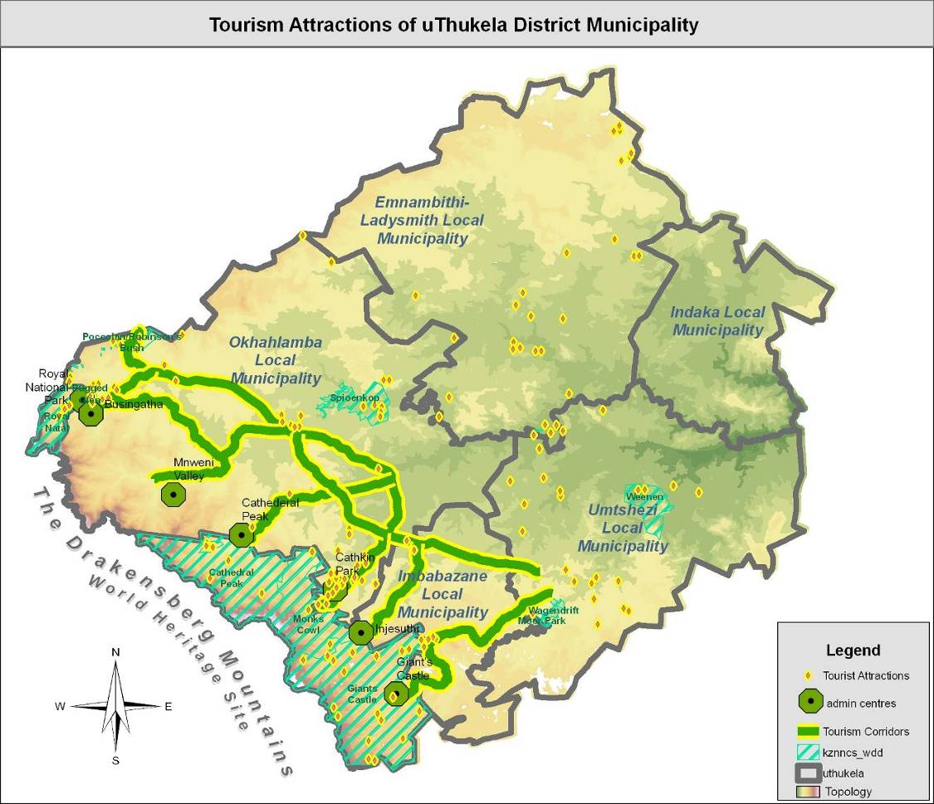

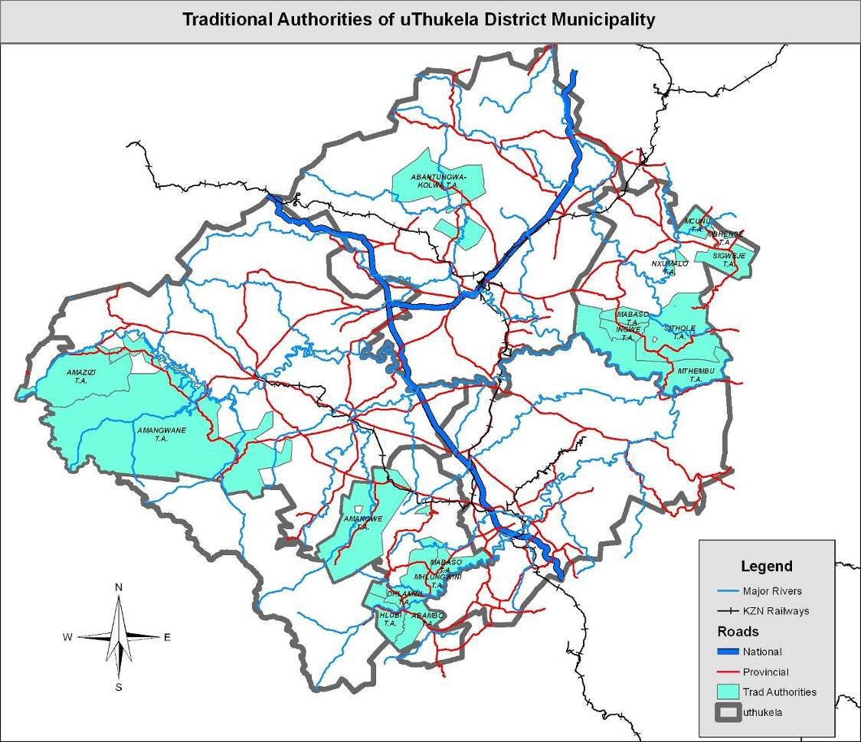
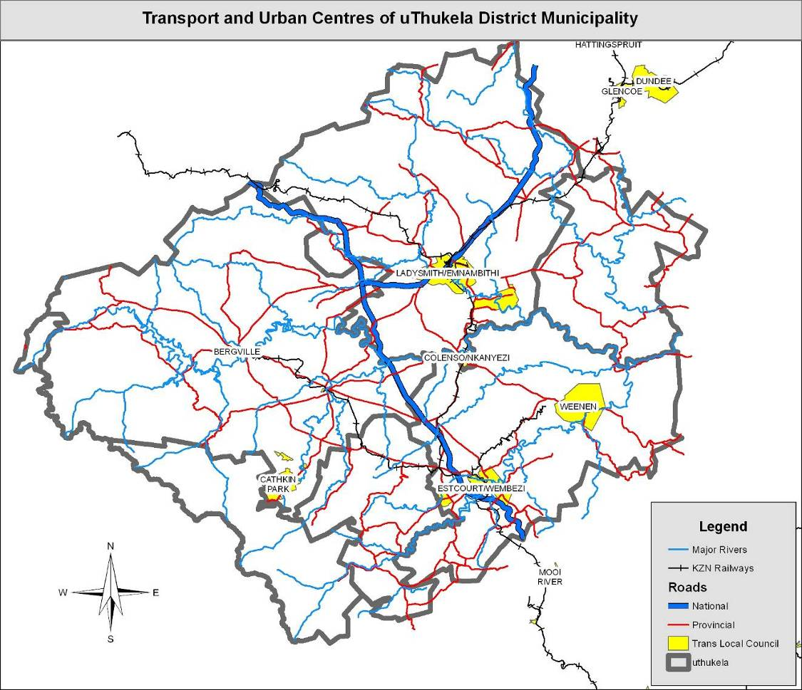

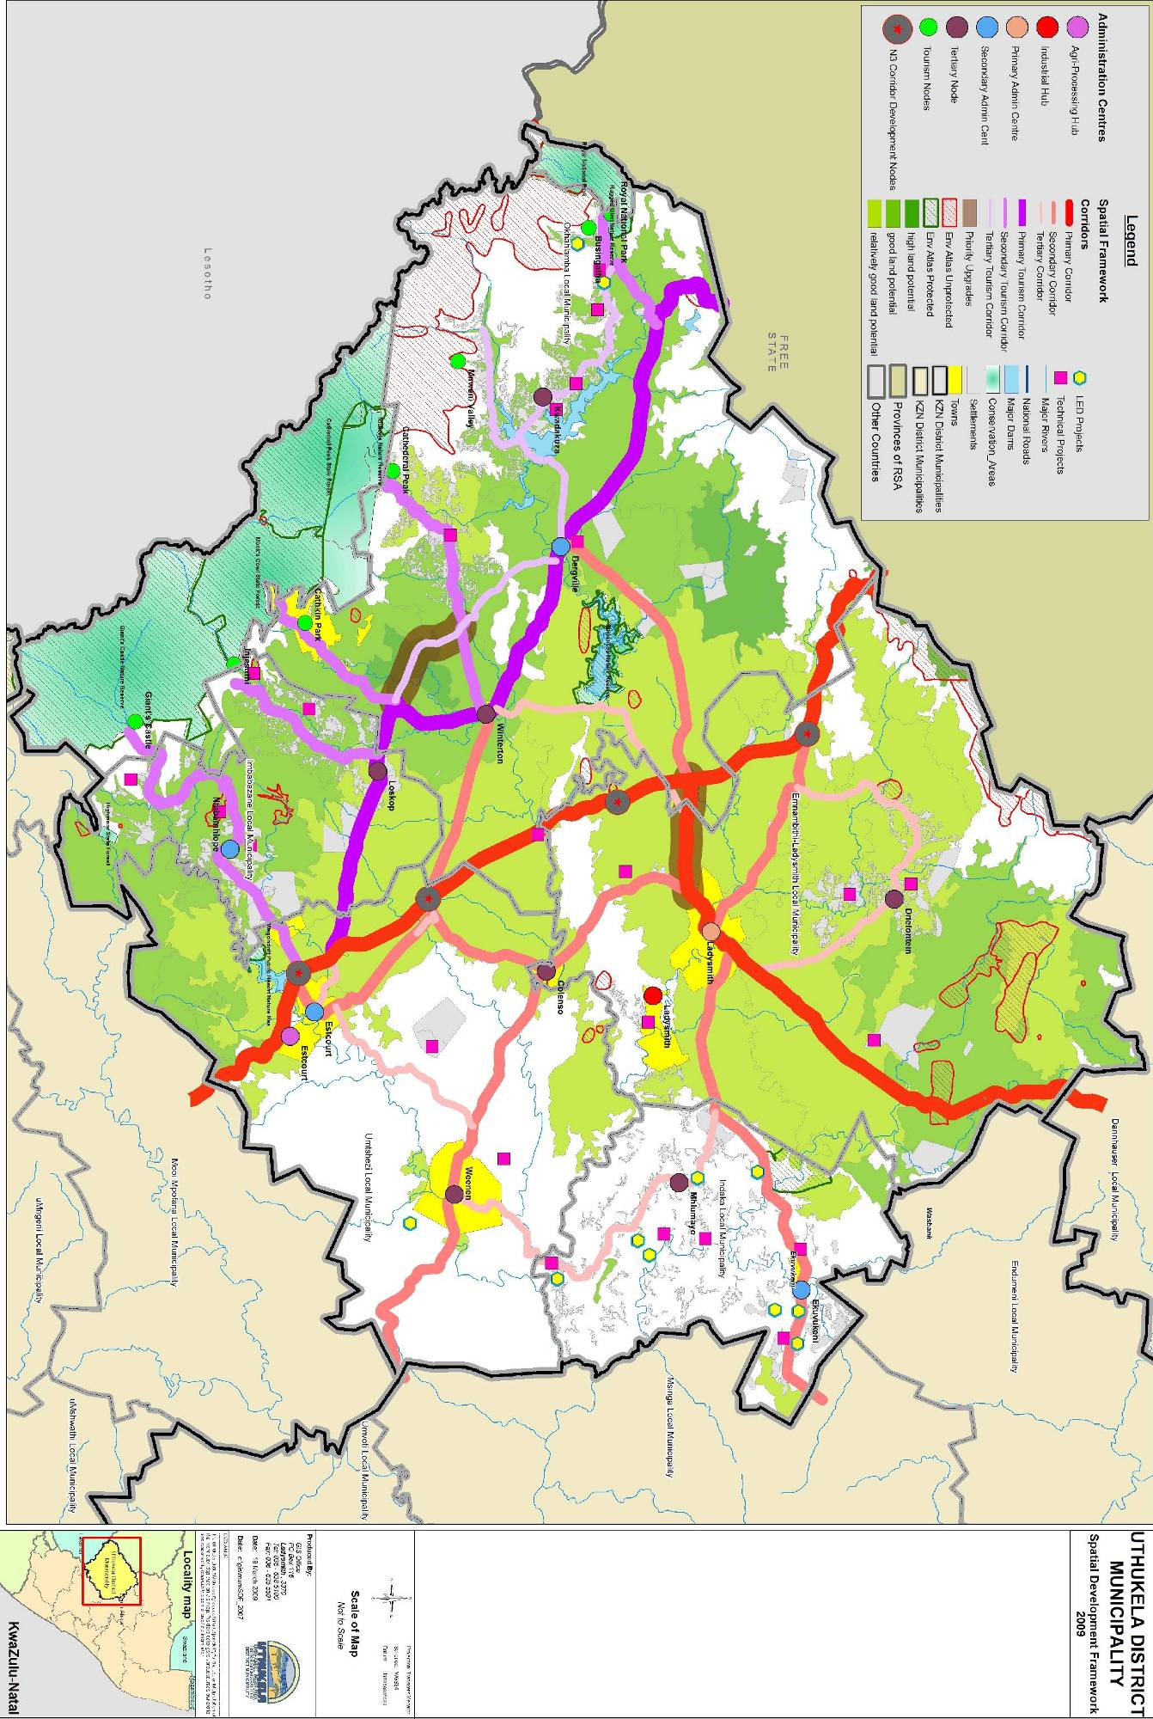

D1.1.2 SPATIAL ANALYSIS
uThukela District Municipality is predominantly rural in character with a dispersed rural settlement. Rural dense villages with a population of over 5,000 people are mostly found within the traditional areas of the Indaka and Imbabazane Local Municipalities. Both these Municipalities are characterised by very steep mountainous areas with limit opportunities for agricultural activities and creating difficulties in the provision of infrastructure.
Ladysmith and Estcourt are the two major towns and economic hubs within the uThukela District Municipality. Both Ladysmith and Estcourt are commercial centres for surrounding farming areas and serves as shopping centres for towns such as Bergville, which lacks a strong commercial presence. As Ladysmith is the economic and regional hub, the banking sector is service industry is prevalent. The town is further the industrial hub, with the majority if industries being located around Ladysmith. The only industrial estate in the District is also located a short distance from Ladysmith. Large areas of traditional land are located within uThukela, with about 35% of land classified as either “tribal” or peri-urban. A spatial analysis revealed that a large portion of degraded land is located in traditional areas. This is especially true in the Emnambithi, Indaka and Umtshezi Municipalities. The high propensity for soil erosion in these areas, coupled with land mismanagement, has contributed to this.

Indaka and Imbabazane has by far the largest share in traditional land, with areas as high as 83% being traditional land. As such, very little of the municipality’s land has been transferred through the land reform process. By comparison, the municipalities with the smallest percentage of traditional land, being Emnambithi and Umtshezi have also experienced the highest level of land reform. In terms of overall ownership, tribal lands and land reform areas account for about 40% of all land in uThukela.

There are two national routes, the N3 and N11, traversing the District, which forms a critical link between uThukela and provincial, national and international destinations. The Indaka and Imbabazane municipal areas are relatively isolated from these routes and can only be accessed via the provincial road network. The N3 traverses uThukela and form the connection between Durban and Gauteng. This route carries a vast amount of goods and passengers, with only a few filling stations along the route gaining economic benefit. The N11 is an alternative route from Ladysmith to Gauteng and Limpopo and forms an important route between Ladysmith and Newcastle located in the neighbouring Amajuba District Municipality. In line with Provincial Guidelines, tourism routes have been identified along the Drakensberg, linking areas such as Cathkin Park, Bergville, Winterton and the Northern Berg. The route has been expanded recently to include linkages to tourism nodes within the Drakensberg range.

D1.1.3 ALIGNMENT OF UTHUKELA SDF WITH LOCAL MUNICIPALITIES AND NEIGHBOURING DISTRICTS
uThukela District Municipality had a number of strategic meetings in aligning the SDF with Local Municipalities and uThukela District Municipality engages with neighbouring municipalities on cross border issues. The neighbouring districts which includes Amajuba, Umzinyathi, Umgungundlovu, Zululand District Municipalities, members of the uThukela family of municipalities had meetings on cross border alignment, where issues that are cross border development nature were discussed such as projects that have a service delivery impact across municipal boundaries like transport systems etc.Community facilities that are located close to municipal borders that have potential.

D1.1.4 ALIGNMENT OF SDF WITH NATIONAL SPATIAL DEVELOPMENT PERSPECTIVE (NSDP)
The NSDP is the initiative from the Office of the Presidency to reconfigure apartheid spatial relations and to implement spatial priorities that meet the constitutional imperative of providing basic services to all and alleviating poverty and inequality. To ensure that the SDF is talking to the NSDP, a workshop was held in March 2009 where sector departments, NGO’s, Chamber of Business were invited. In the workshop the service providers engaged with stakeholders in identifying the key driving forces and develop new scenarios for future development. The report of part 1and 2 was completed and it contains analysis of the District spatial and economic development.
In reviewing the uThukela SDF, the NSDP principles were taken into consideration.

The table below show the alignment between the NSDP Principles and uThukela District Municipality priority Focus
NSDP Principles UTDM IDP Priority Focus for 2010/2011
Rapid Economic Growth that is sustained and inclusive is a pre requisite for the achievement of other policy objectives, among which poverty alleviation | Economic Development
Government spending on fixed investment should be focused on localities of economic growth in order to gear up private-sector investment, to stimulate sustainable economic activities and create long term employment opportunities | Provision of sustainable infrastructure, water and sanitation services and backlog thereof. Coordination of social services
Efforts to address the past and current social inequalities should focus on people not places. In localities where there are high levels of poverty and demonstrated economic potential, this could include fixes capital investment beyond basic services to exploit the potential of those localities | Economic Development
Future settlement and economic development opportunities should channelled into activity corridors and nodes that link the main growth centre.Infrastracture investment should support localities that will be the major growth nodes in South Africa. | Economic Development and Spatial Development Framework
To provide basic service to all citizen wherever they reside | Provision of sustainable infrastructure, water and sanitation services and backlog thereof.

D1.1.5 ALIGNMENT OF SDF WITH PSEDS
The Provincial Spatial Economic Development Strategy (PSEDS) is built on the principles of the National Spatial Development Strategy (NSDP).uThukela Spatial Development Framework (SDF) is also focusing on the four key sectors identified as key drivers of the Economic Growth in the PSEDS.The key sectors are Agricultural, Tourism, Industrial and Service sectors. The SDF is aligned to PSEDS.
The PSEDP identifies nodes and activity corridors which would facilitate increased growth of existing centres & corridors of economic development, Ensure that the economic development potential in areas of high poverty levels and densities is realised.
The nodes in uThukela are prioritised as followed in the PSEDS:
Tertiary Node7 LADYSMITH
Quaternary Node1 BERGVILLE
Quaternary Node33 WEENEN
Quaternary Node34 WINTERTON
Secondary Corridor 8 UKHAHLAMBA
The overview of Potential per Economic sector in uThukela District Municipality are the following:
AGRICULTURE AND LAND REFORM
- Support land reform beneficiaries – Weenen & Winterton;
- Support for land reform cluster projects across uThukela – Besters, Ladysmith & Weenen(with special focus on maize and beef farming);

TOURISM
  - Battlefields routes: Development of linkages to benefit previously disadvantaged;
  - Drakensberg eco-tourism: Develop cultural tourism opportunities with bordering communities;
  - Improve tourism signage along Drakensberg fringe;
  - Improve state of access roads to tourist centres

INDUSTRY
- Emnambithi Industrial area: provision of world class infrastructure; and
- Provide adequate affordable housing and related services

SERVICES
- Plan Weenen to position for investment; and
- Provide adequate affordable housing and related services in towns.
D1.1.6 LAND USE MANAGEMENT SYSTEM
The main role of uThukela District Municipality is to give support and develop the LUMS Guidelines/Framework that assists the Local Municipalities in preparation of LUMS.In order to ensure that there is a sustainable development; the LUMS Framework considers the environmental conservation of resources. The all 5 local municipalities under uThukela have developed, reviewed and adopted their LUMS using the guidelines formulated by uThukela District Municipality. The challenge that faces local municipalities is the implementation of these LUMS.

D1.1.7 LUMS GUIDELINES/FRAMEWORK
Areas with High Agricultural Potential
No further development other than commercial agriculture.
- Department of Agriculture and Environmental Affairs must in writing commit their support to land reform projects within High Agricultural Potential land in order to deliver commercial and environmental sustainable land reform projects.
- Development subject to development application.

Areas with Good Agricultural Potential
- Agricultural theme to be continued, possibly in the form of Agri-tourism.
- Very Limited development in line with the SCAP and DAP.
- Development subject to development application.

Areas with Relatively Good Potential
- Limited development in line with the SCAP and DAP.
- Development subject to development application.

Areas remaining
- Development subject to development application.

Rivers

- No development within the 1:100 flood lines and where the integrity of a river bank may be compromised.
- Developments below a dam wall, must take cognisance of the dam failure flood line.
- No agricultural activity should take place closer than 20 metres from any river bank.

Wetlands

- Wetlands are important to environmental sustainability, water retention and filtration and flood mitigation and must be conserved as far as possible.
- No wetlands are to be converted or drained without approval from the Department of Agriculture and Environmental Affairs.

Dams

- No future settlements within the 1:100 year flood line and dam failure flood lines.
- Existing settlements should be encouraged to relocate outside of these flood lines.
- No development should be closer that 20m from the high-water mark of any unprotected dam, until such time as the Disaster Management Plan identifies settlements that are at risk of being flooded.

Environmental

- Cognisance should be taken regarding the unprotected areas.
- Further investigation by the local LUMS is required in these identified areas.

Settlements

- Local LUMS should aim to increase the density of rural and urban settlements.
- Local LUMS should aim to address spatial segregation, particulate in housing delivery by identifying suitable areas for low-income housing.
- Local LUMS should identify the need for expansion of towns and indicate areas for future growth.
- Settlement service provision should followed RSS guidelines.

Roads

- Settlement service provision should followed RSS guidelines.
- N11 should be maintained as a primary access route in order to increase the benefit to Ladysmith.
- Upgrade of the gravel road between Emmaus and Loskop to accommodate tourism developments.
- Maintenance of a good standard of roads to tourism nodes.
- Upgrading of the road between Ladysmith and Bergville toll plaza is absolutely essential as it is an important link to the N3.
- Local LUMS to investigate P294 from the N3 to Winterton as it may have a benefit for tourism.
- The table below is an indication of the access road standard to the various settlement categories

Table: Access Road Standard
Type of service | Hub | Primary Settlement | Secondary Settlement | Tertiary Settlement | Smallest
Access Roads | Tar | Gravel good | Gravel Good | Good condition | Accessible

Proposed Standards

Five Classifications of Primary Health Care facilities were identified:

a) Mobile Clinics –to reach the most isolated people in the rural areas.
b) Clinics – to serve areas of approximately an eight kilometre radius, providing a five day per week service and catering for a population of about 10,000 people.
c) Community Health Centres - provides a 24-hour service.
d) Regional Gate Clinics – located within the premises of the hospitals, staffed by nurses who refer patients to a doctor if unable to assist.
e) Regional Hospitals – provide a 24-hour service.

Settlement Hierarchies

The following two tables provide some guidance towards the classification of settlement types and service standards.

Table: uThukela Settlement Hierarchies
Level | Type | Approximate Population
1 | Hub | More than 15 000
2 | Primary Settlement | 7 000 - 15 000
3 | Secondary Settlement | 4 000 – 7 000
4 | Tertiary Settlement | 1 000 – 4 000
5 | Smallest | Less than 1000

Table: Service Standards
Type of service | Hub | Primary Settlement | Secondary Settlement | Tertiary Settlement | Smallest
Population | District Service Area | 15,000 | 7,000 | 4,000 | 1,000 and less
Education | High School/  FET System | High School | Grade 10 | Grade 8 | Grade 7
Crèches | No. of Crèches | No. of Crèches
Health | Hospital | 24-hour Clinic | Clinic | Mobile Clinic | Mobile Clinic
Housing | Priority Scheme | Scheme | Community Driven | Community Driven | Community Driven
Postal | Post Net | Post Boxes | Post Boxes
Police | Station | Satellite Station | Mobile Service | Mobile Service
Access Roads | Tarred Access | Gravel good | Gravel Good | Good condition | Accessible
Community Halls | Multi purpose | Community hall to serve large area | Community Hall
Sport | District Facility | Medium size | Small
Taxi Rank | With Hawker stalls and ablution | Small | Small
Telephones | Public phones at MPCC | Public Phones | Public phone at core | Community Driven | Community Driven
MPCC | MPCC | Satellites to MPCC
Business Centres | Well developed | Small | LED core | LED core | LED core
Pension Point | Community Hall | Community Hall | Community Hall | Shelter and Ablution
Cemeteries | Regional variety of facilities | District facility | Local facility | Local facility | Use facilities at tertiary web
Emergency Services | Service Centres | Satellite | Communication Point

SECTION E SECTOR INVOLVEMENT
E1.1.1 INTRODUCTION
In the previous IDP, uThukela was using the IDP Service Providers Forum in getting the information and planning together but it was not effective because of inconstancy of attending meeting. In this financial year which is 2010/2011 uThukela District Municipality had come up with another strategy of engaging the sector departments on one on one basis. The challenge that came from the discussion between uThukela District Municipality and sector departments was the different budgeting cycles between local government and Provincial Government. In engaging the sector departments, most of them indicated that they will only be having their programmes/projects with budgets in April 2010.When we engage them after April nothing was provided to the municipality.
The following are the sector departments that forwarded their programmes for 2010/2011 financial year:
E1.1.2 Department of Arts and Culture
UTHUKELA DM | Project/Programme Details ( per LM) | Project Cost  Actual and Expenditure | Ward /Area where project will be implemented | Project Start Period | Project Status
Emnambithi LM | Support to Arts and Culture Forum. | R4 000.00 | All Wards | 2008 | Ongoing
Emnambithi LM | Establish and support War on Poverty Cadres | R5 000.00 | All Wards | Nov 2009 | Ongoing
Emnambithi LM | Support/facilitation of multicultural projects | R14 000.00 | All wards | 2010 | Planned
Emnambithi LM | Moral Regeneration Programme – focusing on Women, youth and disabled | R8 250.00 | All wards | 2010 | Planned
Emnambithi LM | Visual Arts and Craft Promotion  (Access to LM & District exhibition platforms) | R6 000.00 | All wards | 2010 | Ongoing
Emnambithi LM | Hip-Hop, Story Telling & Kwaito eliminations | R10 000.00 | All wards | 2010 | Planned
Emnambithi LM | Non- Accredited Skills Training (Visual Arts, Craft & Performing Arts Training) | R40 000.00 | All wards | 2010 | Planned
Emnambithi LM | Participation in uThukela Community Arts Festival | R22 000.00 | All wards | 2010 | Planned
Emnambithi LM | Performing Arts Promotion | R55 467.00 | All wards | 2010 | Ongoing
Emnambithi LM | Providing platform & market to visual Artists, Crafters & Performers | R10 000.00 | All wards | 2010 | Planned
Okhahlamba LM | Support to Arts and Culture Forum. | R4 000.00 | All Wards | 2008 | Ongoing
Okhahlamba LM | Establish and support War on Poverty Cadres | R5 000.00 | All Wards | Nov 2009 | Ongoing
Okhahlamba LM | Support/facilitation of multicultural projects | R17 250.00 | All wards | 2010 | Planned
Okhahlamba LM | Moral Regeneration Programme – focusing on Women, youth and disabled | R8 250.00 | All wards | 2010 | Planned
Okhahlamba LM | Visual Arts and Craft Promotion  (Access to LM & District exhibition platforms) | R6 000.00 | All wards | 2010 | Ongoing
Okhahlamba LM | Hip-Hop, Story Telling & Kwaito eliminations | R7 500.00 | All wards | 2010 | Planned
Okhahlamba LM | Non- Accredited Skills Training (Visual Arts, Craft & Performing Arts Training) | R16 250.00 | All wards | 2010 | Planned
Okhahlamba LM | Participation in uThukela Community Arts Festival | R22 000.00 | All wards | 2010 | Planned
Okhahlamba LM | Performing Arts Promotion | R15 250.00 | All wards | 2010 | Ongoing
Okhahlamba LM | Providing platform & market to visual Artists, Crafters & Performers | R10 000.00 | All wards | 2010 | Planned
Imbabazane LM | Support to Arts and Culture Forum. | R4 000.00 | All Wards | 2008 | Ongoing
Imbabazane LM | Establish and support War on Poverty Cadres | R5 000.00 | All Wards | Nov 2009 | Ongoing
Imbabazane LM | Support/facilitation of multicultural projects | R172 500.00 | All wards | 2010 | Planned
Imbabazane LM | Moral Regeneration Programme – focusing on Women, youth and disabled | R8 250.00 | All wards | 2010 | Planned
Imbabazane LM | Visual Arts and Craft Promotion  (Access to LM & District exhibition platforms) | R6 000.00 | All wards | 2010 | Ongoing
Imbabazane LM | Hip-Hop, Story Telling & Kwaito eliminations | R7 500.00 | All wards | 2010 | Planned
Imbabazane LM | Non- Accredited Skills Training (Visual Arts, Craft & Performing Arts Training) | R16 250.00 | All wards | 2010 | Planned
Imbabazane LM | Participation in uThukela Community Arts Festival | R22 000.00 | All wards | 2010 | Planned
Imbabazane LM | Performing Arts Promotion | R15 250.00 | All wards | 2010 | Ongoing
Imbabazane LM | Providing platform & market to visual Artists, Crafters & Performers | R10 000.00 | All wards | 2010 | Planned
Umtshezi LM | Support to Arts and Culture Forum. | R4 000.00 | All Wards | 2008 | Ongoing
Umtshezi LM | Establish and support War on Poverty Cadres | R5 000.00 | All Wards | Nov 2009 | Ongoing
Umtshezi LM | Support/facilitation of multicultural projects | R17 250.00 | All wards | 2010 | Planned
Umtshezi LM | Moral Regeneration Programme – focusing on Women, youth and disabled | R10 000.00 | All wards | 2010 | Planned
Umtshezi LM | Visual Arts and Craft Promotion  (Access to LM & District exhibition platforms) | R16 250.00 | All wards | 2010 | Ongoing
Umtshezi LM | Hip-Hop, Story Telling & Kwaito eliminations | R7 500.00 | All wards | 2010 | Planned
Umtshezi LM | Non- Accredited Skills Training (Visual Arts, Craft & Performing Arts Training) | R10 000.00 | All wards | 2010 | Planned
Umtshezi LM | Participation in uThukela Community Arts Festival | R22 000.00 | All wards | 2010 | Planned
Umtshezi LM | Performing Arts Promotion | R15 250.00 | All wards | 2010 | Ongoing
Umtshezi LM | Providing platform & market to visual Artists, Crafters & Performers | R10 000.00 | All wards | 2010 | Planned
I Indaka LM | Support to Arts and Culture Forum. | R4 000.00 | All Wards | 2008 | Ongoing
I Indaka LM | Establish and support War on Poverty Cadres | R5 000.00 | All Wards | Nov 2009 | Ongoing
I Indaka LM | Support/facilitation of multicultural projects | R17 250.00 | All wards | 2010 | Planned
I Indaka LM | Moral Regeneration Programme – focusing on Women, youth and disabled | R8 250.00 | All wards | 2010 | Planned
I Indaka LM | Visual Arts and Craft Promotion  (Access to LM & District exhibition platforms) | R6 000.00 | All wards | 2010 | Ongoing
I Indaka LM | Hip-Hop, Story Telling & Kwaito eliminations | R7 500.00 | All wards | 2010 | Planned
I Indaka LM | Non- Accredited Skills Training (Visual Arts, Craft & Performing Arts Training) | R16 250.00 | All wards | 2010 | Planned
I Indaka LM | Participation in uThukela Community Arts Festival | R22 000.00 | All wards | 2010 | Planned
I Indaka LM | Performing Arts Promotion | R15 250.00 | All wards | 2010 | Ongoing
I Indaka LM | Providing platform & market to visual Artists, Crafters & Performers | R10 000.00 | All wards | 2010 | Planned

E1.1.3 PUBLIC WORKS
Programme | Sub-Programme | Project Name | Local Municipality | Total Project Budget over multiple financial years (‘000) | Completion Date | 2009/10 Financial Year Allocation (‘000) | 2010/11 (‘000)
 |  |  |  | R 417,715,000 |  | R 33,829,008 | R 117,764,000
District Hospitals | Upgrades & Additions | Estcourt Replacements Clinic | KZ234 | R 12,000,000 | R 0 | R 0 | R 0
District Hospitals | Upgrades & Additions | Bergville Clinic | KZ235 | R 10,000,000 | R 0 | R 0 | R 0
District Hospitals | Upgrades & Additions | Cornfields Clinic | KZ234 | R 425,000 | 10-Aug-09 | R 325,000 | R 100,000
District Hospitals | Upgrades & Additions | Estcourt Hospital | KZ234 | R 129,100,000 | 16-Sep-13 | R 500,000 | R 29,500,000
District Hospitals | Upgrades & Additions | Emmaus Hospital | KZ235 | R 18,000,000 | 15-Jan-13 | R 250,000 | R 11,000,000
District Hospitals | Upgrades & Additions | Estcourt Hospital | KZ234 | R 81,105,000 | 23-Apr-12 | R 400,000 | R 28,300,000
Auxilialy Services | Office Accomodation | Ladymith District Office | KZ232 | R 3,000,000 | 22-May-12 | R 250,000 | R 2,400,000
District Hospitals | Upgrades & Additions | Estcourt Hospital | KZ234 | R 685,000 | 04-Aug-09 | R 685,000 | R 0
Regional Hospitals | Upgrades & Additions | Emmaus Hospital | KZ235 | R 98,660,000 | 18-Mar-13 | R 4,000,000 | R 34,378,000
District Hospitals | Upgrades & Additions | Wembezi Clinic | KZ234 | R 2,200,000 | 30-Nov-08 | R 99,000
District Hospitals | Upgrades & Additions | Ezakheni E Clinic | KZ232 | R 1,102,000 | 30-Nov-09 | R 167,000 | R 0
District Hospitals | Upgrades & Additions | Ladysmith Hospital | KZ232 | R 1,120,000 | 26-Aug-09 | R 384,000 | R 0
District Hospitals | Upgrades & Additions | Sgweje Clinic | KZ233 | R 10,500,000 | 03-Jun-11 | R 3,637,000 | R 6,230,000
Clinics | Repairs & Renovations | Gcinalishone Clinic | KZ233 | R 1,200,000 | 25-Sep-09 | R 1,169,000 | R 0
District Hospitals | Upgrades & Additions | Estcourt Hospital | KZ234 | R 9,330,000 | 19-Apr-11 | R 3,890,000 | R 4,648,000
District Hospitals | Upgrades & Additions | Ekuvukeni Clinic | KZ233 | R 3,522,000 | 05-May-12 | R 3,000,000 | R 137,000
District Hospitals | Upgrades & Additions | Ncibidwane Clinic | KZ233 | R 8,812,000 | 27-Sep-09 | R 2,727,800 | R 203,000
District Hospitals | Upgrades & Additions | Mazizini Clinic | KZ235 | R 1,250,000 | 15-Aug-09 | R 199,000 | R 0
District Hospitals | Upgrades & Additions | Ezakheni 2 Clinic | KZ232 | R 4,638,000 | 08-Mar-10 | R 3,380,000 | R 208,000
District Hospitals | Upgrades & Additions | KwaMteyi Clinic | KZ233 | R 1,829,000 | 22-Feb-10 | R 1,375,000 | R 60,000
District Hospitals | Upgrades & Additions | Ladysmith Hospital | KZ232 | R 9,970,000 | 15-Jun-09 | R 2,710,000 | R 400,000
District Hospitals | Upgrades & Additions | Ladysmith Hospital | KZ232 | R 6,776,000 | 14-Dec-09 | R 3,700,208 | R 200,000
District Hospitals | Upgrades & Additions | Watersmeet Clinic | KZ232 | R 1,222,000 | 26-Jun-09 | R 890,000 | R 0
District Hospitals | Upgrades & Additions | Kleinfontein Clinic | KZ232 | R 1,269,000 | 08-Dec-08 | R 91,000 | R 0
 |  |  |  | R 417,715,000 |  | R 33,829,008 | R 117,764,000

E.1.1.4 DEPARTMENT OF HUMAN SETTLEMENTS
2010 - 2011 - 2012 MTEF
PROJECT NAME | LOCAL MUNICIPALITY | PROJECT STATUS | TOTAL UNITS | 2011/12 BUDGET | 2012/13 BUDGET
Colenso dyce | Emnambithi | Top Structure | 300 | 2,000,000 | 6,544,700
Thembalihle Steadville | Emnambithi | Planning | 500 |  | 5,100,000
Colenso Ntokozweni | Emnambithi | Planning | 205 | 850,000 | 3,400,000
Ezakheni B & C Tin Houses | Emnambithi | Preparation Funding | 1,000 |  | 0
Ezakheni E | Emnambithi | Preparation Funding | 300 |  | 3,400,000
St Chads Urban Institu Upgrade | Emnambithi | Top Structure | 2,500 | 14,715,000 | 14,535,000
Umbulwane Area Uthukela | Emnambithi | Top Structure | 560 | 5,900,000 | 5,745,000
Steadville Area J | Emnambithi | Planning | 914 |  | 0
Steadville Area E | Emnambithi | Services | 175 |  | 0
Ingodini | Umtshezi | Top Structure | 500 |  | 0
Wembezi C Ph 3 | Umtshezi | Top Structure | 500 |  | 2,575,000
Mimosadale Ph 2 | Umtshezi | Planning | 500 |  | 3,445,000
Rensburgdrift | Umtshezi | Planning | 1,000 |  | 1,700,000
Owl and Elephant | Umtshezi | Top Structure | 400 |  | 0
Ephangweini | Imbabazane | Top Structure | 1,000 | 1,745,000 | 14,192,000
Mqedendaba | Imbabazane | Top Structure | 1,000 | 6,000,000 | 11,800,000
Good Home | Imbabazane | Top Structure | 1,000 | 15,000,000 | 13,500,000
Loch Sloy 1 | Imbabazane | Planning | 500 | 8,940,000 | 8,090,000
Loch Sloy 2 | Imbabazane | Planning | 500 | 9,862,000 | 4,400,000
Sobabili | Imbabazane | Top Structure | 1,000 | 18,000,000 | 156,000,000
Zwelisha Craig | Imbabazane | Planning | 700 | 5,000,000 | 0
Kwahlathi | INDAKA | Planning | 1,000 | 11,000,000 | 11,000,000
Mhlumayo | INDAKA | Planning | 1,000 | 13,750,000 | 5,500,000
Sahlumbe | INDAKA | Services | 800 | 16,500,000 | 16,500,000
Uitval | INDAKA | Services/ Top Structure | 1,000 | 2,150,000 | 10,750,000
Vaalkop | INDAKA | Top Structure | 600 |  | 850,000
Action Homes | Okhahlamba | Planning | 1,000 | 1,632,000 | 8,340,000
Amazizi 1 | Okhahlamba | Top Structure | 1,000
Amazizi 2 | Okhahlamba | Top Structure | 1,000
Gugulethu | Okhahlamba | Top Structure | 500
Nhlanhleni Bergivlle | Okhahlamba | Planning | 510
Winterton Khethani Ph 2 | Okhahlamba | Top Structure | 503
Winterton Khethani Ph 3 | Okhahlamba | Top Structure | 500

SECTION F IMPLEMENTATION PLAN
Three year Implementation of uThukela District Municipality with Committed Human and Financial Resources
 |  | ESTIMATED
EXPENDITURE | BUDGET | ACTUAL | BUDGET | BUDGET | BUDGET
 | 2009/2010 | 2009/2010 | 2010/2011 | 2011/2012 | 2012/2013
MUNICIPAL GOVERNANCE ANDADMINISTARATION
Affirmative Action | 0 | 17,465 | 0 | 0 | 0
Job Creation | 54,000 | 34,929 | 0 | 0 | 0
Ongoing training and capacity building | 20,000 | 0 | 0 | 0 | 0
COMMINITY & PUBLIC SAFETY
Uthukela District Associations (SAFA) SPORTS | 600,000 | 223,750 | 0 | 0 | 0
Kwanaloga Game SPORTS | 2,900,000 | 2,107,553 | 0 | 0 | 0
Promotion of Sport SPORTS | 700,000 | 505,000 | 4,000,000 | 4,240,000 | 4,494,400
Arts, Culture and Music OTHER SOCIAL | 1,000,000 | 299,000 | 0 | 0 | 0
Youth And Gender Development SPORTS | 300,000 | 300,000 | 1,000,000 | 1,060,000 | 1,123,600
Gender Programs OTHER SOCIAL | 330,000 | 227,500 | 0 | 0 | 0
Mayoral Cup SPORTS | 700,000 | 689,511 | 0 | 0 | 0
Educational Support Activities | 440,000 | 439,954 | 0 | 0 | 0
Elderly Persons Program AGE CARE | 210,000 | 0 | 200,000 | 212,000 | 224,720
Disability Programs OTHER SOCIAL | 150,000 | 6,000 | 300,000 | 318,000 | 337,080
Youth Day CHILD CARE | 300,000 | 0 | 0 | 0 | 0
ECONOMIC AND ENVIRONMENTAL SERVICES
Social Economic Activities ECONOMIC DEVELOPMENT | 1,500,000 | 1,136,328 | 0 | 0 | 0
LED Program | 2,600,000 | 1,288,889 | 2,000,000 | 2,120,000 | 2,247,200
Local Economic Development Support | 0 | 0 | 0 | 0 | 0
Integrated Development Plan | 20,000 | 6,137 | 0 | 0 | 0
Performance Management System PERFORMANCE MANAGEMENT | 100,000 | 106,000 | 0 | 0 | 0
SECURITY WATER
Uthukela Civil Defence / Security Contract | 7,300,000 | 7,161,384 | 7,200,000 | 7,632,000 | 8,089,920
FINANCE COLLECTION COSTS
Credit Control Road Shows & Implementation | 150,000 | 72,223 | 700,000 | 742,000 | 786,520
Data Cleansing | 0 | 0 | 1,400,000 | 1,484,000 | 1,573,040
COMMUNITY AND PUBLIC SAFETY
Community consultation meetings on Service Delivery | 0 | 0 | 0 | 0 | 0
MUNICIPAL GOVERNANCE AND ADMINISTRATION
Upgrade IT System (Munsoft) | 150,000 | 16,053 | 600,000 | 636,000 | 674,160
Monitoring of IT Service Provider | 0 | 0 | 2,000,000 | 2,120,000 | 2,247,200
Maintenance Network Infrastructure | 315,000 | 28,515 | 0 | 0 | 0
Computer Network, Hardware Plus UPS | 300,000 | 104,741 | 0 | 0 | 0
CORPORATE SERVICES - CONTRACTED SERVICES
Review & Implement Employment Equity Plan | 30,000 | 0 | 0 | 0 | 0
Review & Implement District Workplace Skills Plan | 40,000 | 0 | 300,000 | 318,000 | 337,080
PROJECTS - INHOUSE FUNDED
Mgazini Water Project | 200,000 | 212,000 | 0 | 0 | 0
Kwanomoya Water Project | 200,000 | 212,000 | 0 | 0 | 0
Ncunjane Water Project | 200,000 | 212,000 | 0 | 0 | 0
Land Purchase | 0 | 0 | 0 | 0 | 0
Counter Funding - Projects | 0 | 0 | 0 | 0 | 0
Infrastructural Development | 4,300,000 | 3,654,277 | 0 | 0 | 0
ESTABLISHMENT COSTS - PROJECTS
IT And Establishment Cost - New Building | 0 | 0 | 6,263,374 | 6,639,176 | 7,037,527
OPERATIONAL FINANCE - FINANCIAL REFORMS
Asset Verification | 0 | 0 | 1,200,000 | 1,272,000 | 1,348,320
Supply Chain Management | 20,000 | 0 | 0 | 0 | 0
Reviewable of Financial Policies | 40,000 | 40,000 | 150,000 | 159,000 | 168,540
GRAP/GAMAP Compliance | 200,000 | 45,860 | 400,000 | 424,000 | 449,440
Fleet Management | 0 | 0 | 0 | 0 | 0
MPRA Implementation | 0 | 0 | 0 | 0 | 0
OPERATIONAL - PROJECTS
Pre-Paid Meters | 0 | 0 | 6,000,000 | 6,360,000 | 6,741,600
GRAND TOTAL | 25,369,000 | 19,147,069 | 33,713,374 | 35,736,176 | 37,880,347

 | IMPLEMENTATION OF MIG PROJECTS 3-YEAR CASHFLOW
 | Financial year | 2010/2011
Agent | MIG NO. | Project Name | MOA | Balance
 |  |  |  | Annual Allocation
DC23 | 2006MIGFDC230015 | Ekuvukeni Taxi Rank | 915,575 | 297,754.00
DC23 | 2006MIGFDC23111829 | Moyeni/zwelisha RWSS Phase4(Dukuza/hoffental) | 56,013,762 | 21,473,466.94
DC23 | 2006MIGFDC23112081 | Driefontein Complex Bulk Water Supply | 126,101,362.00 | 59,856,031.49
DC23 | 2006MIGFDC23113342 | Bergville Bulk Water Supply | 24,362,664.00 | 9,211,033.22
DC23 | 2006MIGFDC23114101 | Waters meet Sanitation Phase 2 | 19,020,495.00 | 1,321,836.59
DC23 | 2006MIGFDC23114315 | Indaka Bulk Water Audit | 498,038.00 | 498,038.00
DC23 | 2006MIGFDC23117245 | KwaHlathi Sanitation | 15,142,933.00 | 3,162,672.36
DC23 | 2008MIGFDC23160811 | Ntabamhlophe Water Supply Scheme Phase 4-13 | 70,891,154.00 | 64,067,209.64
DC23 | 2008MIGFDC23162167 | Fitty Park Umhlumayo Extension | 15,700,000.00 | 14,526,202.30
DC23 | 2008MIGFDC23165442 | Jononoskop Sanitation | 11,460,350.00 | 198,045.00
DC23 | 2008MIGFDC23178832 | Emcitsheni Sanitation Phase2 | 18,036,858.00 | 8,853,328.00

SECTION G PROJECTS
G1.1.1 ONE YEAR OPERATIONAL PLAN
FINANCE
NAME OF PROJECT | ESTIMATED BUDGET | FUNDER | FINANCIAL YEAR
Credit Control Roadshow | R700 000 | UTDM | 2010/2011
Budget / IDP participation | R2 100 000 | UTDM | 2010/2011
Data cleansing | R1 400 000 | UTDM | 2010/2011
Interns | R500 000 | MSIG | 2010/2011
GRAP/GAMAP Implementation | R400 000 | UTDM | 2010/2011
Assets verification | R1 200 000 | UTDM | 2010/2011
Pre-paid meters | 6000 000 | (DBSA) | 2010/2011
Review of Financial Policies | R150 000 | UTDM | 2010/2011
Implementation of additional Munsoft modules i.e. Supply Chain and Credit Control | R600 000 | UTDM | 2010/2011
Establishment Cost | 6 263 374 | UTDM | 2010/2011
HEALTH AND ENVIRONMENTAL SERVICES
NAME OF PROJECT | ESTIMATED BUDGET | FUNDER | FINANCIAL YEAR
Implementation of HIV/AIDS Strategy | R500 000.00 | uThukela DM | 2010/2011
Conducting Strategic Environmental Assessment | R300 000.00 | uThukela DM | 2010/2011
Implementation of Air Quality Management Plan | R200 000.00 | uThukela DM | 2010/2011
Implementation of Water Conservation Strategy | R100 000.00 | uThukela DM | 2010/2011
Hhealth Promotion | R500 000.00 | uThukela DM | 2010/2011

STRATEGIC PLANNING AND ECONOMIC DEVELOPMENT
NAME OF PROJECT | ESTIMATED BUDGET | FUNDER | FINANCIAL YEAR
Review, enhance, engage and create LED, SMME and Business Retention Forums (BRF) | Operational | UTDM | 2010/2011
Engage infrastructure provision meetings | Operational | UTDM | 2010/2011
Develop SMME Policy | Operational | UTDM | 2010/2011
As identified in the LED Plan | R2000 000 | UTDM | 2010/2011
Review Tourism Plan | Operational | UTDM | 2010/2011
Engagement with Tourism Structures | Operational | UTDM | 2010/2011
Review of the marketing opportunities within the District | Operational | UTDM | 2010/2011
Review of the marketing opportunities within the District | R350 000 | UTDM | 2010/2011
Monitoring of the IT Service Provider | R2,000,000 | UTDM | 2010/2011
Environmental Economic Study | Grant | COGTA | 2010/2011
Review of the youth, women and people with disabilities programmes | R1000 000 | UTDM | 2010/2011
Review Terms of Reference and members of the gender working committee | Operational | UTDM | 2010/2011
Implementation of the Sports Programme | R1 200 000 | UTDM | 2010/2011
Implementation of the physically challenged Programme | R300 000 | UTDM | 2010/2011
Implementation of the senior citizen Programme | R200 000 | UTDM | 2010/2011
WATER SERVICES
NAME OF PROJECT | ESTIMATED BUDGET | FUNDER | FINANCIAL YEAR
Bulk meter installation at extraction and exit points of WTP |  | UTDM | 2010/2011
Bulk meter installation at reticulation zones |  | UTDM | 2010/2011
WTP and WWTP Compliance |  | UTDM | 2010/2011
Reservoir maintenance/refurbishment |  | UTDM | 2010/2011
Upgrade of Raw Water Pumps at the Ezakheni WTP | R4 m | DWAE | 2010/2011
Refurbishment of Spieonkop and George Cross Pumps |  | UTDM | 2010/2011
Implementation of a telementary system across the district |  | UTDM | 2010/2011

CORPORATE SERVICES
NAME OF PROJECT | ESTIMATED BUDGET | FUNDER | FINANCIAL YEAR
Review and Implement the Disaster Management Plan | R300 000 | UTDM | 2010/2011
Firefighting equipment | 400 000 | UTDM | 2010/2011
Disaster Management Centre |  | UTDM | 2010/2011
Disaster Management Advisory Forum | R100 000 | UTDM | 2010/2011
Review and implement the District workplace skills Plan | R300 000 | UTDM | 2010/2011

COMMUNICATIONS
NAME OF PROJECT | BUDGET | FUNDER | F/YEAR
Radio ukhozi slot | 500 000 | UTDM | 2010/2011
Mayoral izimbizo | 2000 000 | UTDM | 10/11
Communications/newsletter/Magazine | 600 000 | UTDM | 10/11
Stipend community workers | 300 000 | UTDM | 10/11

G1.1.2 SANITATION PROJECTS WITHOUT FUNDING

Name of project | Local Municipality | Ward | Status
Mathondwane sanitation | Emnambithi | 17 | No funding
Kleinfontein | Emnambithi | 19 | No funding
Peacetown | Emnambithi | 15 | No funding
Burford | Emnambithi | 14 | No funding
Driefontein | Emnambithi | 13, 18 | No funding
Inkunzi | Emnambithi | 24 | No funding
KwaMthandi | Emnambithi | 20 | No funding
Weenen | Umtshezi | 5, 7 | No funding
Thembalihle | Umtshezi | 4 | No funding
Umtshezi | Umtshezi | 3 | No funding
Sandlwana | Okhahlamba | 5 | No funding
Hoffental | Okhahlamba | 4 | No funding
Hambrook | Okhahlamba | 13 | No funding
Acton Homes | Okhahlamba | 12 | No funding
Thintwa | Okhahlamba | 13 | No funding
Shayamoya | Imbabazane | 3 | No funding
Emhubheni | Imbabazane | 7 | No funding
Ephangwini | Imbabazane | 12 | No funding
Umkhumbane,kwaShuzi | Indaka | 8 | No funding
Ilenge | Indaka | 7 | No funding
Abathembu | Indaka | 6 | No funding
Etholeni | Indaka | 3 | No funding
Uitval,emlilweni | Indaka | 2 | No funding
Kwanogejane | Indaka | 9 | No funding

SECTION H FINANCIAL VIABILITY AND MANAGEMENT
H1.1.1 INTRODUCTION
Finances are the lifeline of any organisation. uThukela District has ensured that the finances of the Municipality are managed, utilized and accounted for in a professional manner. It is for this reason that UTDM has established a well resourced Treasury and Financial Services Department to ensure that the objectives of UTDM are not compromised. The Chief Finance Officer is a Section 57 employee, who is responsible for the running of the Department, producing expenditure reports, allocating budgets for all KPA’s and responding to audit queries in compliance with the Municipal Finance Management Act No 56 of 2003 (MFMA).

In terms of section 165 of the MFMA, each municipality must have an internal audit unit, subject to subsection (3) which says that the municipality may outsource services if the municipality requires assistance to develop its internal capacity. Therefore, the Municipality appointed the service provider that performs internal auditing functions in advising the Accounting Officer and reporting to the Audit Committee on the implementation of the internal audit plan and matters relating to internal control, accounting procedures and practices, risk management, performance control, loss control and compliance with this act MFMA, DORA and any other applicable legislation.

In the drawing of the current Financial Plan, the Municipality has taken into cognisance the need to balance the Financial Plan and the IDP process. As a result, the IDP is aligned to the municipality budget and PMS .The Municipality has also devised stringent monitoring procedures to track income cash-flows and expenditure.

H1.1.2 SUPPORT ON LOCAL MUNICIPALITIES
The District Municipalities has supported the local municipalities through the following:
- Administration of the financial systems
- Funding for public participation
- Capacitation of the Ward committees
- Funding through MIG projects

H1.1.3 DEBT COLLECTION
The debt collection function of the municipality is performed by Amavananda Consultants. The appointed service provider was given the target of collecting the amount of 5 million rand per month. They are meeting on regular basis with the municipality to discuss the problems encountered by the service provider and the progress made. There is an improvement in dept collection since the appointment of the service provider.

H1.1.4 AUDIT COMMITTEE
The Audit Committee of the municipality is fully functionall.The audit committee of uThukela district municipality consist of three members and these members are not councillors or employees of the municipality. It came into existence in February 2007.They sit four times per year. Some of the functions of the Audit Committee is to evaluate the reports of the Heads of Departments. The also review the financial statements of the municipality and they discuss the findings from the Auditor General

H1.1.5 INTERNAL AUDIT
uThukela District municipality internal audit is also functional. The council has appointed the Price Water House Coopers as a service provider to assist the municipality’s internal auditor that was appointed by Council and some of their responsibilities is to advice the accounting officer. The internal auditors audit the performance measurements of the municipality on a continuous basis and submit their reports quarterly to the Accounting Officer and Audit Committee They report to the audit committee on the implementation of the internal audit plan, risk assessment, PMS etc.

H1.1.6 INDIGENT POLICY
In terms of our Indigents Policy, all rural communities qualify for up to 6kl of free basic water. Urban indigent consumers are required to register as indigent consumers and thereafter qualify for up to 6kl of free basic water. Rural communities are provided with free basic sanitation facilities mainly through Ventilated Improved Pit Latrines (VIPs). Households benefited-(water 21 800 and sanitation 22 720).The municipality is implementing the free basic water which is 6kl and free basis sanitation services.

H1.1.7 BILLING SYSTEM
The municipality does have a billing system in place. Clients are billed according to consumption. The readings function is performed by the meter readers of the municipality

H1.1.8 SUPPLY CHAIN MANAGEMENT POLICY
uThukela District Municipality has developed and adopted the Supply Chain Management Policy.Supply Chain Management Policy is guiding procurement of goods and services in a fair, transparent, competitive and efficient manner and to ensure that historically disadvantaged individuals (HDI) are accorded preferential consideration. The municipality have a fully fledged section of supply chain that is in the finance department

H1.1.9 ASSETS MANAGEMENT STRATEGY
uThukela District municipality has appointed a service provider to do a verification of fixed assets, compile GAMAP/ GRAP compliance asset register. The appointed service provider has developed an implementation plan for asset policies and procedures, supply GPS coordinates infrastructure assets. They also submit to the municipality a status quo report on backlogs and replacement of assets.

H1.1.10 FRAUD PREVENTION PLAN
uThukela District has developed and adopted the Fraud Prevention Plan. The plan recognises basis fraud and corruption prevention measures which are in a place within uThukela. It also identifies strategic fraud and corruption risks that must be addressed and could jeopardise the successful implementation of each component of the plan. The plan also incorporates principles contained in the Public Sector Anti Corruption Strategy dated January 2002 endorsed by Cabinet

The plan will be reviewed annually, whilst progress with the implementation of the various components will be reviewed on quarterly basis.The staff of the municipality was workshopped about the fraud prevention plan.

H1.1.11 RISK MANAGEMENT POLICY
uThukela District municipality have develop a risk management policy. The policy of the district covers the following five steps:
Step 1: Identify

For each business objective, it is necessary to identify the key risks that might impede the achievement of the respective business objectives. Risk identification shall be performed as part of all major decision making processes.

Identifying the current risk profile is a separate and discreet exercise when the Risk Management policy and framework is first adopted. Thereafter, risks must be updated on an ongoing basis by integrating the identified steps within the core business management processes.

Step 2: Analyse

Assess the significance of risks to enable the development of Risk Responses

Once the risks have been identified, the likelihood of the risk occurring and the potential impact if the risk does occur must be assessed using a risk-rating table during a Risk Assessment exercise.

Those risks are then depicted in a Risk Map or Risk Register which represents uThukela District Municipality’s risk profile.

Step 3: Respond

Once risks have been analyzed, appropriate risk responses must be determined to mitigate risk to an acceptable level within reasonable costs. Uthukela District Municipality’s inherent and residual risk profile presented on the Risk Map / Risk Register must be monitored against the target risk profile.

- Inherent Risk – risks without the mitigating effects of controls.
- Residual Risk – risk that remain after all existing controls have been implemented.
- Target Risk – Risk that management desire after existing controls and future actions.

Risks can be dealt with in various ways. The risk response options encompass all possible management responses to risk, whether viewed as opportunities, uncertainties or hazards. The risk response options and examples of activities under each option are outlined below:

- Mitigate (steps taken to reduce either the likelihood or impact);
- Transfer (steps taken to shift the loss or liability to others);
- Exploit (steps taken to leverage opportunities);
- Avoid (steps taken to prevent the occurrence of hazards); or
- Accept (an informed decision to accept both the impact and likelihood of risk events).

Step 4: Monitoring

Monitoring activities are mechanisms for following, understanding and adjusting the actions to respond to risks. These are generally performed on a routine or ongoing basis, and are primarily designed to focus on compliance with defined risk responses and actions. The purpose of the monitoring review is to:
- Provide assurance that risks are being managed as expected;
- Assess whether the risk response plans remain relevant; and
- Ensure that the risk profile anticipates and reflects changed circumstances and new exposures.

Key aspects of monitoring will be:
- Assessment of the quality and appropriateness of mitigating actions, including the extent to which identifiable risks can be transferred outside the municipality (e.g. Insurance).
- Regular monitoring reports from all departments/business units within the municipality on a regular basis.

Risk response should be measured in terms of efficiency and effectiveness. Efficiency measures the cost of implementing risk management responses in terms of time, money and resources, whereas effectiveness measures the relative degree to which the responses reduce the impact or likelihood of the risk occurring.

Step 5: Reporting

Key reporting information will be:

- Critical risks facing, or potentially facing the municipality;
- Risk events and issues, together with intended remedial actions;
- Effectiveness of action taken;
- Details of plans taken to address any risks; and
- Status of steps taken to address risks.

H1.1.12 RISK MANAGEMENT COMMITTEE
uThukela has complied with MFMA in establishing a risk management committee that sits on regular basis to advice about risk and also to manage risk. This committee report to the Accountable Officer or the Management of the Council

H1.1.13 INVESTMENTS
uThukela District municipality do have an investment with ABSA Bank. The value of the investment as of the 1July 2008 is R765725.79.It is a 90 day call account.

H1.1.14 INTEGRATED FINANCIAL SYSTEM
uThukela district municipality is using an Integrated System which comprises of the following modules:
General ledger (Income and Expenditure)
Debtors Saundry debtors
Creditors Assets
Costing Cashbook
Procurement Receipt
Stores Budget control

H1.1.15 AUDITOR GENERAL OPINION
uThukela District municipality has received the unqualified report for the year 2008/2009 financial year with other matters that are listed below in the Auditor General report and the District Municipality is taking cognisance of the report by coming up with the action plan to address the other matters raised by the Auditor General.

H1.1.16 REPORT OF THE AUDITOR-GENERAL TO THE KWAULU-NATAL PROVINCIAL LEGISLATURE AND THE COUNCIL ON THE FINANCIAL STATEMENTS AND PERFORMANCE INFORMATION OF THE UTHUKELA DISTRICT MUNICIPALITY FOR THE YEAR ENDED 30 JUNE 2009

REPORT ON THE FINANCIAL STATEMENTS

Introduction
- I have audited the accompanying financial statements of the Uthukela District Municipality which comprise the statement of financial position as at 30 June 2009, the statement of financial performance, the statement of changes in net assets and the cash flow statement for the year then ended, and a summary of significant accounting policies and other explanatory notes, as set out on pages 1 to 48.

The accounting officer’s responsibility for the financial statements
- The accounting officer is responsible for the preparation and fair presentation of these financial statements in accordance with the Standards of Generally Recognised Accounting Practice (Standards of GRAP) and in the manner required by the Local Government: Municipal Finance Management Act, 2003 (Act No. 56 of 2003) (MFMA) and for such internal control as the accounting officer determines is necessary to enable the preparation of financial statements that are free from material misstatement, whether due to fraud or error.

The Auditor-General’s responsibility
- As required by section 188 of the Constitution of the Republic of South Africa, 1996 read with section 4 of the Public Audit Act, 2004 (Act No. 25 of 2004) (PAA) and section 126(3) of the MFMA, my responsibility is to express an opinion on these financial statements based on my audit.
- I conducted my audit in accordance with the International Standards on Auditing read with General Notice 616 of 2008, issued in Government Gazette No. 31057 of 15 May 2008. Those standards require that I comply with ethical requirements and plan and perform the audit to obtain reasonable assurance about whether the financial statements are free from material misstatement.
- An audit involves performing procedures to obtain audit evidence about the amounts and disclosures in the financial statements. The procedures selected depend on the auditor’s judgement, including the assessment of the risks of material misstatement of the financial statements, whether due to fraud or error. In making those risk assessments, the auditor considers internal control relevant to the entity’s preparation and fair presentation of the financial statements in order to design audit procedures that are appropriate in the circumstances, but not for the purpose of expressing an opinion on the effectiveness of the entity’s internal control. An audit also includes evaluating the appropriateness of accounting policies used and the reasonableness of accounting estimates made by management, as well as evaluating the overall presentation of the financial statements.
- Paragraph 11 et seq. of the Standard of Generally Recognised Accounting Practice, GRAP 1 Presentation of Financial Statements requires that financial reporting by entities shall provide information on whether resources were obtained and used in accordance with the legally adopted budget. As the budget reporting standard is not effective for this financial year, I have determined that my audit of any disclosures made by the Uthukela District Municipality in this respect will be limited to reporting on non-compliance with this disclosure requirement.
- I believe that the audit evidence I have obtained is sufficient and appropriate to provide a basis for my audit opinion.

Opinion
- In my opinion, the financial statements present fairly, in all material respects, the financial position of the Uthukela District Municipality as at 30 June 2009 and its financial performance and its cash flows for the year then ended, in accordance with the Standards of GRAP and in the manner required by the MFMA.

Emphasis of matters
Without qualifying my opinion, I draw attention to the following matters.

Going concern
- Note 36 to the financial statements indicate that the Uthukela District Municipality is experiencing cash flow difficulties. A net deficit of R64,3 million was incurred during the year ended 30 June 2009 and conditional grants of R29,1 million had been used for operational expenditure. These conditions, along with other matters as set forth in note 36, indicate the existence of a material uncertainty that may cast significant doubt on the entity’s ability to continue as a going concern.

Unauthorised expenditure
- As disclosed in note 38 to the financial statements, unauthorised expenditure to the amount of R 2,4 million was incurred, as bulk water expenditure was not included in the approved budget.

Fruitless and Wasteful expenditure
- As disclosed in note 39 to the financial statements, fruitless and wasteful expenditure to the amount of R67,950 was incurred due to penalty interest being levied on late payment of electricity accounts.

Restatement of corresponding figures
- As disclosed in note 2 to the financial statements, the corresponding figures for 30 June 2008 have been restated as a result of a change in accounting policy and errors discovered during 2008/2009 in the financial statements of the municipality at and for the year ended 30 June 2008.

Material Losses
- As disclosed in note 34 to the financial statements, water losses amounting to R16,2 million were incurred during the water distribution process.

Other matters
Without qualifying my opinion, I draw attention to the following matters that relates to my responsibilities in the audit of the financial statements:

Material inconsistencies in information included in the annual report
- I have not obtained the other information included in the annual report and have not been able to identify any material inconsistencies with the financial statements.

Unaudited supplementary schedules
- The municipality provided supplementary information in the Annexure E1 and E2 to the financial statements on whether resources were obtained and used in accordance with the legally adopted budget, in accordance with GRAP 1 Presentation of Financial Statements. The supplementary budget information and other supplementary information set out on pages 49 to 65 does not form part of the financial statements and is presented as additional information. I have not audited these schedules accordingly; I do not express an opinion thereon.

Non-compliance with applicable legislation

Municipal Finance Management Act
- Sections 74(1) and 104(1)(b) of the MFMA were not complied with, in that, reports for all contracts awarded over R100 000 had not been submitted to treasury.
- Section 71 of the MFMA was not complied with, in that signed reports on conditional grant spending was not timeously submitted to the National Treasury.

Governance framework
- The governance principles that impact the auditor’s opinion on the financial statements are related to the responsibilities and practices exercised by the accounting officer and executive management and are reflected in the internal control deficiencies and key governance responsibilities addressed below:

Key governance responsibilities
- The MFMA tasks the accounting officer with a number of responsibilities concerning financial and risk management and internal control. Fundamental to achieving this is the implementation of key governance responsibilities, which I have assessed as follows:
No. |  | Matter | Y | N
Clear trail of supporting documentation that is easily available and provided in a timely manner
1. | No significant difficulties were experienced during the audit concerning delays or the availability of requested information. |  | 
Quality of financial statements and related management information
2. | The financial statements were not subject to any material amendments resulting from the audit. |  |  | 
3. | The annual report was submitted for consideration prior to the tabling of the auditor’s report. |  |  | 
Timeliness of financial statements and management information
4. | The annual financial statements were submitted for auditing as per the legislated deadlines section 126 of the MFMA. |  | 
Availability of key officials during audit
5. | Key officials were available throughout the audit process. |  | 
Development and compliance with risk management, effective internal control and governance practices
6. |  | Audit committee
 |  | - The municipality had an audit committee in operation throughout the financial year. | 
 |  | - The audit committee operates in accordance with approved, written terms of reference. |  | 
 |  | - The audit committee substantially fulfilled its responsibilities for the year, as set out in section 166(2) of the MFMA. |  | 
7. |  | Internal audit
 |  | - The municipality had an internal audit function in operation throughout the financial year. | 
 |  | - The internal audit function operates in terms of an approved internal audit plan. | 
 |  | - The internal audit function substantially fulfilled its responsibilities for the year, as set out in section 165(2) of the MFMA. | 
8. |  | There are no significant deficiencies in the design and implementation of internal control in respect of financial and risk management. | 
9. |  | There are no significant deficiencies in the design and implementation of internal control in respect of compliance with applicable laws and regulations. |  | 
10. |  | The information systems were appropriate to facilitate the preparation of the financial statements. | 
11. |  | A risk assessment was conducted on a regular basis and a risk management strategy, which includes a fraud prevention plan, is documented and used as set out in section 62(1)(c)(i) of the MFMA. |  | 
12. |  | Delegations of responsibility are in place, as set out in 79 of the MFMA. | 
Follow-up of audit findings
13. |  | The prior year audit findings have been substantially addressed. | 
14. |  | SCOPA/Oversight resolutions have been substantially implemented. | 
Issues relating to the reporting of performance information
15. |  | The information systems were appropriate to facilitate the preparation of a performance report that is accurate and complete. |  | 
16. |  | Adequate control processes and procedures are designed and implemented to ensure the accuracy and completeness of reported performance information. |  | 
17. |  | A strategic plan was prepared and approved for the financial year under review for purposes of monitoring the performance in relation to the budget and delivery by the Uthukela District Municipality against its mandate, predetermined objectives, outputs, indicators and targets section 68 of the MFMA. | 
18. |  | There is a functioning performance management system and performance bonuses are only paid after proper assessment and approval by those charged with governance. | 

- Key officials have been available throughout the audit to offer assistance, thus enabling the entity to timeously provide a clear trail of supporting documents. However, insufficient monitoring by management and an ineffective audit committee resulted in material adjustments having to be made to the amounts and disclosure notes to the financial statements. Furthermore, the organisational structure did not address areas of responsibility to support effective controls over performance information reporting.

REPORT ON OTHER LEGAL AND REGULATORY REQUIREMENTS

Report on performance information
- I was engaged to review the performance information.

The accounting officer’s responsibility for the performance information
- In terms of section 121(3)(c) of the MFMA, the annual report of a municipality must include the annual performance report of the municipality, prepared by the municipality in terms of section 46 of the Local Government: Municipal Systems Act, 2000 (Act No. 32 of 2000) (MSA).

The Auditor-General’s responsibility
- I conducted my engagement in accordance with section 13 of the PAA read with General Notice 616 of 2008, issued in Government Gazette No. 31057 of 15 May 2008 and section 45 of the MSA.
- In terms of the foregoing my engagement included performing procedures of a review nature to obtain sufficient appropriate evidence about the performance information and related systems, processes and procedures. The procedures selected depend on the auditor’s judgement.
- I believe that the evidence I have obtained is sufficient and appropriate to provide a basis for the findings reported below.

Findings on performance information

Non-compliance with regulatory requirements

Content of integrated development plan
- The integrated development plan of the Uthukela District Municipality did not include the key performance indicators and performance targets determined in terms of its performance management system, as required by sections 26(i) and 41(1)(b) of the MSA and regulation 12 of the Municipal Planning and Performance Management Regulations, 2001.

Internal auditing of performance measurements
- The internal auditors of the Uthukela District Municipality did not audit the performance measurements on a continuous basis and submit quarterly reports on their audits to the municipal manager and the performance audit committee.

Performance information not received in time
- An assessment could not be performed of the reliability of the reported performance information, as set out on page 66 to 94 of the annual report, since the information was not received in time for review.

APPRECIATION
- The assistance rendered by the staff of the Uthukela District Municipality during the audit is sincerely appreciated.

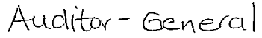

Pietermaritzburg

30 November 2009



H1.1.17 RESPONSE TO AUDITOR GENERAL REPORT

ACTION PLAN TO ADRESSS AUDITOR GENERAL

Aim: To achieve clean audit in 2014

FINANCIAL YEAR 2009/2010

AUDIT FINDING | Strategy | Activities | Responsible official comments
Going concern  Conditional grants used for operational expenditure.  Debtor non payment for water and sanitation services and a resultant 61% increaes in consumer debtors from prior year.  Payments to creditors not made within the prescribed time frames as contained in the MFMA due to cash flow difficulties.  Te municipality incurred a deficit of R64,3 m for the year ended 30 June 2009. | - Engaging politicians for possible solutions  - Engaging provincial and National Treasury for possible solutions  - Engaging other role players for possible solutions  - Mobilizing internal resources to minimize the impact.  - Reconciliation of grant income  - Cash flows to be aligned to budget  - Realistic budgeting | - Organize workshop  - Identify and schedule meetings with affected stakeholders  - Identify possible cost saving areas  - Engage HOD on grant expenditure  - Align expenditure to income patterns | Refer the attached report
Material losses  Distribution losses | - Recording of distribution losses on monthly basis  - Reconciliation of distribution losses to billed income  - Identification of areas of concern  - Developing management tool to deal with the losses  - Suggesting a strategy to deal with losses | - Documentation distribution losses  - Management of distribution losses
AUDIT FINDING | Strategy | Activities | Responsible official comments
Unauthorised/fruitless and wasteful/irregular expenditure  The municipality incurred fruitless and wasteful expenditure due to penalty interest being charged for late payment of electricity accounts  Late payment of Eskom invoices.  DWAF bulk water purchases not budgeted. | - Payment plan to be discussed with Eskom  - Dedicated personnel to be delegated responsibility of certain account.  - Approval method to be revisited  - Any other area of delay to be investigated  - Realistic budgeting | - Arrange meetings with the affected individuals  - Establish mechanism to speed the processing and approval process | The procurement Clerk (Miss B Magasela) has been assigned to process all sundry payments such as eskom, rent, telkom and etc.  The Deputy Water Service manager signs invoices for water departments on the HOD’s absentia.  The SCM Manager confirmed that, eskom invoices / statements are delayed due to late collection from the post and also through authorising by the HOD.  Responsible official S.P. Shabalala
Non compliance with applicable legislation  Reports for all contract above R100,000 had not been submitted to treasury as it contained in the MFMA, Circular 34, as well as S74(1) and 104(1)(b) of MFMA. | - Supply Chain Manager to be instructed to deal with the matter  - Supply Chain unit (administration ) to be capacitated around reporting requirements | - Submission of monthly reports  - Report on training progress | Reports on contracts above R 100,000.00 will be sent to P/treasury by the 31 March 2010 for 08/09.  The SCM and the Demand Audit Clerk has been trained by the P/treasury  Responsible official: SP Tshabalala’
AUDIT FINDING | Strategy | Activities | Responsible official comments
Division of revenue act  Signed conditional grants reports spending was not submitted to the National Treasury.  Contrary to S28 of DORA 2008, the municipality did not obtain prior approval for the roll over of the unspent portion of the conditional grants. | - Explore the possibility of a dedicated person to deal with all reporting requirements  - Identification of all reportable matters
AUDIT FINDING | Strategy | Activities | Responsible official comments
Governance  Information included in the annual report has not been obtained and have not been able to identify any material inconsistencies with the financial statements.  Internal audit  Risk assement not being done  Performance measurements not done.  Audit committee  Audit committee did not meet prior the submission of financial statements to review for adequacy, rreliability and accuracy.  Identification of roads and responsibilities of the audit committee.  Risk management not done  Reviewal risk policy  Consideration of financial statements  Key governance responsibility  Financial statements were not subject to any material amendments resultiting from the audit.  Annual report not submitted for consideration prior tabling of the auditor’s report.  The audit committee did not operates in accordance with the approved, written terms of reference  The audit committee did not substantially fulfilled its responsibilities for the year as set out in S166(2) of the MFMA  A risk assessment was not conducted on a regular basis.  Information systems were not appropriate to facilitate Quality of financial statements and related management information.  None quality of financial statements and related management information. | - Establishment of a Performance management dedicated centre  - Communication of all performance related matters  - Expectation from affected HOD’s to be communicated in writing and reminders to timeously sent to affected employees  - Risk management activities to be communicated affected stakeholders  - Audit Plan to be followed  - Schedule of activities to be drawn up and adopted for implementation  - Financial statements to be reviewed by both internal auditors and audit committee before submission for audit  - Internal auditors to advise on internal controls aimed at ensuring timeous submission of financial statements  - Time frame for submission of the annual report to be communicated to all stakeholders  - Audit committee to commit to audit charter and audit plan  - Management to appoint the risk committee to deal with risk related matters  - IT audit to be conducted  - IT related policies to be developed |  | PMS manager confirmed that HOD’s are informed via e-mails for PMS status.  Responsible official: PMS Manager  Risk assessment for 08/09 was conducted by our internal audit and the report has been issued to all HOD’s  By the time of the Annual Audit, performance was not done because PMS files were not compiled only for the Exec.Dir. Health Services was obtained from the PMS; however the audit has been done in January and the draft report has been issued.  Responsible official: MM & Planning Director  Schedule of activities for Audit Committee has been drawn and still need to be submitted to the Municipal Manager for approval.  Risk Management Committee has been established and risk policy has been adopted and approved by the council.  Fraud prevention plan has been approved by the audit committee and has been implemented.  Responsible official: Audit committee and the Municipal Manager.  Risk committee has been established as from February 2010 and functionally.  Responsible Official: Chief Financial officer  Annual report was not submitted for consideration to council  Responsible official: Planning Director  Schedule of activities and responsibilities for Audit Committee has been drawn and still need to be submitted to the Municipal Manager for approval
Performance information  Performance information not submitted for audit  Non compliance with the legislative requirements pertaing tio the planning  The IDP did not includes the KPI and performance targets as required by S26(i) and 41(1)(b) of the MSA  Audit committee did not review the performance management system and make recommendation to the council  Internal aditors dod noit audut the perfomance measurements on continous basis  Internal auditors did not submitt quaterly reports on their audit to the municipal manager and the audit committee. | Refer above on performance management |  | By the time the Annual Audit, Performance was done because the files were not compiled however the audit has been done in January and the Draft report has been submitted.  Responsible official: MM & Planning Director
AUDIT FINDING | Strategy | Activities | Responsible official comments
Ezakheni area not being billed for consumption of water  No meters are being read for the entire Ezakheni area for the estimated loss revenue of R 1,8m. | - Credit control to do situational analysis  - Recommendations to be tabled for Manco consideration  - Action plan going forward to be adopted  - Political involvement
Input vat incorrectly debited to expense vote  Vat was incorrectly debited to the expense vote instead of the vat input account for certain payments. | - Vat audit by a private firm to conducted
Vat claimed from non-registered vendors  Vendors that had invalid vat registration numbers as per vat vendor search performed from SARS website. | - Vat audit to conducted by the private firm | Appointment of the service provider | The tender was advertised for the appointment of the service provider for the vat audit however the tendering process has not been finalized for the appointment.  Financial intern (S. Makhathini) from the SCM Unit has been assigned to check incoming tax invoices for the validity and accuracy of vat number prior processing to the system.  Responsible official S.P Shabalala
AUDIT FINDING | Strategy | Activities | Responsible official comments
Fixed asset register discrepancies  From the asset register, it was noted that cetain fields had not been completed for some asset recorded i.e. location of asset, building description | - Asset register to be verified by the private firm before compilation of financial statements | Appointment of the service provider
Accurate asset register | - Refer above on assets
Fixed asset not tagged  From the selected items from the asset register, it was noted that they were not teagged. | - Private firm to ensure that all assets are tagged
Physical verification of asset  Asset selected from the register could not be physically verified. | - Random verification of assets to be conducted
No policy in place for the long outstanding debtors | - Policy amendments to be considered | - Consideration of amendments to the policy
Inventory reconciliation not performed  Reconciliation between physical and recorded inventory not performed resulted to variances not identified timeously. | - Random verification of inventories to be performed | - Performance of random audits | Reconciliation will be done monthly starting this month and as from the following year it will be done quarterly.  Responsible official S.P. Shabalala
Inaccurate valuation of stock  During the audit of inventory , we noted thet the wighted average cost per unit used to value stock at year end was incorrectly calculated. | - Accurate assessments to be adopted | - Refer above
AUDIT FINDING | Strategy | Activities | Responsible official comments
Other compliance – MFMA – website  The municipality did not update its website as required by S75of the MFMA. | - Planning to identify a person responsible for website updates  - That individual to be familiarized with the requirements of the act.
Vacancies in finance component  A review of the organisational structure had reveled the following key post in Finance since 2006  - Deputy CFO, Director Operations, Financial Controller, Syatems Administrator, Project Admin Clerk and Salaries Clerk.  The vacancies have affected service delivery in the following manner  - The accountant for expenditure performed functions in the salaries section in addition to normal responsibilities as laid down in his job description and also performed a review of the payroll. | - Organogram to be revisited  - Strategic posts to be budgeted and filled  - Roles and responsibilities to be clearly defined
AUDIT FINDING | Strategy | Activities | Responsible official comments
Tender administration | - Supply chain unit to be capacitated on tender management  - Reports to be submitted on matters which are reportable |  | - Project management unit administrator has implemented a checklist system to all projects files as to ensure that all relevant documentation are filed and safeguarded.

H1.1.18 OPERATIONAL INCOME BUDGET 2010/2011
OPERATIONAL INCOME BUDGET 2009/2010
Service Charges | 61 748 001 | 13.09%
Property Rates | 387 325 | 0.08%
Penalty Fees on Arrears | 722 027 | 0.15%
Equity Share Allocation | 198 196 000 | 42.01%
Municipal Infrastructure Grant | 125 334 000 | 26.56%
Other National Grants And Subsidies | 40 205 000 | 8.52%
Provincial Grants And Subsidies | 0 | 0.00%
Free Basic Services (LM'S) | 0 | 0.00%
Gain on Disposal of Property, Plant & Equipment | 0 | 0.00%
Other Income | 45 116 780 | 9.56%
Interest On Investments | 101 189 | 0.02%
Creditors Carry over Projects | 0 | 0.00%
 | 471 810 322 | 100.00%
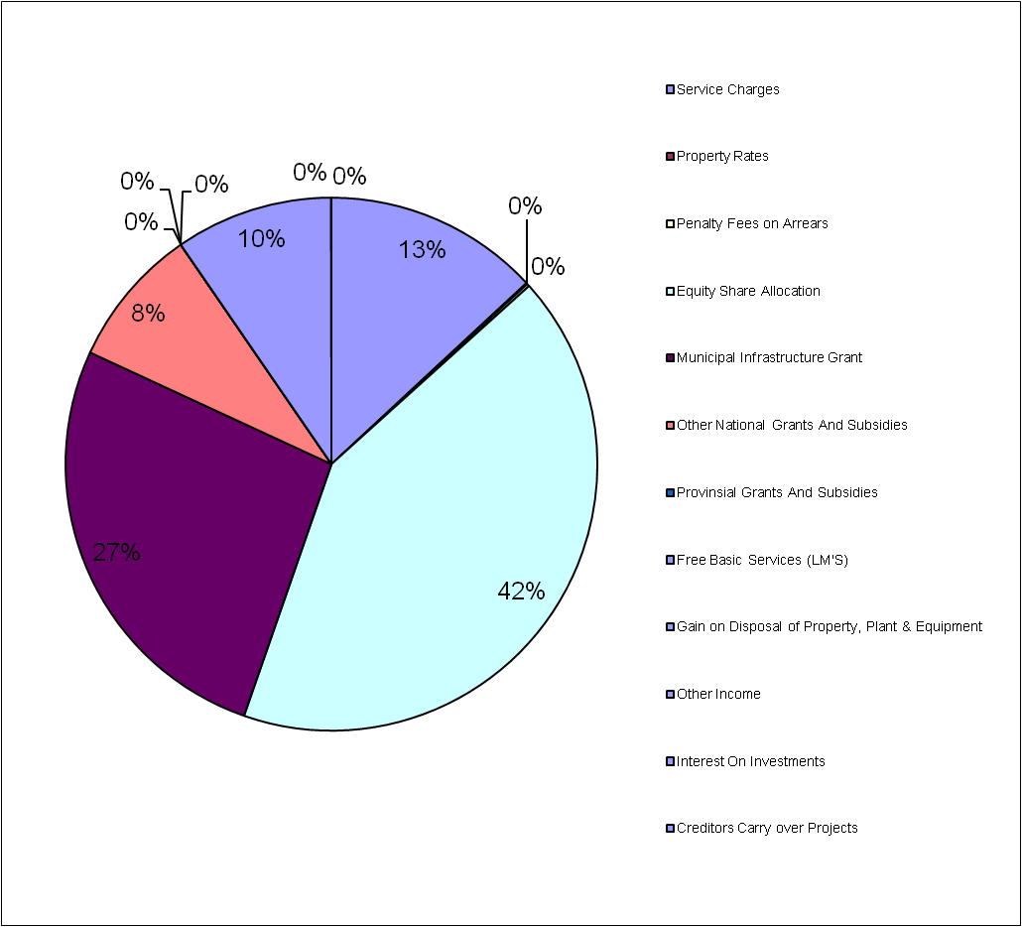

UTHUKELA DISTRICT UNICIPALITY
EXPENDITURE PER DEPARTMENT FOR 2010/2011
COUNCIL |  | 17 518 292 |  | 3.71%
MUNICIPAL MANAGER |  | 3 197 911 |  | 0.68%
CORPORATE SERVICES |  | 13 006 085 |  | 2.76%
SATELITE OFFICES |  | 1 017 780 |  | 0.22%
FINANCE |  | 10 496 582 |  | 2.22%
TECHNICAL REGIONAL |  | 354 090 |  | 0.08%
TECHNICAL PLANNING AND IT |  | 2 328 511 |  | 0.49%
PROJECT MANAGEMENT UNIT |  | 2 600 734 |  | 0.55%
CORPORATE SOCIAL SERVICES |  | 2 462 308 |  | 0.52%
LABORATRY |  | 2 136 017 |  | 0.45%
LOCAL ECONOMIC DEVELOPMENT |  | 3 247 269 |  | 0.69%
MUNICIPAL HEALTH SERVICES |  | 4 783 058 |  | 1.01%
TOURISM |  | 820 759 |  | 0.17%
STORES WATER |  | 630 913 |  | 0.13%
WATER & SEWERAGE |  | 183 107 633 |  | 38.81%
CAPITAL PROJECTS |  | 224 102 380 |  | 47.50%
 |  | 471 810 323 |  | 100.00%
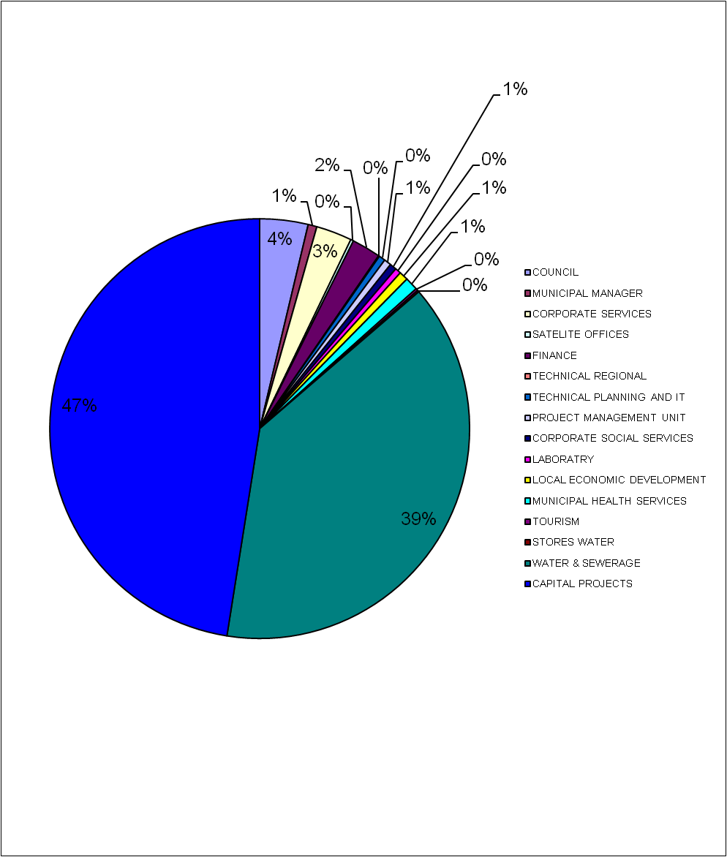

 |  |  | ESTIMATED
EXPENDITURE | BUDGET |  | ACTUAL |  | BUDGET |  | BUDGET |  |  |  | BUDGET
 | 2009/2010 |  | 2009/2010 |  | 2010/2011 |  | 2011/2012 |  |  |  | 2012/2013
Affirmative Action | 0 |  | 17,465 |  | 0 |  | 0 |  |  |  | 0
Job Creation | 54,000 |  | 34,929 |  | 0 |  | 0 |  |  |  | 0
Uthukela District Associations (SAFA) | 600,000 |  | 223,750 |  | 600 000 |  | 636 000 |  |  |  | 674 160
Kwanaloga Games | 2,900,000 |  | 2,107,553 |  | 2 900 000 |  | 3 074 000 |  |  |  | 3 258 440
Promotion of Sports | 700,000 |  | 505,000 |  | 1 200 000 |  | 1,272,000 |  |  |  | 1,348,320
Social Economic Activities | 1,500,000 |  | 1,136,328 |  | 2 000 000 |  | 2120 000 |  |  |  | 2247200
Arts, Culture and Music | 1,000,000 |  | 299,000 |  | 1000 000 |  | 1060 000 |  |  |  | 1123600
 | 0 |  | 0 |  | 0 |  | 0 |  |  |  | 0
Counter Funding - Projects | 0 |  | 0 |  | 200 000 |  | 2120 000 |  |  |  | 2247 200
Youth And Gender Development | 300,000 |  | 300,000 |  | 1,000,000 |  | 1,060,000 |  |  |  | 1,123,600
Gender Programs | 330,000 |  | 227,500 |  | 0 |  | 0 |  |  |  | 0
Infrastructural Development | 4,300,000 |  | 3,654,277 |  | 7000 000 |  | 7420 000 |  |  |  | 7865 200
Uthukela Civil Defence / Security Contract | 7,300,000 |  | 7,161,384 |  | 4,200,000 |  | 4,452,000 |  |  |  | 4719 120
Educational Support Activities | 440,000 |  | 439,954 |  | 500 000 |  | 530 000 |  |  |  | 561 800
MPRA Implementation | 0 |  | 0 |  | 0 |  | 0 |  |  |  | 0
Credit Control Road Shows & Implementation | 150,000 |  | 72,223 |  | 700,000 |  | 742,000 |  |  |  | 786,520
Community consultation meetings on Service Delivery | 0 |  | 0 |  | 0 |  | 0 |  |  |  | 0
Upgrade IT System (Munsoft) | 150,000 |  | 16,053 |  | 600,000 |  | 636,000 |  |  |  | 674,160
Ongoing training and capacity building | 20,000 |  | 0 |  | 0 |  | 0 |  |  |  | 0
GRAP/GAMAP Compliance | 200,000 |  | 45,860 |  | 400,000 |  | 424,000 |  |  |  | 449,440
Fleet Management | 0 |  | 0 |  | 0 |  | 0 |  |  |  | 0
Land Purchase | 0 |  | 0 |  | 0 |  | 0 |  |  |  | 0
LED Program | 2,600,000 |  | 1,288,889 |  | 2,000,000 |  | 2,120,000 |  |  |  | 2,247,200
Mayoral Cup | 700,000 |  | 689,511 |  | 700 000 |  | 742 000 |  |  |  | 786 520
Youth Day | 300,000 |  | 0 |  | 0 |  | 0 |  |  |  | 0
Childrens Council | 0 |  | 0 |  | 0 |  | 0 |  |  |  | 0
Elderly Persons Program | 210,000 |  | 0 |  | 200,000 |  | 212,000 |  |  |  | 224,720
Disability Programs | 150,000 |  | 6,000 |  | 300,000 |  | 318,000 |  |  |  | 337,080
Integrated Development Plan | 20,000 |  | 6,137 |  | 50 000 |  | 53000 00 |  |  |  | 56 180
Supply Chain Management | 20,000 |  | 0 |  | 0 |  | 0 |  |  |  | 0
Review & Implement Employment Equity Plan | 30,000 |  | 0 |  | 0 |  | 0 |  |  |  | 0
Review & Implement District Workplace Skills Plan | 40,000 |  | 0 |  | 300,000 |  | 318,000 |  |  |  | 337,080
Computer Network, Hardware Plus UPS | 300,000 |  | 104,741 |  | 0 |  | 0 |  |  |  | 0
Reviewable of Financial Policies | 40,000 |  | 40,000 |  | 150,000 |  | 159,000 |  |  |  | 168,540
Performance Management System | 100,000 |  | 106,000 |  | 0 |  | 0 |  |  |  | 0
Mgazizni Water Project | 200,000 |  | 212,000 |  | 0 |  | 0 |  |  |  | 0
Kwanomoya Water Project | 200,000 |  | 212,000 |  | 0 |  | 0 |  |  |  | 0
Ncunjane Water Project | 200,000 |  | 212,000 |  | 0 |  | 0 |  |  |  | 0
Maintenance Network Infrastructure | 315,000 |  | 28,515 |  | 0 |  | 0 |  |  |  | 0
IT And Establishment Cost - New Building | 0 |  | 0 |  | 6,263,374 |  | 6,639,176 |  |  |  | 7,037,527
Asset Verification | 0 |  | 0 |  | 1,200,000 |  | 1,272,000 |  |  |  | 1,348,320
Pre-Paid Meters | 0 |  | 0 |  |  |  | 0 |  |  |  | 0
Data Cleansing | 0 |  | 0 |  | 1,400,000 |  | 1,484,000 |  |  |  | 1,573,040
Monitoring of IT Service Provider  Drought relief project | 0 |  | 0 |  | 0  1 159841 |  | 0  1 229431 |  |  |  | 0  1 303 197
GRAND TOTAL | 25,359,000 |  | 19,147,069 |  | 37,823,215 |  | 40 092 608 |  |  |  | 42,498,164

EXPENDITURE | BUDGET | ACTUAL | BUDGET | BUDGET | BUDGET
 | 2009/2010 | 2009/2010 | 2010/2011 | 2011/2012 | 2012/2013
Dwaf Drought Relief (DORA) | 0 | 0 | 0 | 0 | 0
Backlog In Water & Sanitation At Schools Grant (DORA) | 8,760,000 | 8,760,000 | 0 | 0 | 0
Regional Bulk Infrastructure grant (DORA) | 2,757,000 | 2,757,000 | 24,295,000 | 38,187,000 | 61,386,000
Bulk Meter Installation at extraction and exit points WTP | 0 | 0 | 0 | 0 | 0
Bulk Meter installation at reticulation zones | 0 | 0 | 0 | 0 | 0
WTP and WWTP compliance | 0 | 0 | 0 | 0 | 0
Reservoir maintenance / refurbishment | 0 | 0 | 0 | 0 | 0
Upgrade of raw water pumps at Ezakheni WTP | 0 | 0 | 0 | 0 | 0
Refurbishment of Spioenkop and George Cross pumps | 0 | 0 | 0 | 0 | 0
Implementation of telementary system across the district | 0 | 0 | 0 | 0 | 0

CONDITIONAL GRANTS
 |  | ESTIMATED
EXPENDITURE | BUDGET | ACTUAL | BUDGET | BUDGET | BUDGET
 | 2009/2010 | 2009/2010 | 2010/2011 | 2011/2012 | 2012/2013
Local Government Fin Mangt Grant (DORA) | 750,000 | 750,000 | 1,000,000 | 1,250,000 | 1,250,000
National Electrification (Eskom) Grant (DORA) | 0 | 0 | 0 | 0 | 0
KZN - Provincial Management Assistance Program | 0 | 0 | 0 | 0 | 0
KZN - Library Services | 0 | 0 | 0 | 0 | 0
KZN-Municipal Development Information Services | 250,000 | 250,000 | 0 | 0 | 0
KZN-Infrastructure | 3,399,000 | 3,399,000 | 0 | 0 | 0
KZN-Development Administration | 500,000 | 500,000 | 0 | 0 | 0
KZN-Spatial Development | 500,000 | 500,000 | 0 | 0 | 0
KZN-Strategic Support | 500,000 | 500,000 | 0 | 2,510,000 | 0
KZN-Incentive Grant To Meet Targets (DORA) | 500,000 | 500,000 | 0 | 0 | 0
KZN-Motor vehicle Licence Fees | 19,000 | 19,000 | 0 | 0 | 0
KZN-Centre Management Support | 0 | 0 | 0 | 0 | 0
KZN-Small Town Regeneration | 1,875,000 | 1,875,000 | 0 | 0 | 0
Expanded Public Works Program Incentive Grant (DORA) | 0 | 0 | 12,410,000 | 0
GRAND TOTAL | 8,293,000 | 8,293,000 | 13,410,000 | 3,76,000 | 1,250,000

GRANTS AND SUBSIDIES CARRY OVER
 | DEPARTMENT | VOTE | CREDITOR
DESCRIPTION | NUMBER | NUMBER | PROJECTS
 |  |  | AS AT
 |  |  | 28/02/2010
MSIG PERFORMANCE MANAGEMENT SYSTEM | 797 | 55010 | 8,595.00
MSIG PIMMS DEPARTMENT | 798 | 055010 | 377,249.16
KZN DEVELOPMENT PLAN CAPACITY | 799 | 800003 | 0.00
DWAF WATER CONSERVATION | 801 | 401000 | 1,442,555.26
DWAF IEC 04/05 WATER &SANITATI | 801 | 401002 | 367,456.94
WATER SERVICES DEV PLAN DWAF | 801 | 401003 | 12,732.80
DWAF BALANCE EX 03/04 | 801 | 401004 | 55,674.44
DWAF WORKS REFURB GRANT | 801 | 401005 | 7,789,095.58
DWAF MVULA SANI 04/05 | 801 | 401006 | 272.84
DWAF BLUE BANK | 801 | 401007 | 2,386.86
DWAF BALDASKRAAL | 801 | 401008 | 2,348.97
DWAF GREENPOINT | 801 | 401009 | 11,205.88
DWAF NYEZANE | 801 | 401010 | 31,585.00
DWAF DROUGHT RELIEF | 801 | 401011 | 2,009.79
ROOSBOOM WATER RETICULATION | 801 | 401012 | 861,102.12
RAIN WATER HARVESTING | 801 | 401013 | 293,865.63
FEASIBILITY STUDY | 801 | 401014 | 77,210.26
ASSET MANAGEMENT | 801 | 401015 | 385,285.44
DWAF EX 03/04 | 801 | 401021 | 0.40
DRIEFONTEIN BULK SCHEME | 801 | 401024 | 1,774,113.24
KZN TRANSFORMATION | 822 | 422002 | 377,921.34
KZN MULTI PURPOSE VEHICLE | 822 | 422003 | 13,512.00
KZN UITVAL SPORT FIELDS | 822 | 422004 | 4,583.79
KZN GIS CAPACITY BUILDING | 822 | 422005 | 6,678.90
KZN DISASTER MAN FRAME MSIG | 822 | 422007 | 34,100.92
KZN TOURISM PROJECTS MSIG | 822 | 422008 | 2,758.24
KZN KWADAKUZA RURAL SERV SYSTE | 822 | 422012 | 18,000.00
KZN INCORP LAND REF SUB REG PL | 822 | 422014 | 2,600.00
KZN ST CHADS EMERGENCY WATER | 822 | 422015 | 5,891.00
KZN G.I.S. GRANT | 822 | 422016 | 2,103.78
KZN CHANGE MANAGEMENT COMMITTE | 822 | 422017 | 82,955.00
KZN SECRETERIAL MFC | 822 | 422018 | 50,000.00
KZN IMMEDIATE SUPPORT TECH | 822 | 422019 | 15,208.00
KZN DUKUZA SPORT & REC | 822 | 422020 | 16,729.47
KZN TOURISM INITIATIVE | 822 | 422021 | 0.00
KZN DEVELOPING G.I.S. | 822 | 422022 | 66,143.98
KZN NEWSTAND SPORT & REC | 822 | 422023 | 2,091.87
KZN INTERGRATED TRANS PLAN | 822 | 422024 | 381,755.49
KZN CAPACITY BUILDING PLAN | 822 | 422026 | 120,000.00
KZN DIMMS | 822 | 422028 | 186,827.00
KZN PERFORMANCE MNGT SYSTEM | 822 | 422029 | 7,868.86
KZN IDP SUPPORT SYSTEM | 822 | 422030 | 0.87
KZN TUGELA ESTATE FISH PROJ | 822 | 422031 | 731,314.07
KZN REGIONAL ECONOMIC DEVELOPM | 822 | 422033 | 23,000.00
KZN UMTSHEZI SPORT & REC | 822 | 422034 | 233,320.00
KZN S 78 ASSESSMENT | 822 | 422035 | 501,500.00
KZN BACKLOG STUDY | 822 | 422036 | 249,455.50
KZN W S D P | 822 | 422037 | 50,000.00
KZN M.A.P FUNDING | 822 | 422039 | 8,183.89
KZN KANDAHAR FIELD PROFES FEES | 822 | 422040 | 47,182.65
KZN KANDAHAR FIELD PROGRAM | 822 | 422041 | 9,318.19
KZN KANDAHAR FIELD CONSTRUCTIO | 822 | 422042 | 71,394.52
KZN FINANCE MANAGEMENT GRANT | 822 | 422043 | 1,200,147.52
KZN DPLG DROUGHT GRANT | 822 | 422044 | 12,809.06
KZN UMHLUMAYO SPORT & REC | 822 | 422045 | 26,879.85
KZN NTABAMHLOPE SPORT & REC | 822 | 422046 | 33,549.64
KZN ASSESMENT WATER SD PLAN | 822 | 422048 | 3,498.79
KZN ASSESMENT WATER & ELECTRIC | 822 | 422050 | 38,927.31
KZN IMP TECH & SCIENTIFIC SUPP | 822 | 422051 | 500,000.00
KZN DEV IMFORM SYSTEM SUPPORT | 822 | 422053 | 190,000.00
KZN TECH SUPP & INFRAST BACKLO | 822 | 422054 | 579,940.00
KZN SHARED SERVICE CENTRES | 822 | 422055 | 936,054.29
KZN ENERGY SECTOR PLAN & SUPP | 822 | 422056 | 3,100.00
KZN INSTITU SUPP & CAPACITY BU | 822 | 422058 | 289,390.98
KZN WATER SERV DELIV PLAN | 822 | 422059 | 35,358.69
KZN LAND REFORM GIJIMA | 822 | 422060 | 14,454.03
KZN LED GIJIMA | 822 | 422061 | 3,763.26
KZN DEV INFORM SYS SUPPORT | 822 | 422063 | 1,080,000.00
KZN MUN PERFORMANCE MANG | 822 | 422064 | 45,331.86
KZN IDP SUPPORT | 822 | 422065 | 31,709.44
KZN CAP BUILD WATER STAFF | 822 | 422066 | 316,720.00
KZN WSA INSTITUTIONAL SUPP | 822 | 422067 | 12,280.70
KZN DISASTER MANAGEMENT | 822 | 422068 | 5,065.43
KZN LOCAL GOV SETA GRANT | 822 | 422069 | 187,521.50
KZN LGSETA GRANT TRAINING | 822 | 422070 | 722,409.57
KZN SOCIAL PILOT PROJECT | 822 | 422071 | 856,860.00
KZN SOCIAL EMABHEKAZI | 822 | 422072 | 69,535.00
KZN GROUTH & DEV SUMMIT | 822 | 422074 | 100,000.00
KZN ARTS, CUL & TOURISM | 822 | 422075 | 1,378.16
WASTE MANAGEMENT PLAN | 822 | 422076 | 41,052.63
DMA BUFFER SUPPORT | 822 | 422077 | 264,781.63
PUBLIC WORKS INCENTIVE GRANT | 822 | 422078 | 522,300.00
SOCIAL PILOT PROJECT LIMEHILL | 830 | 800025 | 0.00
SOCIAL EMABHEKAZI WATER PROJECT | 830 | 800026 | 0.00
UDM LAND REFORM PROJECTS | 945 | 445,002 | 1,237,079.74
COMMUNITY BASED PUBLIC WORKS PROGRAM | 946 | 446,002 | 72,754.42
BUDGET |  |  | 26,251,798.44

 |  | ESTIMATED
EXPENDITURE | BUDGET | ACTUAL | BUDGET | BUDGET | BUDGET
 | 2009/2010 | 2009/2010 | 2010/2011 | 2011/2012 | 2012/2013
MUNICIPAL GOVERNANCE ANDADMINISTARATION
Affirmative Action | 0 | 17,465 | 0 | 0 | 0
Job Creation | 54,000 | 34,929 | 0 | 0 | 0
Ongoing training and capacity building | 20,000 | 0 | 0 | 0 | 0
COMMINITY & PUBLIC SAFETY
Uthukela District Associations (SAFA) SPORTS | 600,000 | 223,750 | 600 000 | 636 000 | 674 160
Kwanaloga Game SPORTS | 2,900,000 | 2,107,553 | 2 900 000 | 3 074 000 | 3 258 440
Promotion of Sport SPORTS | 700,000 | 505,000 | 1 200 000 | 1 272 000 | 2 247 200
Arts, Culture and Music | 1,000,000 | 299,000 | 1000 000 | 2120 000 | 2247 200
Youth And Gender Development | 300,000 | 300,000 | 1,000,000 | 1,060,000 | 1,123,600
Gender Programs | 330,000 | 227,500 | 0 | 0 | 0
Mayoral Cup SPORTS | 700,000 | 689,511 | 700 000 | 742 000 | 786 520
Educational Support Activities | 440,000 | 439,954 | 500 000 | 530 000 | 561 800
Elderly Persons Program | 210,000 | 0 | 200,000 | 212,000 | 224,720
Disability Programs OTHER SOCIAL | 150,000 | 6,000 | 300,000 | 318,000 | 337,080
Youth Day CHILD CARE | 300,000 | 0 | 0 | 0 | 0
ECONOMIC AND ENVIRONMENTAL SERVICES
Social Economic Activities ECONOMIC DEVELOPMENT | 1,500,000 | 1,136,328 | 0 | 0 | 0
LED Program | 2,600,000 | 1,288,889 | 2,000,000 | 2,120,000 | 2,247,200
Local Economic Development Support | 0 | 0 | 0 | 0 | 0
Integrated Development Plan | 20,000 | 6,137 | 50 000 | 53 000 | 56 180
Performance Management System PERFORMANCE MANAGEMENT | 100,000 | 106,000 | 0 | 0 | 0
SECURITY WATER
Uthukela Civil Defence / Security Contract | 7,300,000 | 7,161,384 | 4,200,000 | 4,452,000 | 4,719,120
FINANCE COLLECTION COSTS
Credit Control Road Shows & Implementation | 150,000 | 72,223 | 700,000 | 742,000 | 786,520
Data Cleansing | 0 | 0 | 1,400,000 | 1,484,000 | 1,573,040
COMMUNITY AND PUBLIC SAFETY
Community consultation meetings on Service Delivery | 0 | 0 | 0 | 0 | 0
MUNICIPAL GOVERNANCE AND ADMINISTRATION
Upgrade IT System (Munsoft) | 150,000 | 16,053 | 600,000 | 636,000 | 674,160
Monitoring of IT Service Provider | 0 | 0 | 0 | 0 | 0
Maintenance Network Infrastructure | 315,000 | 28,515 | 0 | 0 | 0
Computer Network, Hardware Plus UPS | 300,000 | 104,741 | 0 | 0 | 0
CORPORATE SERVICES - CONTRACTED SERVICES
Review & Implement Employment Equity Plan | 30,000 | 0 | 0 | 0 | 0
Review & Implement District Workplace Skills Plan | 40,000 | 0 | 300,000 | 318,000 | 337,080
PROJECTS - INHOUSE FUNDED
Mgazizni Water Project | 200,000 | 212,000 | 0 | 0 | 0
Kwanomoya Water Project | 200,000 | 212,000 | 0 | 0 | 0
Ncunjane Water Project | 200,000 | 212,000 | 0 | 0 | 0
Land Purchase | 0 | 0 | 0 | 0 | 0
Counter Funding – Projects | 0 | 0 | 2000 000 | 2 120 000 | 2 247 200
Infrastructural Development | 4,300,000 | 3,654,277 | 700 000 | 7 420 000 | 7 865 200
ESTABLISHMENT COSTS - PROJECTS
IT And Establishment Cost - New Building | 0 | 0 | 6,263,374 | 6,639,176 | 7,037,527
OPERATIONAL FINANCE - FINANCIAL REFORMS
Asset Verification | 0 | 0 | 1,200,000 | 1,272,000 | 1,348,320
Supply Chain Management | 20,000 | 0 | 0 | 0 | 0
Reviewable of Financial Policies | 40,000 | 40,000 | 150,000 | 159,000 | 168,540
GRAP/GAMAP Compliance | 200,000 | 45,860 | 400,000 | 424,000 | 449,440
Fleet Management | 0 | 0 | 0 | 0 | 0
MPRA Implementation | 0 | 0 | 0 | 0 | 0
OPERATIONAL - PROJECTS
Pre-Paid Meters | 0 | 0 | 0 | 0 | 0
GRAND TOTAL | 25,369,000 | 19,147,069 | 37,823,215 | 40,092,608 | 42,498,164
SECTION I ORGANISATIONAL PERFOMANCE MANAGEMENT SYSTEM

I1.1.1 INTRODUCTION

The Municipal Planning and Performance Regulations (MPPMR) is a set of regulations which clarifies the process of how the Performance Management System and Integrated Development Plan should be developed and implemented. It also indicates how the auditing of the Performance Management System should take place. The section 14(1) of the Municipal Planning and Performance Regulations states that a municipality must develop and implement mechanisms, systems and process for auditing the results of performance measurements as part of the internal auditing process.

Section 7(2) (c) of the MPPR requires the municipality to clarify the roles and responsibilities of each stakeholders, including the local community in the functioning of the PMS.The Municipal Systems Act (Act 32 of 2000) stipulates the development of a Performance Management System for all spheres of local government in order to assist in the implementation of their IDP’s.The uThukela District Municipality has therefore commissioned the development of a Performance Management Framework in order to enable the municipalities within uThukela to comply with the legal mandate. The uThukela Performance Management System relies greatly on the information provided by existing documentation within the municipality such as the Municipal IDP and the Best Practice Guide developed by COGTA

I1.1.2 BACKGROUND

Detailed terms of reference were developed by the uThukela District Municipality for the drafting of an uThukela Performance Management System and Performance Management Framework. The terms of reference identified expected outputs, emphasising the link between the IDP and PMS, as well as the identification of role players in the PMS process, the proposed reporting systems and the key performance areas of the Municipality.

The various departments of the uThukela District Municipality were identified as the operational level of the municipality, thus the PMS will be focused on the departments and their respective heads, as well as the organizational performance of the Municipality.

The Municipal Performance Management System was subdivided into three phases, being:
- Phase One : Municipal PMS Status Quo
- Phase Two: Communication Structures
- Phase Three: Performance Management System

The phases were separated in order to identify different aspects of the municipal operations and to assist the role players to easily understand the performance process.

LEGISLATIVE FRAMEWORK

The uThukela Performance Management System is based on the legislative mandate that governs the operations of the local government spheres. In addition, the National and Provincial guidelines have been taken into consideration during the process.

uThukela Performance Management System is influenced by the following legislations:
- Municipal Systems Act, Act 32 of 2000
- White Paper on Local Government, 1998
- Municipal Planning and Performance Management Regulations,2001
- The Constitution of the Republic of South Africa,Act108 of 1996
- The Municipal Finance Management Act 56 of 2003
- Intergovernmental Relations of 2005

PERFORMANCE MANAGEMTN SYSTEM

The uThukela Performance Management System is subdivided into three sections for easy reference. These are:

Phase One: Municipal PMS Status Quo

Phase one is aimed at the identification of the existing facilities within the Municipality, as well as the investigation of existing departmental structures and management styles of each department in order to verify the level of interaction between the departmental heads and the junior staff.

During this phase, the methods of communication used by departments will be investigated and documented, including the use of computerised systems in order to track the performance of staff, as well as manual systems, such as departmental meetings and progress reports.

In addition, the management tools used by the organisation to measure the performance of departments will be investigated and the management meetings analysed in order to understand the process of evaluating organisational performance

Phase Two: Communication Structures

The aim of this phase is to analyse the role of different stakeholders and their level of participation in the process of developing and implementing a Performance Management System. During this phase different role players will be identified and their responsibilities defined. Participatory and communication structures will also be identified during this phase.

Phase Three: Performance Management System

The development of this phase is focusing on the development of a municipal Performance Management System. This includes the development of a new approach in evaluating performance and the development of an organisational and departmental scorecard which will be aligned to the Municipal IDP. This will include the development of departmental business plans and the establishment of a Performance Management Auditing Committee. The following table below is the Organizational scorecard for 2010/2011.

I1.1.3 Organisational Scorecard
UTHUKELA DISTRICT MUNICIPALITY - ORGANISATIONAL SCORECARD 2010-11
 |  |  |  |  |  |  |  | 2010/11 |  | Financial Implications
IDP Indicator No. | National KPA | Strategic Objective | Measurable Objective/Output | Performance Measure/Indicator (Unit of Measure) | Demand | Baseline (Previous Year Actuals) | Backlog | Target | Responsible Department | Source of funding
IDP2011/001 | Municipal Transformation and Institutional Development | To provide effective and efficient Human Resources Management Services | Approved organogram | Yes/No | n/a | Yes | n/a | Yes | Corporate | Operational
IDP2011/002 | Municipal Transformation and Institutional Development |  | Number of Black staff employed in management | Number of staff | n/a | 5 | n/a | 5 | Corporate | Operational
IDP2011/003 | Municipal Transformation and Institutional Development |  | Women employed by the municipality | Number of staff | 197 | 90 | 107 | 7275 | Corporate | Operational
IDP2011/004 | Municipal Transformation and Institutional Development |  | Youth employed by the municipality | Number of staff | 215 | 41 | 174 | 41 | Corporate | Operational
IDP2011/005 | Municipal Transformation and Institutional Development |  | Employees with disabilities employed by the municipality | Number of staff | 6 | 0 | 6 | 0 | Corporate | Operational
IDP2011/006 | Municipal Transformation and Institutional Development |  | Approved Workplace Skills Plan | Yes/No | n/a | Yes | n/a | Yes | Corporate | Operational
IDP2011/007 | Municipal Transformation and Institutional Development |  | Budget spent on Work Place Skills Plan | % spent | n/a | 1% | n/a | 1.00% | Corporate | Operational
IDP2011/008 | Municipal Transformation and Institutional Development |  | Scarce Skills Policy | Yes/No | n/a | Yes | n/a | Yes | Corporate | Operational
IDP2011/009 | Municipal Transformation and Institutional Development |  | Recruitment policy | Yes/No | n/a | Yes | n/a | Yes | Corporate | Operational
IDP2011/010 | Municipal Transformation and Institutional Development | To ensure effective administrative support services | Review of fleet management policy | Date of review | n/a | n/a | n/a | 2010/09/30 | Finance | Operational
IDP2011/011 | Municipal Transformation and Institutional Development | To ensure effective administrative support services | Provision of secretarial services | Number of meetings | n/a | 30 | n/a | 40 | Corporate | Operational
IDP2011/012 | Municipal Transformation and Institutional Development | To ensure effective administrative support services | Provision of secretarial services | Notice of meeting (agendas) | n/a | 2 days prior to meeting | n/a | 5 working days prior to meeting | Corporate | Operational
IDP2011/013 | Municipal Transformation and Institutional Development | To ensure effective administrative support services | Provision of secretarial services | Turnaround time for minutes | n/a | 3 working days | n/a | 3 working days | Corporate | Operational
IDP2011/014 | Municipal Transformation and Institutional Development | To conform to the Batho Pele Principles | Community surveys | Number of surveys | n/a | n/a | n/a | 2 | Corporate | Operational
IDP2011/015 | Municipal Transformation and Institutional Development |  | Develop a consumer charter | Date of adoption | n/a | n/a | n/a | 2010/12/31 | Corporate | Operational
IDP2011/016 | Municipal Transformation and Institutional Development | To ensure integrated development planning | Adopted IDP | Date adopted | n/a | 2010/06/30 | n/a | 2011/06/30 | Planning | Operational
IDP2011/017 | Municipal Transformation and Institutional Development | To ensure integrated development planning | Spatial development framework | Y/N | n/a | Yes | n/a | 2011/06/30 | Planning | Operational
IDP2011/018 | Municipal Transformation and Institutional Development | To ensure integrated development planning | Environmental Management Plan | Y/N | n/a | No | n/a | 2011/06/30 | Health and environmental services | Operational
IDP2011/019 | Municipal Transformation and Institutional Development | To ensure integrated development planning | Land use management system | Y/N | n/a | No | n/a | 2011/06/30 | Planning | Operational
IDP2011/020 | Municipal Transformation and Institutional Development | To ensure integrated development planning | IDP Process Plan | Date adopted | n/a | Yes | n/a | 2010/09/30 | Planning | Operational
IDP2011/021 | Municipal Transformation and Institutional Development | To ensure integrated development planning | IDP Framework Plan | Date adopted | n/a | Yes | n/a | 2010/09/30 | Planning | Operational
IDP2011/022 | Municipal Transformation and Institutional Development | To promote occupational health and safety | Implement Employee Wellness Programme | Date of review | n/a | No | n/a | 2011/06/30 | Health and environmental services | Operational
IDP2011/023 | Municipal Transformation and Institutional Development | To promote occupational health and safety | Implement Employee Wellness Programme | Number of programmes/ workshops undertaken | n/a | No | n/a | 4 | Health and environmental services | Operational
IDP2011/024 | Municipal Transformation and Institutional Development | To promote occupational health and safety | Implement Employee Wellness Programme | Establish a functional occupational health and safety committee | Date committee established | Yes | n/a | 2010/09/30 | Health and environmental services | Operational
IDP2011/025 |  |  |  |  | Number of meetings | 1 | n/a | 3 | Health and environmental services | Operational
IDP2011/026 | Municipal Transformation and Institutional Development | To implement an effective organisational and individual performance management system | Performance Management Systems | Yes/No | n/a | Yes | n/a | Yes | Planning | Operational
IDP2011/027 | Municipal Transformation and Institutional Development |  | Adopt Performance Management Framework | Date adopted | n/a | Yes | n/a | 2010/09/30 | Planning | Operational
IDP2011/028 | Municipal Transformation and Institutional Development |  | S57 performance agreements | Number of agreements | n/a | 5 | n/a | 7 | Office of the MM | Operational
IDP2011/029 | Municipal Transformation and Institutional Development |  | Quarterly performance reports prepared within 30 days of quarter end | Date | n/a | Not achieved | n/a | Quarterly | Planning / All | Operational
IDP2011/030 | Municipal Transformation and Institutional Development |  | Mid year budget and performance report | Date | n/a | Not achieved | n/a | 2011/01/25 | Planning | Operational
IDP2011/031 | Municipal Transformation and Institutional Development |  | Draft Annual Performance Report submitted to Auditor General | Date | n/a | submitted after 31/08/2009 | n/a | 2010/08/31 | Planning / All | Operational
IDP2011/032 | Municipal Transformation and Institutional Development |  | Draft Annual Report | Date | n/a | November 2009 | n/a | 2010/11/30 | Planning | Operational
IDP2011/033 | Municipal Transformation and Institutional Development |  | Table Annual Report | Date | n/a | Tabled in February 2010 | n/a | 2011/01/31 | Planning | Operational
IDP2011/034 | Municipal Transformation and Institutional Development |  | Oversight Report | Date | n/a | Not done | n/a | 2011/03/31 | Planning | Operational
IDP2011/035 | Municipal Transformation and Institutional Development |  | Establish Oversight Committee to review Annual Report | Date | n/a | No | n/a | 2010/09/30 | Office of the MM | Operational
IDP2011/036 | Municipal Transformation and Institutional Development | To develop and implement the Municipal Turn Around Strategy | Achievement of the approved Municipal Turnaround Strategy | % of plan achieved | n/a | 10% | n/a | 100% | All | Operational
IDP2011/037 | Municipal Transformation and Institutional Development | To provide effective communication solutions | Develop and implement communication strategy | Date | n/a | No | n/a | 2010/12/31 | Corporate | Operational
IDP2011/038 | Municipal Transformation and Institutional Development | To provide effective Information Technology solutions | Implement District Information Management System (DIMS) | Date | n/a | n/a | n/a | 2011/06/30 | Planning | Operational
IDP2011/039 | Municipal Transformation and Institutional Development | To provide effective Information Technology solutions | Develop IT Policy (ITIL) | Date | n/a | n/a | n/a | 2010/12/31 | Planning | Operational
IDP2011/040 | Municipal Transformation and Institutional Development | To provide effective Information Technology solutions | Implementation of the IT Policy | % of policy implemented | n/a | n/a | n/a | 50% | Planning | Operational
IDP2011/041 | Basic Service Delivery and Infrastructure Development | To reduce infrastructure backlogs within water and sanitation services | Review the Water Services Development Plan | Date of review | n/a | n/a | n/a | 2011/06/30 | WSA | Grant
IDP2011/042 | Basic Service Delivery and Infrastructure Development |  | Implementation of identified projects in IDP | % of capital budget spent (cumulative) | n/a | 100% | n/a | 100% | Technical | Grant
IDP2011/043 | Basic Service Delivery and Infrastructure Development |  | Households with access to basic water | Number of households | 139639 | 116599 | 23040 | 6000 | Technical | Grant
IDP2011/044 | Basic Service Delivery and Infrastructure Development |  | Provision of bulk water infrastructure | Number of kilometres of piping laid | n/a | 135 | n/a | 592 | Technical | Grant
IDP2011/045 | Basic Service Delivery and Infrastructure Development |  | Households with access to basic sanitation | Number of households | 139639 | 110315 | 29324 | 7000 | Technical | Grant
IDP2011/046 | Basic Service Delivery and Infrastructure Development |  | Develop a Comprehensive Infrastructure Plan | Date approved | n/a | n/a | n/a | 2011/06/30 | WSA | Donor funding
IDP2011/047 | Basic Service Delivery and Infrastructure Development | To provide sustainable portable water and sanitation services | Operation and maintenance plan to be developed and implemented | Number of plans developed | 114 | 10 | 104 | 104 | Water services | Operational
IDP2011/048 | Basic Service Delivery and Infrastructure Development |  |  | % of plans implemented | n/a | n/a | n/a | 100% | Water services | Operational
IDP2011/049 | Basic Service Delivery and Infrastructure Development |  | Response time to attend to water complaints | Time | n/a | within 48 hours | n/a | 48 hours | Water services | Operational
IDP2011/050 | Basic Service Delivery and Infrastructure Development |  | Reduction of water losses | % reduction in losses | n/a | R10.7m loss in 2008/09 | n/a | 10% | Water services | Operational
IDP2011/051 | Basic Service Delivery and Infrastructure Development |  | Ensure water quality standards are maintained | Compliance to SANS 241 water quality standards (micro-biological quality) | n/a | n/a | n/a | 100% | Water services / WSA | Operational
IDP2011/052 | Basic Service Delivery and Infrastructure Development | To provide social services infrastructure | Construction of sportsfields | Number of sportfields constructed/provided | n/a | 1 | n/a | 1 | Technical | Department of Sport and Recreation
IDP2011/053 | Basic Service Delivery and Infrastructure Development | To provide access to free basic services | Households with access to free water services | Number of households | n/a | 81000 (estimate) | n/a | 81000 (estimate) | Water services | Operational
IDP2011/054 | Basic Service Delivery and Infrastructure Development |  | Households with access to sanitation services | Number of households | n/a | 86000(estimate) | n/a | 86000(estimate) | Water services | Operational
IDP2011/055 | Local Economic Development | To stimulate sustainable economic development and to reduce poverty within the District | District growth and development summit | Number of summits | n/a | 0 | n/a | 1 | Planning | Grant
IDP2011/056 | Local Economic Development |  | Functioning District LED forum | Number of meetings | n/a | 1 | n/a | 4 | Planning | Operational
IDP2011/057 | Local Economic Development |  | Develop SMME Policy | Date approved | n/a | No | n/a | 2010/09/30 | Planning | Operational
IDP2011/058 | Local Economic Development |  | Develop SMME Programme | Date approved | n/a | No | n/a | 2010/09/30 | Planning | Operational
IDP2011/059 | Local Economic Development |  | SMME Programme implemented | % of SMME budget spent | n/a | 0% | n/a | 90% | Planning | Operational
IDP2011/060 | Local Economic Development |  | Implementation of the LED plan | % of LED budget spent | n/a | 50% | n/a | 90% | Planning | Operational
IDP2011/061 | Local Economic Development |  | Jobs created through the municipality's LED initiatives | Number of jobs | n/a | 940 | n/a | 2000 | Planning | Operational
IDP2011/062 | Local Economic Development |  | Jobs created through the municipality's capital projects | Number of jobs |  |  |  | 23132 | Technical | Grant
IDP2011/063 | Local Economic Development | To promote tourism within the District | Implementation of the tourism plan | % of budget spent | n/a | 25% | n/a | 90% | Planning | Operational
IDP2011/064 | Local Economic Development | To promote tourism within the District | Functional District Tourism Forum | Number of forum meetings | n/a | 1 | n/a | 4 | Planning | Operational
IDP2011/065 | Local Economic Development | To promote tourism within the District | Functional District Tourism fora | Number of fora meetings | n/a | 2 | n/a | 4 | Planning | Operational
IDP2011/066 | Local Economic Development | To promote tourism within the District | Publish tourism brochure | date published | n/a | May 2010 | n/a | 2011/06/30 | Planning | Operational
IDP2011/067 | Local Economic Development | To develop a marketing strategy | Develop marketing strategy | Date approved | n/a | No | n/a | 2010/12/31 | Planning | Operational
IDP2011/068 | Good Governance, Community Participation and Ward Committee Systems | To undertake on-going research to the benefit of the district. | Creation of database of research areas/projects | Y/N | n/a | n/a | n/a | Y | All | Operational
IDP2011/069 |  |  | Research projects undertaken | Number of research projects undertaken | n/a | n/a | n/a | 4 | All | Operational
IDP2011/070 |  |  | Sourcing of funding for research/researched projects | Number of projects funded | n/a | n/a | n/a | 4 | All | Operational
IDP2011/071 |  | To ensure an effective internal audit and risk management strategy | Perform risk assessment of the municipality | Approved risk profile | n/a | Yes | n/a | 2010/09/30 | Office of the MM / Finance | Operational
IDP2011/072 |  |  | Review and implement fraud/anti-corruption plan | Number of workshops | n/a | 3 | n/a | 2 | Finance | Operational
IDP2011/073 |  |  | Financial and Performance audit committee | Yes/No | n/a | Yes | n/a | Yes | Finance | Operational
IDP2011/074 |  |  | Financial and Performance audit committee | Number of meetings | n/a | 3 | n/a | 4 | Finance | Operational
IDP2011/075 |  |  | Internal audit activity | % achievement of the internal audit plan | n/a | 92% | n/a | 100% | Finance | Operational
IDP2011/076 |  |  | Implementation of action plan stemming from Auditor General's findings | % achieved | n/a | 95% | n/a | 100% | All | Operational
IDP2011/077 |  | To actively involve the community and stakeholders in the affairs of the municipality | Awareness campaigns | Number of campaigns | n/a | 0 | n/a | 4 | All | Operational
IDP2011/078 |  |  | Mayoral imbizo's | Number of Imbizo's | n/a | 0 | n/a | 1 | Planning / Corporate | Operational
IDP2011/079 |  |  | Budget and IDP roadshows | Number of roadshows | n/a | 7 | n/a | 7 | Planning / Finance | Operational
IDP2011/080 |  |  | IDP representative forums | Number of meetings held | n/a | 2 | n/a | 2 | Planning | Operational
IDP2011/081 |  |  | Sector department meetings | Number of meetings held | n/a | 3 | n/a | 5 | Health and Planning | Operational
IDP2011/082 |  |  | Number of council meetings | Number of meetings held | n/a | 3 | n/a | 4 | Office of the MM | Operational
IDP2011/083 |  |  | Adverts in local media | Number of adverts newsprint | n/a | 4 | n/a | 7 | Planning and corporate | Operational
IDP2011/084 |  |  | Adverts in local media | Number of radio slots | n/a | 52 | n/a | 52 | Office of the MM | Operational
IDP2011/085 |  | To actively participate in IGR structures | Mayoral Forum | Number of meetings | n/a | 0 | n/a | 4 | Office of the MM | Operational
IDP2011/086 |  | To actively participate in IGR structures | Municipal managers' Forum | Number of meetings | n/a | 0 | n/a | 4 | Office of the MM | Operational
IDP2011/087 |  | To actively participate in IGR structures | CFO Forum | Number of meetings | n/a | 2 | n/a | 4 | Finance | Operational
IDP2011/088 |  | To actively participate in IGR structures | IDP managers Forum | Number of meetings | n/a | 2 | n/a | 4 | Planning | Operational
IDP2011/089 |  | To actively participate in IGR structures | District Aids Council Forum | Number of meetings | n/a | 2 | n/a | 4 | Health and environmental services | Operational
IDP2011/090 |  | To actively participate in IGR structures | WSA Managers Forum | Number of meetings | n/a | 3 | n/a | 4 | Health and environmental services | Operational
IDP2011/091 |  | To actively participate in IGR structures | Housing Forum | Number of meetings | n/a | 1 | n/a | 2 | Health and environmental services | Operational
IDP2011/092 |  | To develop, review and implement policies, procedures, by-laws and sector plans | Assessment / Documentation of policies, procedures, by-laws and sector plans | Date of completion | n/a | n/a | n/a | 2010/09/30 | All | Operational
IDP2011/093 |  |  | Develop new policies, procedures, by-laws and sector plans where necessary | % Compliance | n/a | n/a | n/a | 100% | All | Operational
IDP2011/094 |  |  | Review existing policies, procedures, by-laws and sector plans where necessary | % Compliance | n/a | n/a | n/a | 100% | All | Operational
IDP2011/095 |  |  | Effectively implement policies, procedures, by-laws and sector plans | % Compliance | n/a | n/a | n/a | 100% | All | Operational
IDP2011/096 |  |  | Establishment of a buffer zone around the world heritage sites | Number of meetings | n/a | 8 | n/a | 4 | Planning | Operational
IDP2011/097 | Financial Viability and Financial Management | To enhance the revenue of the municipality | Efficiency in cash collections | % of billed/invoiced collected | n/a | 38% | n/a | 45% | Finance | Operational / Grant
IDP2011/098 | Financial Viability and Financial Management | To enhance the revenue of the municipality | Review of tariffs 2011/12 | Date of review | n/a | 2010/06/30 | n/a | 2011/05/31 | Finance | Operational
IDP2011/099 | Financial Viability and Financial Management | To enhance the revenue of the municipality | Review of credit control policy | Date of review | n/a | No | n/a | 2010/12/31 | Finance | Operational
IDP2011/100 | Financial Viability and Financial Management | To enhance the revenue of the municipality | Review of rates policy | Date of review | n/a | No | n/a | 2010/12/31 | Finance | Operational
IDP2011/101 | Financial Viability and Financial Management | To enhance the revenue of the municipality | Undertake data cleansing | Date completed | n/a | n/a | n/a | 2011/06/30 | Finance | Operational / Donor / Loan
IDP2011/102 | Financial Viability and Financial Management | To enhance the revenue of the municipality | Intelligent metering system | Number of meters installed per household | n/a | n/a | n/a | 7500 | Finance | Loan / Donor
IDP2011/103 | Financial Viability and Financial Management | To enhance the revenue of the municipality | Awareness campaign to encourage payment | Number of roadshows | n/a | 0 | n/a | 4 | Finance | Operational
IDP2011/104 | Financial Viability and Financial Management | To ensure compliance to financial management requirements | Debt (loan) service payments | R value | n/a | R2,4 million | n/a | R2.4 million | Finance | Operational
IDP2011/105 | Financial Viability and Financial Management | To ensure compliance to financial management requirements | Compliance to terms of loan agreements | % compliance | n/a | 100% | n/a | 100% | Finance | Operational
IDP2011/106 | Financial Viability and Financial Management | To ensure compliance to financial management requirements | Total revenue received from grants and subsidies | R value | n/a | 305715881 | n/a | 407481294 | Finance | Operational
IDP2011/107 | Financial Viability and Financial Management | To ensure compliance to financial management requirements | Grants and subsidies spent | % spent | n/a | 100% | n/a | 100% | Finance | Operational
IDP2011/108 | Financial Viability and Financial Management | To ensure compliance to financial management requirements | Audit opinion 2009/10 | Unqualified | n/a | Unqualified | n/a | Unqualified | All | Operational
IDP2011/109 | Financial Viability and Financial Management | To ensure effective budgeting and timeous reporting | Total operating budget | R value | n/a | 355718769 | n/a | 471810322 | Finance | Operational
IDP2011/110 | Financial Viability and Financial Management | To ensure effective budgeting and timeous reporting | Total salaries and wages (including benefits) | R value | n/a | 98577349 | n/a | 105891518 | Finance | Operational
IDP2011/111 | Financial Viability and Financial Management | To ensure effective budgeting and timeous reporting | Monthly report submitted to mayor within 10 workings days after month end | number of days | n/a | within 10 working days | n/a | 10 days | Finance | Operational
IDP2011/112 | Financial Viability and Financial Management | To ensure effective budgeting and timeous reporting | Quarterly reports to Mayor within 30 days of the quarter end. | Number of days | n/a | within 30 days | n/a | 30 days | Finance | Operational
IDP2011/113 | Financial Viability and Financial Management | To ensure effective budgeting and timeous reporting | Monthly report submitted to Provincial Treasury | Number of reports submitted | n/a | 12 | n/a | 12 | Finance | Operational
IDP2011/114 | Financial Viability and Financial Management | To ensure effective budgeting and timeous reporting | Table mid-year budget and performance report | Date tabled | n/a | 2010/01/31 | n/a | 2011/01/25 | Finance / Planning | Operational
IDP2011/115 | Financial Viability and Financial Management | To ensure effective budgeting and timeous reporting | Table adjustment budget | Date tabled | n/a | 2010/01/31 | n/a | 2011/01/31 | Finance | Operational
IDP2011/116 | Financial Viability and Financial Management | To ensure effective budgeting and timeous reporting | Budget process plan 2011/12 | Date adopted | n/a | Tabled in September 2009 | n/a | 2010/08/30 | Finance | Operational
IDP2011/117 | Financial Viability and Financial Management | To ensure effective budgeting and timeous reporting | Adopt 2011/12 municipal budget | Date adopted | n/a | 2010/05/31 | n/a | 2011/05/31 | Finance | Operational
IDP2011/118 | Financial Viability and Financial Management | To ensure effective budgeting and timeous reporting | SDBIP for 2011/12 approved by Mayor 28 days after approval of Budget | Date approved | n/a | 2009/07/28 | n/a | 28 days after approval of budget | Planning | Operational
IDP2011/119 | Financial Viability and Financial Management | To ensure effective budgeting and timeous reporting | Compile and submit Annual Financial Statements to the Auditor General | Date submitted | n/a | 2009/08/31 | n/a | 2010/08/31 | Finance | Operational
IDP2011/120 | Financial Viability and Financial Management | To ensure effective budgeting and timeous reporting | Compliance with MFMA requirements (checklist) | % Compliance | n/a | 60% | n/a | 60% | Finance | Operational
IDP2011/121 | Financial Viability and Financial Management | To ensure effective expenditure control | Compliance with GRAP | % Compliance | n/a | 90% | n/a | 90% | Finance | Operational
IDP2011/122 | Financial Viability and Financial Management | To ensure effective expenditure control | Budget vs. Actual | % variance (income) | n/a | 5% | n/a | 5% | Finance | Operational
IDP2011/123 | Financial Viability and Financial Management | To ensure effective expenditure control | Budget vs. Actual | % variance (expenditure) | n/a | 10% | n/a | 10% | Finance | Operational
IDP2011/124 | Financial Viability and Financial Management | To ensure effective expenditure control | Maintain Fixed assets register | Verification of assets | n/a | 1 | n/a | 1 | Finance | Operational
IDP2011/125 | Financial Viability and Financial Management | To ensure effective expenditure control | Expenditure incurred in terms of cash flow | % variance | n/a | 40% | n/a | 5% | Finance | Operational
IDP2011/126 | Financial Viability and Financial Management | To ensure compliance to SCM prescripts | Compliance to suplly chain management regulations | % compliance | n/a | 85% | n/a | 100% | Finance | Operational
IDP2011/127 | Financial Viability and Financial Management | To ensure compliance to SCM prescripts | Implement Financial system for SCM | Date implemented | n/a | n/a | n/a | 2010/10/31 | Finance | Operational
IDP2011/128 | Financial Viability and Financial Management | To ensure compliance to SCM prescripts | Update supplier database | Date of update | n/a | reviewed 31/05/2010 | n/a | 2 | Finance | Operational
IDP2011/129 | Financial Viability and Financial Management | To ensure compliance to SCM prescripts | SCM performance reporting | Number of reports submitted | n/a | 4 | n/a | 12 | Finance | Operational
IDP2011/130 | Financial Viability and Financial Management | To ensure compliance to SCM prescripts | SCM Policy reviewed | Date of review | n/a | n/a | n/a | 2010/12/31 | Finance | Operational
IDP2011/131 | Financial Viability and Financial Management | To ensure compliance to SCM prescripts | Implement BBBEE strategy - targeted spend achieved | Total rand value of contracts awarded | n/a | R147,7 million | n/a | 337670804 | Finance | Operational
IDP2011/132 | Financial Viability and Financial Management | To ensure compliance to SCM prescripts | Implement BBBEE strategy - targeted spend achieved | Total rand value of contracts awarded to SMMEs | n/a | No information | n/a |  | Finance | Operational
IDP2011/133 | Financial Viability and Financial Management | To ensure compliance to SCM prescripts | Implement BBBEE strategy - targeted spend achieved | Total rand value of contracts awarded to BEE suppliers | n/a | No information | n/a |  | Finance | Operational
IDP2011/134 | Financial Viability and Financial Management | To ensure compliance to SCM prescripts | Implement BBBEE strategy - targeted spend achieved | Total rand value of contracts awarded to women | n/a | No information | n/a |  | Finance | Operational
IDP2011/135 | Financial Viability and Financial Management | To ensure compliance to SCM prescripts | Implement BBBEE strategy - targeted spend achieved | Total rand value of contracts awarded to youth | n/a | No information | n/a |  | Finance | Operational
IDP2011/136 | Financial Viability and Financial Management | To ensure compliance to SCM prescripts | Implement BBBEE strategy - targeted spend achieved | Total rand value of contracts awarded to people with disabilities | n/a | No information | n/a |  | Finance | Operational
IDP2011/137 | Community & Social Services Development | To prevent the occurrence and spread of communicable diseases | Implement the Foodstuffs, cosmetics and disinfectants Act | Number of inspections (food premises) | n/a | 600 | n/a | 600 | Health and environmental services | Operational
IDP2011/138 | Community & Social Services Development |  | Review of Health and Hygiene Promotion Strategy | Date reviewed | n/a | No | n/a | 2011/06/30 | Health and environmental services | Operational
IDP2011/139 | Community & Social Services Development |  | Water quality monitoring and assurance | Number of water samples | n/a | 1800 | n/a | 864 | Health and environmental services | Operational
IDP2011/140 | Community & Social Services Development |  | Review the Water Services bylaws | Date reviewed | n/a | No | n/a | 2011/06/30 | Health and environmental services | Operational
IDP2011/141 | Community & Social Services Development | To mitigate the impact of HIV/AIDS within the District | Implement the district HIV/AIDS strategy | Date of review | n/a | No | n/a | 2011/06/30 | Health and environmental services | Operational
IDP2011/142 | Community & Social Services Development | To mitigate the impact of HIV/AIDS within the District | Implement the district HIV/AIDS strategy | Number of projects implemented | n/a | 1 | n/a | 2 | Health and environmental services | Operational
IDP2011/143 | Community & Social Services Development | To ensure sustainable development of the environment | Review Environmental Management policy | Date of review | n/a | No | n/a | 2011/06/30 | Health and environmental services | Operational
IDP2011/144 | Community & Social Services Development | To facilitate a swift response to incidents of disaster | Review the disaster management plan | Date of review | n/a | No | n/a | 2010/12/31 | Corporate Services | Operational
IDP2011/145 | Community & Social Services Development | To facilitate a swift response to incidents of disaster | District disaster management advisory forum | Number of meetings | n/a | 3 | n/a | 4 | Corporate Services | Operational
IDP2011/146 | Community & Social Services Development | To facilitate a swift response to incidents of disaster | Operational Joint Committees | Response time to a disaster | n/a | within 24 hours | n/a | 24 hours | Corporate Services | Operational
IDP2011/147 |  | To implement programmes to promote women, youth, senior citizens and people with disabilities | Outreach programmes for women, youth, senior citizens and people with disabilities | Number of programmes implemented | n/a | 2 | n/a | 4 | Planning | Operational
IDP2011/148 |  |  | Develop policy for awarding bursary | Date of adoption | n/a | No policy | n/a | 2010/12/31 | Planning | Operational
IDP2011/149 |  |  | Bursaries awarded | % implemented | n/a | 120% | n/a | 100% | Planning | Operational
IDP2011/150 |  | To promote gender equality within the district | Functioning Gender Working Committee | Number of meetings | n/a | 2 | n/a | 4 | Planning | Operational
IDP2011/151 |  | To promote sport, arts and culture within the district | Sporting events held/supported | Number of events | n/a | 2 | n/a | 2 | Planning | Operational
IDP2011/152 |  | To promote sport, arts and culture within the district | Support provided to local sporting structures | R value | n/a | 350000 | n/a | 400000 | Planning | Operational
IDP2011/153 |  | To promote sport, arts and culture within the district | Cultural events held/ supported | Number of events | n/a | 2 | n/a | 1 | Planning | Operational

I1.1.4 STATUS OF UTHUKELA THE PMS
- Performance for 2008/2009 have been audited by the internal auditor.
- the uThukela audit committee has been trained on PMS and will evaluate the 2008/2009 performance report
- All quarterly and annual performance reports and supporting documentation for 2008/2009 have been submitted
- Performance targets for 2009/2010 have been developed in line with the 2009/2010 IDP
I1.1.5 ANNUAL REPORT
The uThukela 2008/2009 Annual Report was adopted on 26 January 2010, as per Section 127 of the Municipal Finance Management Act (No. 56 of 2003). The Annual Report was made public for a period of three weeks, without any comments being received during that time. The uThukela District Municipality Annual Report was audited by the Auditor General, which was satisfied that all requirements as per applicable legislation was adhered to. The report is currently being printed in a glossy book form for circulation.

SECTION J: ANNEXURES

J1.1.1 LIST OF ANNEXURES
 | YES | NO | Comments
J.1 Spatial Development Framework | ✓ |  | Reviewed
J.2 Disaster Management Plan | ✓ |  | under review
K. APPENDICES | YES | NO
K.1 Water Services Development Plan | ✓
K.2 Local Economic Development Plan | ✓
K.3 Organisational Performance Management System | ✓
K.4 IDP Process Plan and Framework Plan | ✓
K.5 Public Transport Plan | ✓ |  | Under review
K.6 Tourism Plan | ✓
K.7 Agricultural Plan |  | ✓
K.8 Forestry Plan |  | ✓
K.9 Energy Master Plan |  | ✓
K.10 Area Based Plan |  | ✓
K.11 HIV /AIDS Strategy | ✓
K.12 Land Use Management Framework | ✓
K.13 Environmental Management Plan | ✓
K.14 Integrated Waste Management Plan | ✓
K.15 Fraud Prevention Plan | ✓

