

2020/21 Q2
QUARTERLY REVIEW (S52)
TABLE OF CONTENTS
- PURPOSE
- STRATEGIC OBJECTIVE
- WARDS AFFECTED
- IDP LINKAGE
- MAYOR’S REPORT
- EXECUTIVE SUMMARY
- SUMMARY OF FINANCIAL PERFORMANCE
- SUMMARY OF CAPITAL PROJECT IMPLEMENTATION
- ANALYSIS OF OUTSTANDING DEBTORS
10. ANALYSIS OF CASH & INVESTMENTS
11. ANALYSIS OF GRANTS
13. MUNICIPAL MANAGERS CERTIFICATE

PURPOSE

To report to Council on the quarterly review of the financial and performance results for the second quarter of the 2020/21 financial year as required by section 52 of the Municipal Finance Management Act.

STRATEGIC OBJECTIVE

Promoting good governance

WARDS AFFECTED

All wards

IDP LINKAGE

Financial Reporting

MAYOR’S REPORT

In terms of S52 of the MFMA

The mayor of a municipality

(d) must, within 30 days of the end of each quarter, submit a report to the council on the implementation of the budget and the financial state of affairs of the municipality;

EXECUTIVE SUMMARY

Section 52 of the Municipal Finance Management Act (MFMA) requires that The mayor of a municipality—
(a) Must provide general political guidance over the fiscal and financial affairs of
the municipality;

(b) In providing such general political guidance, may monitor and, to the extent
provided in this Act, oversee the exercise of responsibilities assigned in terms
of this Act to the accounting officer and the chief financial officer, but may not
interfere in the exercise of those responsibilities;

(c) Must take all reasonable steps to ensure that the municipality performs its
constitutional and statutory functions within the limits of the municipality’s
approved budget;

(d) Must, within 30 days of the end of each quarter, submit a report to the council
on the implementation of the budget and the financial state of affairs of the
municipality; and

(e) Must exercise the other powers and perform the other duties assigned to the
mayor in terms of this Act or delegated by the council to the mayor

The following annexure are attached to this item:

Annexure A – S71 for the month ending 31 December 2020

SUMMARY OF FINANCIAL PERFORMANCE

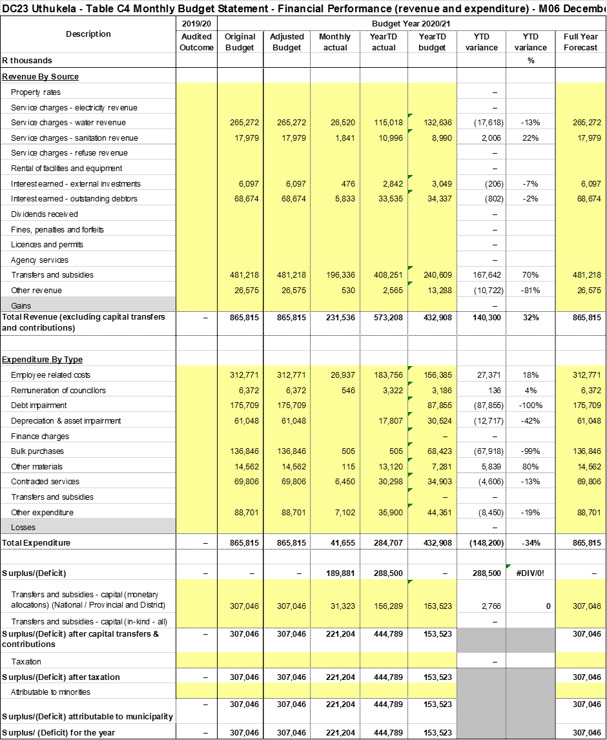

ANALYSIS OF OPERATING REVENUE (JULY 2020 – SEPTEMBER 2020) EXCLUDING
CAPITAL TRANSFERS:

Budgeted Actual Outcomes % Variance
R192, 341 R 284, 824 48

Operating revenue recognised for the period July 2020 to September 2020 amounts to R284 million resulting in a 48% positive variance from the R192 million which was anticipated.

The 48 % variance although positive must still be analysed in order to assess its impact on the budgeting process as a whole, as well as future cash flows.

This variance has been attributed to the following:

- The 45% positive variance on transfers recognised, which is the direct impact of the 3rd tranche of the equitable share of R108 million.

WATER& SANITATION SALES:

Water and sanitation sales income recognised combined is 145% above what was originally anticipated. This is due the high billing of sanitation sales in September 2020.

INTEREST FROM OUTSTANDING DEBTORS:

This line item has yielded a negative variance of 1%, it appears we have billed less interest than we had originally anticipated, however this shows an increase in the previously anticipated collection rate.

The municipality has appointed debt collectors, which will improve the collection of outstanding debt. There is also direct liaising with government departments in attempt to recover outstanding debts. The municipality anticipates an improvement in the collection rate by year end due to these efforts.

INTEREST FROM INVESTMENTS:

A total of R1.7 million has been recognised as interest from external investments resulting in a positive variance of 40%.

The municipality has become heavily dependent on investments due to our poor cash condition. We also note the negative impact of the unapproved rollovers on investment interest materialised.

ANALYSIS OF OPERATING EXPENDITURE (JULY2020 – SEPTEMBER 2020)

Budgeted Actual Outcomes % Variance
R216, 454 R 138, 378 - 36

The total operating expenditure of the municipality for the three-month period is R138 million a 36% negative variance from the R 216 million which was anticipated.

EMPLOYEE RELATED COSTS:

Employee related cost incurred is 10% above what was budgeted for the three-month period. We highlight that overtime remains a critical cost driver.

OTHER MATERIALS:

The bulk of other materials comprises of fuel, oil and chemicals. Other materials have a variance of 208% negative variance from the amount originally budgeted. However council must also note that it is due to fuel and oil that there is huge variance.

CONTRACTED SERVICES:

The bulk of contracted services comprise of vehicle repairs, hire of plant, repairs to pumps and pipe lines. A number of payments for such contracted services remain outstanding and once payments have been verified and accounted for the necessary adjustment will decrease the variance.

GENERAL EXPENDITURE:

General expenditure is 45% below what was budgeted. Which is a cause for concern as expenditure remains highly monitored in light of the adopted budget funding plan. The municipality must aim to cap general expenditure at the budgeted amount in order to avoid any unauthorised expenditure.

SUMMARY OF CAPITAL PROJECT IMPLEMENTATION
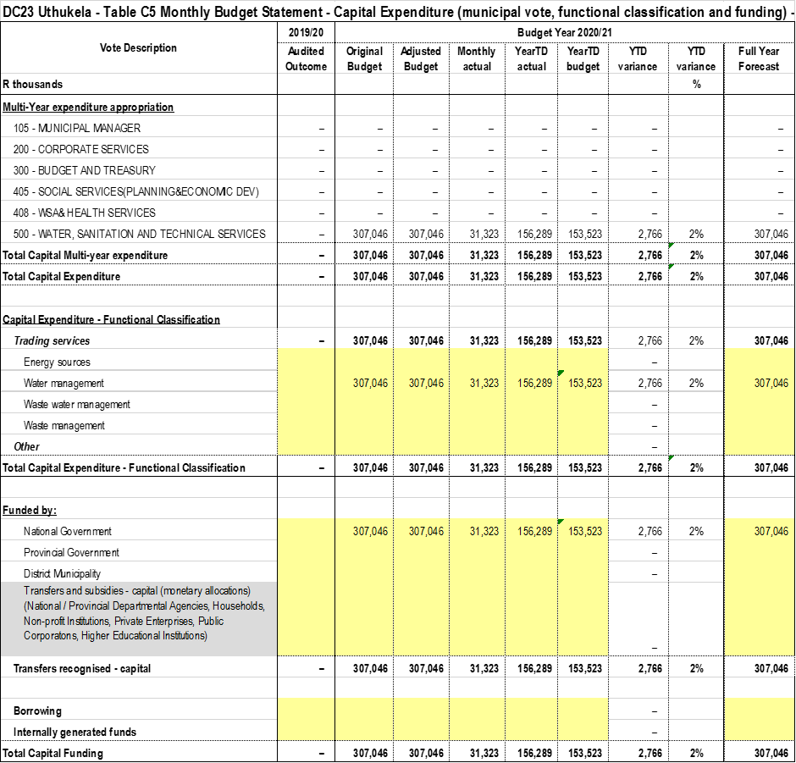

Budgeted Actual Outcomes % Variance
R 76,762 R 63,980 -10

The capital expenditure for the first quarter is R63 million resulting in a negative variance of 10% from the projected R76 million

ANALYSIS OF OUTSTANDING DEBTORS:

Age analysis at September 2020

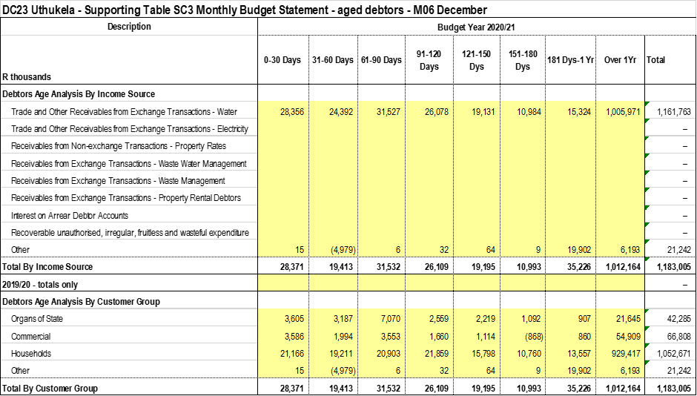

Reflected above is the age analysis of debtors for the months of July 2020 – September 2020 totalling over R1 million.

Midyear Collection Rate:

The average collection rate stood at 30% at the end of December 2020

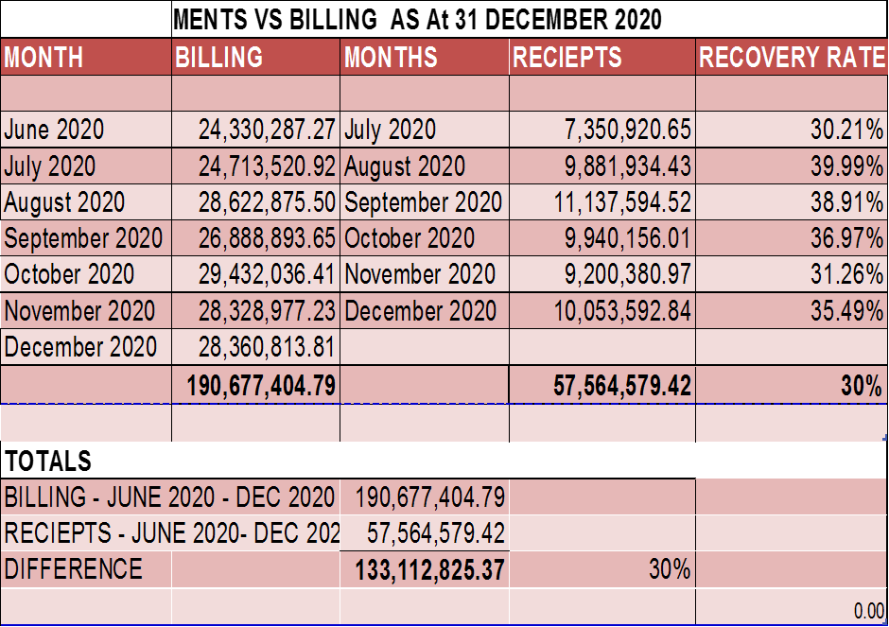

The fluctuation in the collection rate is noted, collection rate was at an average of 39% at the end of the first quarter.
The department is also appointed debt collectors to assist in recovering old debt, which will yield an improvement in receipts.

ANALYSIS OF CASH & INVESTMENTS:

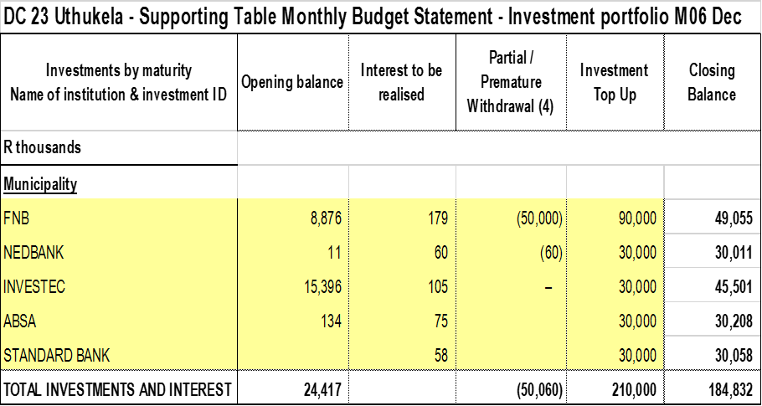

The table above reflects investments as at the end of the first quarter, at the various institutions. The total investments totalled R184 million.

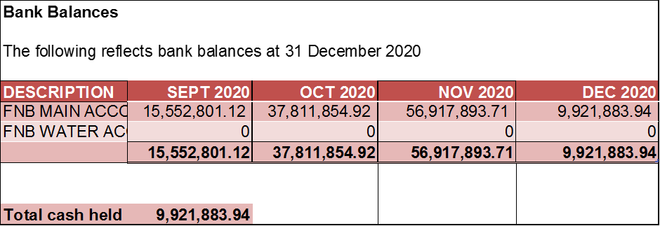

At the end of March 2020 cash on hand was R15 million

ANALYSIS OF GRANTS RECIEVED:

Conditional Grant allocations received at the end of September 2020 were as follows:

- MIG – R140 million

- FMG - R 1,8 million

- EPWP – R 933 thousand

- WSIG – R66 million

Prepared by__ `
Accountant: Budget

Reviewed by: _______________ Approved by: ___________
Senior Manager Finance Chief Financial Officer

Municipal manager’s quality certificate
I Martin Sithole, municipal manager of UThukela District Municipality, hereby certify that the Section 52 and supporting documentation for December 2020 have been prepared in accordance with the Municipal Finance Management Act and the regulations made under the Act.

Print Name: Martin Sithole
Municipal Manager of UThukela District Municipality (DC23)

Signature: _______________

Date: 12 January 2021

