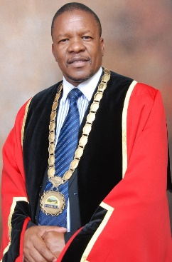

UTHUKELA DISTRICT MUNICIPALITY
PUBLIC NOTICE

The Hon Mayor Cllr Inkosi NB Shabalala

PUBLIC NOTICE FOR THE DRAFT 2026/2027 IDP REVIEW WITH KEY PERFORMANCE INDICATORS IN THE SDBIP, SPATIAL DEVELOPMENT FRAMEWORK AND THE BUDGET FOR UTHUKELA DISTRICT MUNICIPALITY

Notice is hereby given that the uThukela District Municipality has prepared the draft 2026/2027 IDP Review, Spatial Development Framework, and the draft Budget for 2026/2027 as required in terms of Section 34 of the Municipal Systems Act No. 32 of 2000 and Section 21 and 22 of Municipal Finance Management Act No. 56 of 2003. The Draft IDP, Spatial Development Framework and the draft Budget were presented in the Council meeting on the 27 March 2026.

The draft 2026/2027 IDP review with key performance indicators in the SDBIP, spatial development framework and the budget are now available for public comments or inputs, and they can be accessed at the municipal offices located at 33 Forbes Street or 36 Lyell Street in Ladysmith, and in the local municipalities which are Alfred Duma, Inkosi Langalibalele and Okhahlamba. The documents can also be accessed from the municipal website which is: www.uthukela.gov.za .

These documents can be viewed during normal working hours from 07H45 to 16H30 from Mondays to Thursdays, and from 07H30 to 15H00 on Fridays, and should not be removed from the display point. Interested members have 21 days to make comments or inputs. Comments and/ or representations which may be raised thereon should be forwarded to the following personnel in writing not later than 25 May 2026.

For IDP and SDF to: For Budget to:
MG Mazibuko N Mdakane
IDP Manager Budget Manager
Tel: 036 638 2400 Tel: 036 638 5100
Fax: 086 529 8875 Fax: 036 637 5608
E-mail: GMazibuko@uthukela.gov.za E-mail: NMdakane@uthukela.gov.za

LS JILI
MUNICIPAL MANAGER

